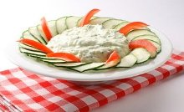
Snezhanka

Ingredients:
1 lbs (4 cups) yoghurt
1/2 cucumber, pealed, chopped in cubes
1 garlic clove, finely chopped
a pinch of salt
1 tbsp olive oil
a pinch of fresh dill, finely chopped

Preparation:
Drain the cucumber as much as you can, add all the ingredients together, refrigerate for at least 1 hour before serving. For best results you can add some sour cream to thicken the mixture.

