Banitsa
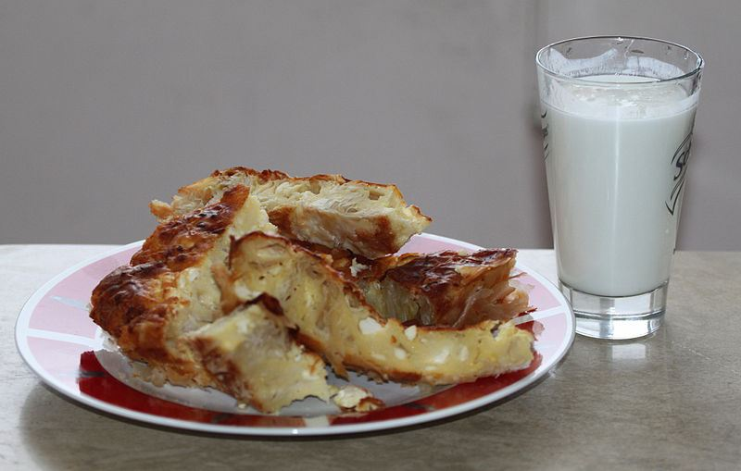
A classic breakfast combination is banitsa and or banitsa and ayran . Banitsa is a traditionally made filo pastry pie. In the most popular version it is filled with white pickled cheese or a combination of cheese, eggs and yogurt. In other variations the banitsa can contain leeks, onions, cabbage, minced meat, pumpkin and sugar or apples with cinnamon. It can be easily be purchased from any street bakery, during the whole day.
The cheesy banitsa fits very well the sweet thick boza drink. Boza is made of rye or wheat and goes into slight fermentation process. If the boza has slight alcoholic taste, it is not fresh and you should not drink it. The alternative to boza – ayran, is basically a deluded with water Bulgarian yogurt. Salt and even pepper can be added to the drink.
Ingredients:
1 pack of filo dough
3 eggs
1 lb Bulgarian cheese (or feta cheese)
3 tablespoons butter
1 cup of milk or yoghurt
Preparation:
Mix the crumbled cheese, milk and eggs together. Don't over mix - cheese should be lumpy. Melt the butter in a cup. Butter the bottom of a casserole pan. Lay 5-6 sheets of filo dough, one after another (not together) as you spread some butter in between - use a brush for this. Spread some of the cheese mixture on top, lay another 3-4 sheets, spreading butter in between. Repeat until all mixture is used. Lay the last 3-4 sheets on the top with no butter in between. Spread the rest of the butter on top. Cut in portion sized squares and bake in the oven until golden (about 30 minutes on 250 C).
Other breakfast options are tutmanik and milinka. Both are breakfast breads with cheese and eggs but each has a typical taste and different preparation method. Mekitsa is a bulgarian sort of donut, usually consumed for breakfast too. It can be eaten both with sweet and savoury additions such as white cheese, confectioner’s sugar or jam.

