Tarator - Bulgarian Cold Cucumber Soup
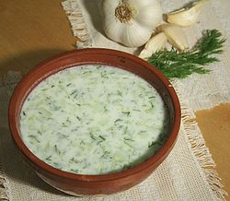
Total Time: 20 mins
Prep Time: 20 mins
Cook Time: 0 mins
Servings: 3-6
Ingredients:
2 cucumbers (about 500 g or 1 lb)
500 g plain yogurt (1 lb)
3 -4 garlic cloves
2 -3 tablespoons of crushed walnuts (optional)
1 bunch fresh dill, oil, salt, water
Directions:
- Cut the cucumbers into cubes and put them in a bowl. You may aslo grate them but it changes the look and the consistency.
- Beat the yogurt with a fork until it gets liquid and pour it over the cucumbers.
- Add the crushed garlic, the walnuts and the minced dill as well as salt and oil to taste.
- If needed add some water to make the soup as liquid as you like but take care not to make it too "thin".
- Put into the refrigerator to cool or add ice cubes.
- Serve cold.
You can read more here: http://en.wikipedia.org/wiki/Tarator

