Wine Kebab
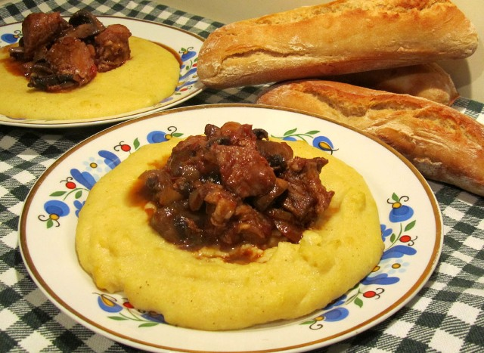
Wine kebab is a popular dish you can easily find in Bulgarian restaurants. It is made of pork lamb or beef chunks, cooked in wine sauce and served with plain white rice.
Ingredients:
1 lbs veal, cut into small cubes
4 onions, finely chopped
1 carrot
1/2 a celery,
1 tbsp tomato paste,
1 tbsp flour,
1 tsp paprika,
1 cup wine, preferably red
1 bay leaf,
ground black pepper,
parsley,
1/2 cup oil, salt
Preparation:
Fry meat in oil adding a little water and the and some water and the onions, celery and carrots. When tender add the tomato paste, add some more water, the flour and paprika. Add the wine, the bay leaf and pepper and simmer on a low fire, adding water if necessary. The meal should have relatively thick sauce. Sprinkle with finely chopped parsley before serving.

