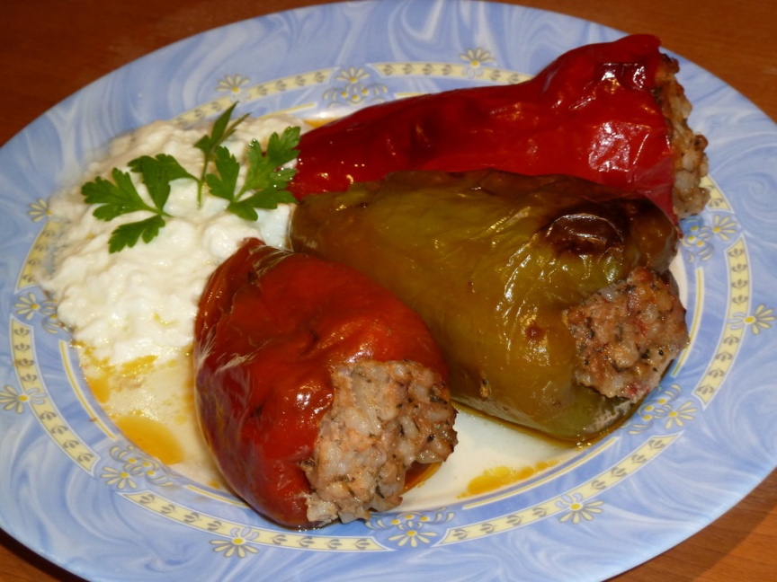
Stuffed peppers
Stuffed peppers are a good alternative. They can be both vegetarian, stuffed with rice and sometimes walnuts, or stuffed with minced meat and rice. There is a variant, in which peppers are stuffed with white cheese, covered with egg and flour and fried, called pepper biurek .

Ingredients:
8 red or green peppers
1/2 - 3/4 c. rice
1 lb. minced meat (beef, pork or chicken)
4 tomatoes
2 onions
3 tbs. oil
paprika
salt
Pepper
plain yogurt
parsley
Preparation:
Preheat oven to 200C. Cook the rice. Cut off top of peppers and remove the seeds. Heat the oil in a pan. Finely chop the onions and fry in oil for 2-3 minutes. Add the meat and cook for 5 minutes.
Add the rice and diced tomatoes. Add salt, pepper and paprika. Cook for 2 minutes. Stuff each pepper with the mixture. Put in an oven proof deep dish. Fill the dish half way with water.
Cover with foil and cook for about 30 minutes in oven. Uncover and cook for another 15-20 minutes until the peppers are cooked. Sprinkle with parsley. Serve with plain yogurt on the side.

