Greta and eight young activists reveal how the climate
crisis is shaping their lives
Nine young activists explain how climate change is affecting their lives and who inspires their efforts to make our planet a better place. Greta Thunberg (Sweden) is joined by Alexandria Villasenor (USA), Catarina Lorenzo (Brazil), Carlos Manuel (Palau), Timoci Naulusala (Fiji), Iris Duquesn (France), Raina Ivanova (Germany), Raslene Jbali (Tunisia) and Ridhima Pandey (India)
- Before watching the video do this matching activity about vocabulary.
flood / cyclone / fire / crop / drought / ice cap
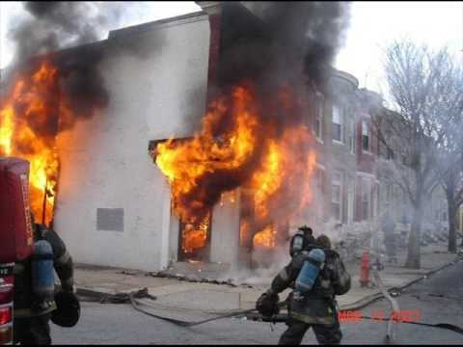 | 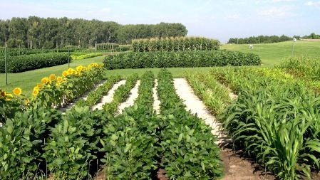 | 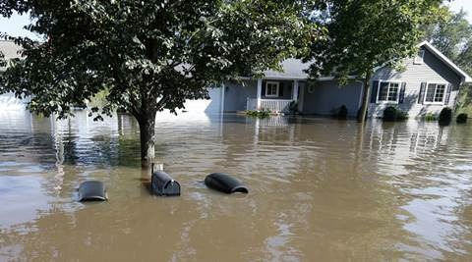
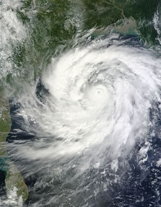 | 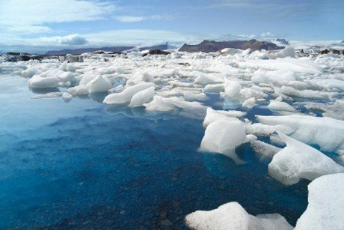 | 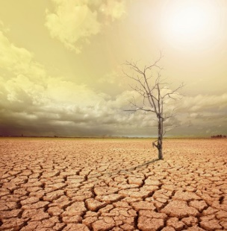

https://www.youtube.com/watch?v=C7dwoqJzETA&feature=emb_logo
2. Watch the video and match the sentences with the right natural disaster (see exercise above).
1. I saw houses blown away. Our school was destroyed. _________
- Our farms were destroyed and our crops were washed away _______

- I had to roll up towels, put them under the windows and door ____________

- The summers are really really hot. In the rainy season, when it should rain, it doesn’t rain ______________
- Sometimes it's raining that much that the river comes up to the danger mark ________

- All the memories that were made in that place are slowly disappearing ______________

3. Watch the video again and say what the young activists think
- Adults take kids seriously T/F
- People need to understand the climate crisis and the climate science T/F
- They think it's time to act right now T/F
- They think that only if everybody takes action, their protest will be successful T/F
- People can just stand aside and watch T/F

4. Read more about these young brave activists clicking this link. Which of them would you like to meet and why? What would you ask him/her?
Write your answer in the Discussion part on the Twinspace page.

