WHAT AM I LIKE?

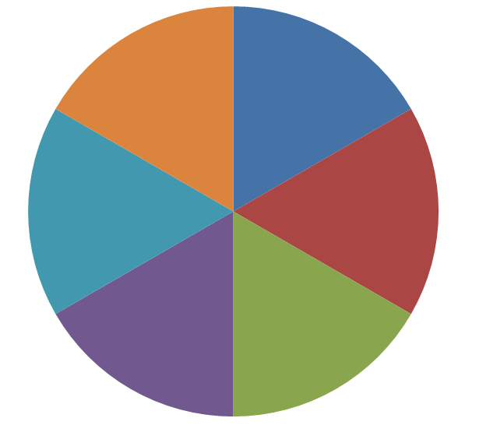
In each piece of cake enter yourself as the season, the dish, the color, the musical instrument, the number and the animal. Justify your answer:

SEASON OF THE YEAR
ANIMAL
NUMBER
DISH
MUSICAL INSTRUMENT
COLOUR

Guess who ?

UNFINISHED TASK

Finish your sentence, write the first thought that comes to your mind:

1. I am …………..
2. Most I like ………………………………..
3. My job is ……………………………………
4. In my work I like ……………………………………
5. In my work I don’t like ………………………………..
6. When the weekend comes I don’t like ………………………………………
7. Sunday evening ………………………………………….
8. In my work it is fascinating ……………………………………..
9. If I were to choose the profession again …………………………………………
10. My workmates are ……………………………………………….
11. When I have a problem at work, then ……………………………………..
12. Problems at work cause that ……………………………………….

OBLIGATION AND RELAXATION

Enter the number of hours you are devoting to your duties, and how much time each day and what activities you associate with relaxation.

MONDAY  Obligation:  Relaxation: | TUESDAY  Obligation:  Relaxation: | WEDNESDAY  Obligation:  Relaxation:
THURSDAY  Obligation:  Relaxation: | FRIDAY  Obligation:  Relaxation: | SATURDAY  Obligation:  Relaxation:

SUNDAY

Obligation:

Relaxation:

MY COMMON FEATURES WITH THE GROUP

Think about commands and find as many people who you have common characteristics with.

Find in a group of people who you have similar characteristics with:
1. People with the same eye colour
2. People with the same zodiac sign
3. People with the same height
4. People who love sweets
5. People who love music
6. People who like sports
7. People born in the same month
8. People who like reading books

YOUR BODY AND STRESS
(group work)

On the schematic form of the man, highlight where you feel the effects of stress most

