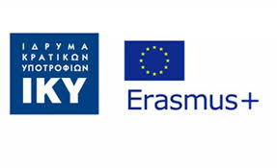
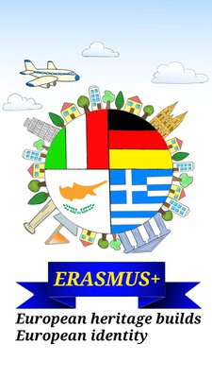
Mobility in Greece
GYMNASIO PARALIAS
Kalamata
8 - 14 / 4 / 2022

Working Sheet
Choose a name for your team ……………………………………………………………………………………………..…..…
Write the names of your team members:
………………………………………………….………………………………………………….
………………………………………………….………………………………………………….
………………………………………………….………………………………………………….
………………………………………………….………………………………………………….
………………………………………………….………………………………………………….

………………………………………………….

Let’s learn about Greece

1. Find Kalamata in the map of Greece and mark your itinerary from Athens:

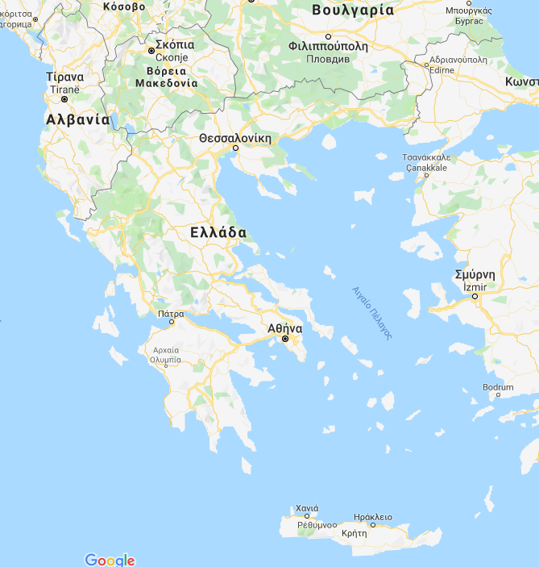

2. Kalamata is in …………………..……………….. of Greece
a. the south
b. the north
3.. Kalamata has………………………. inhabitants.

a. 1.000.000,
b. 56.000,
c. 560.000

4. This is the symbol of Kalamata. What is its meaning?

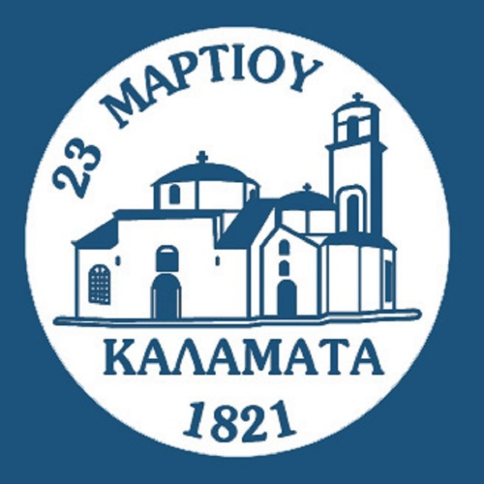

………………………………………………………………………………………………………………………………………………………………………………………………………………………………………………………………………………………..

5. What is the most famous product of Kalamata?

……………………………………………………………………………………………………………………….………………….

6. Write 3 things you could do in Kalamata:
- ……………………………………………………………………………………………………………………………………………………………………………………………………………………………………………………..…….

- ……………………………………………………………………….………………………………………………………………………………………………………………………………………………………………………………….……

- ……………………………………………………………………….………………………………………………………………………………………………………………………………………………………………………………………

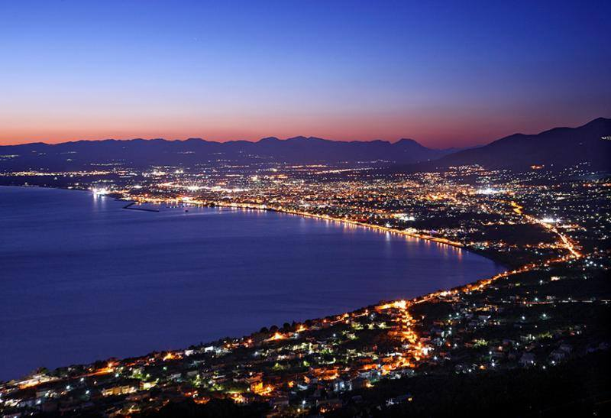

Now let’s learn about our schools!
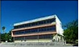

1. The educational system in Greece:
- Pre-primary education (4-5 years old)
- Primary education (6 grades: 6-12 years old)
- Lower secondary Education (high school: gymnasio)(3 grades,12-15 years old)
- Upper secondary education (high school: lykeio)(3 grades, 15-18 years old)
- Higher education (Universities and Polytechnics)

Now briefly describe the educational system in your countries:

- Cyprus :………………………………………………………………………………………….………………………

- Germany: ………………………………………………………………………………………………………………

- Italy: ………………………………………………………………………………………………………………………

Where does your school belong?

2. How is your school called? What does this name mean?

In Cyprus: ....................................................................................................................................
In Germany: ……………………………………………………………………………………....………………………………….
In Greece: ……………………………………………………………………………………………..…………………………….…
In Italy: ........................................................................................................................................

3. Which school has more pupils?
……………………………………………………………………………………………………………………………………………

4. Which school has more teachers?
……………………………………………………………………………………………………………………………………………

5. Who is the headmaster of the school?
Cyprus: ................................................................................................................................
Germany: .............................................................................................................................
Greece: ................................................................................................................................
Italy: ...................................................................................................................................

4. What time do you start and finish school:
Cyprus: ................................................................................................................................
Germany: .............................................................................................................................
Greece: ................................................................................................................................
Italy: ....................................................................................................................................

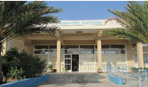
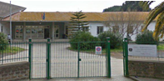
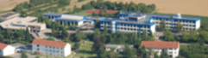
Let’s talk about our Erasmus+ project!

1. What is the title of our project
in English : ...........................................................................................................................
in Germany: ........................................................................................................................
in Greek: .............................................................................................................................
in Italian: …………………………………………………………………………………..........................................

2. Find and colour the partner countries in the map. Mark where the partner schools are:

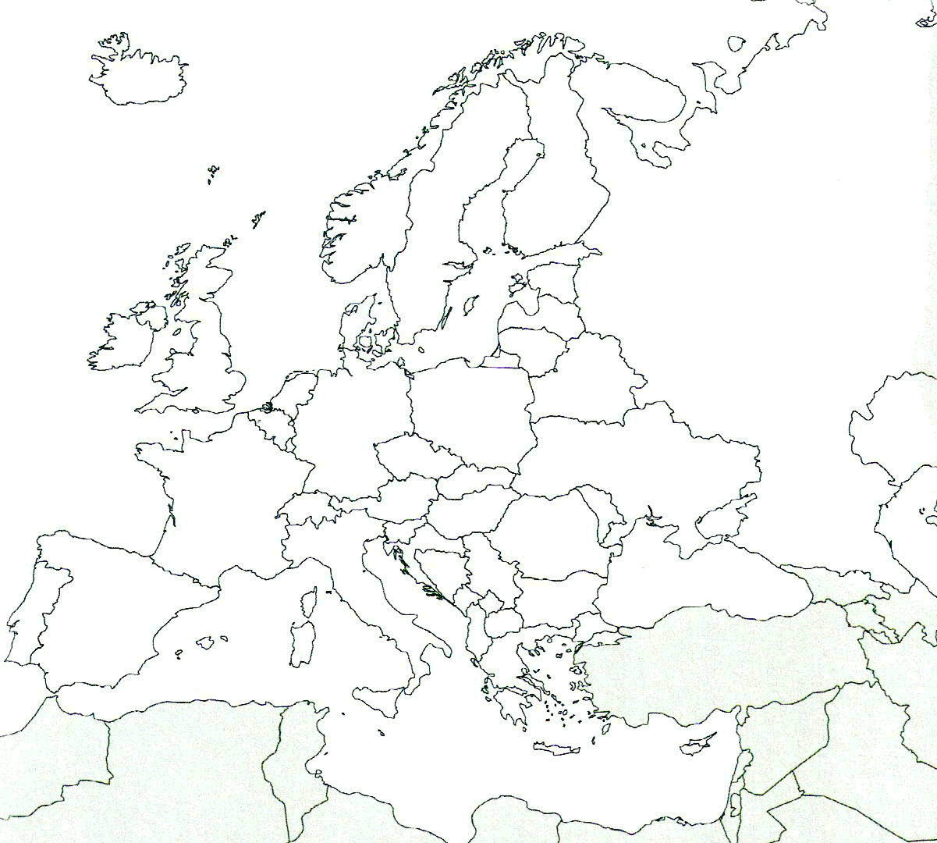

3. Write a monument of tangible, intangible and natural heritage in your country:

Country | tangible | intangible | natural
Cyprus
Germany
Greece
Italy

Let’s talk!

1.Translate from English to your language and teach the members of your team how to pronounce:

English | German | Greek | Italian
Hello
Good morning
Thank you
What’s your name?
My name is……
Nice to meet you!
one
two
three
four
five

2. Practice the words and use them in short dialogues with your partners.
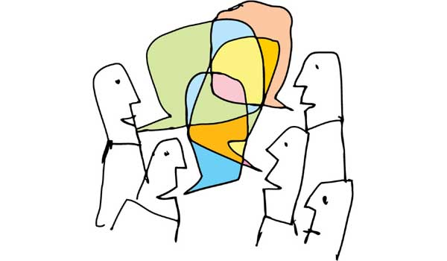
Test your knowledge:

1. Go to the four posters of the Erasmus+ project on the boards of our school: how many monuments of cultural heritage can you recognize?
………………………………………………………………………………………………………………………………………..

2. Match :

- Cyprus | a.Berlin
- Germany | b.Roma
- Greece | c.Nicosia
- Italy | c.Athens

3. Write under the flags the names of the countries:

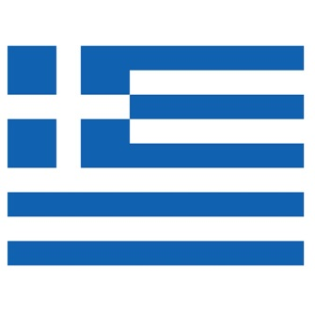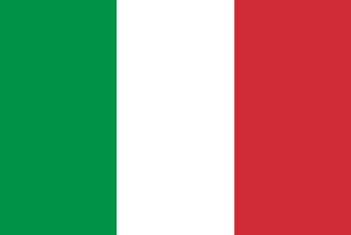

………………………………… ……………………………….……..

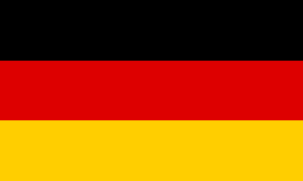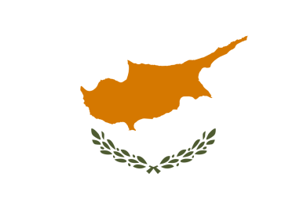

…………….………..……….. …………………………….…………..

4. When are the national holidays of each country?

Cyprus ……………………………………………………………………………………………………….……………

Germany ………………………………………………………………………………………………………………….

Greece ………………………………………………………….…………………………………………………………

Italy …………………………………………………………………………………………………………………………

5. Do you know any German/Greek/Italian words that are used in your language?
………………………………………………………………………………………………………………………………………………………………………………………………………………………………………………………………………………………………………………………………………………………………………………………………………………………………………………………………………………………………………………………………………………………………………………………………………………………………………………………………………………………………………………………………………………………………………………………………………………………………………………………………………………………………

