Clarifications

HOMEPAGE (page2)
TwinSpace is thework area for your project; it is an instrument that really encourages and facilitates collaboration, communication, sharing and interaction amongst pupils. It also places the pupils at the centre of the collaboration activity.
You, your partners and your pupils will be the main users of the TwinSpace but, you can invite other people so that they may have access to this work area, such as other teachers from countries not participating in eTwinning, experts from museums or from professional or cultural organizations, etc.
You might also invite parents, or your school leader, to come and have a look or decide to make the Homepage and Activities section of your TwinSpace public so that the wider school community can benefit from your experience, as well as you, having a great way to proudly show what your pupils have achieved thanks to your help.
HOMEPAGE: The page consists of a series of boxes which provide all the functions related to the management of your project:
- PAGES. Pages can be visible only to TwinSpace members or shared on the Internet via your public TwinSpace.
- IMAGES. You can use these images in pages, forum or journal posts.
- VIDEOS. You must first upload your video to one of the supported video services. They currently support YouTube and Vimeo
- TEACHER BULLETIN. Bulletin posts are only visible to teacher members.
The Teacher Bulletin is a communication tool only visible to teachers. It can be used to manage the project and to discuss the steps to be taken.
The Teacher Bulletin can only contain text messages. It is not possible to attach files.
- PROJECT JOURNAL AND PUBLIC PAGES.Theses posts will be shared online in the public TwinSpace
TwinSpace offers 2 ways of communication with anyone who is NOT taking part in the project. By means ofpublic pages and Project Journal you can select and share information with different stakeholders like parents and other members of the school community.
Giving visibility to the eTwinning project is very important and valuable for the participants and for the school.
Only members with administration rights can post messages on the Project Journal. All members of the TwinSpace can add a comment to the Project Journal Messages.
Project Journal messages can include materials like images and videos.
Profile pictures of participants are not displayed on the public page of the TwinSpace and only visible to participants who are logged in.

Who can post entries in the project diary?
– Teacher administrators
– Partner teachers
– Pupil Administrators
Who can comment on the entries?
– Teachers administrators
– Partner teachers
– Pupil administrators
– Partner pupils
– Visitors
Who can see posts and comments?
Everyone, both users registered in eTwinning and those not registered on the platform, which are often parents or other members of the educational community. We must be careful about what we publish, avoiding individual photos of pupils, using polite language and being consistent in the texts so that anyone who reads it can understand the project.
What contents should be posted?
First you introduce yourself and then you can post an entry for each activity/task performed, always mentioning the pages and/or related materials. You can insert:
Photos: The size shouldn’t exceed 400 pixels wide and 500 pixels high.
In the image folder you can change the photo you’ve uploaded; it has a default number, like the title of the photo, which is visible when you publish it. So it’s better to rename it so that the photo has a coherent publication title. Don’t forget the screenshots that show the invisible parts like chats and forums that are never public for people not invited to the TwinSpace.
Videos: The videos still have the names that have been uploaded to the video folder, but you can always rename them to adapt their titles to the posts.

And you can attach: documents, presentations, mp3 and other files that are visible in a post with an icon, but by clicking on them they can be opened or saved. They can also be renamed.

PAGES (pages 3, 4)
You can tell the story of your project in the pages. Uploaded materials like pictures, videos, presentations and other project outcomes can be presented in a coherent context.
To start, you click on CREATE A PAGE on the top bar of the TwinSpace. Alternatively you can click on PAGES.
Click CREATE PAGE to get started and write a title.That’s the time to select the various options for publishing and editing. After naming the page, selectWho can see the page? Who can change it?. Remember to write something in the box so that you can save changes.
When creating a page you must decide who is going to be the (co-)author of the page. By default the Administrators (founders) and the Teachers can edit any page in the TwinSpace.
Pupil administrators can create new pages. Pupils can only add content to a particular page when they are given the rights.
Who can see the page?Pages have three possible forms of visibility:
- Only me (and administrators): The page is published in this option by default. You must select one of the other two options (2 or 3) so that the page is visible and no longer appears in the “draft” mode”.
- TwinSpace Members: The page is only visible to members with access to the TwinSpace.
- Everyone: if you select this option, the page becomes public. It will be visible for everyone who has the TwinSpace link, without needing passwords.
Who can change the page? The possibility of giving pupils editing permission is a very interesting new feature. The activity pages thereby become collaboration tools in the creation of contents by teams of pupils from different schools. Collaboration is one of the pillars of eTwinning projects and TwinSpace provides the tools to accomplish this work.
Permission is administered by individual pages. Each TwinSpace page can have its own editing permission depending on its object or purpose. Permission may be granted to different profiles simultaneously. Teachers (administrators or members) always have editing permission without being able to modify this editing condition. In addition to the two teacher profiles, there are three more profiles that can be given permission to edit a page: pupil administrators, pupils and/or visitors. Visitors are those agents outside the school community who we want to invite to the project as spectators and even give them a voice: pupils’ families, institutions, collaborating specialists…Editing profiles are not exclusive.
The pages have an edit toolbar to create contents. In addition to text editing items, they have other features that make it possible to insert materials stored in the TwinSpace and/or to embed or link items or objects outside the TwinSpace. Click the icons to add materials or to paste the embedded code of the internet application. Please note that not all embedded codes will work in the TwinSpace.
If the name of the page appears in red, it means that it is active.
In the lower right it appears the author of this page and the last user who modified it.
If there are multiple pages created, all appear in black, except the one that is active, which appears in red.

To create a sub-page, click again CREATE PAGE and deploy the menu page where the pages are already created. Select the page and once the main page is selected, the changes are saved.

The order and the hierarchy of the pages can be rearranged so that the structure is transparent and easy to be understood by all members.
Pages cannot be deleted completely. They can be stored to make them invisible, and if necessary they are made visible again.
The size and position of images can be changed by rights-clicking on the picture.
Make clear arrangements with all members of the TwinSpace: discuss the structure and the order of the pages with all the teachers of the project. If not the TwinSpace might end up in a mess.
Students can also be given ownership by giving them editing rights to particular pages so that they can add content.

IMAGES (page 5)
To upload pictures you click on ADD IMAGES on the front page. Alternatively you can click on MATERIALS.
It is advisable to create IMAGE ALBUMS. The maximum size of a picture is 4 MB. Only these formats are allowed: gif, jpg, jpeg, png.
If you want to integrate pictures in a PAGE, FORUM or PROJECT JOURNAL post, you need to upload your picture in this section first of all.
For copyright reasons it is advisable to use only pictures you own the rights or that have been shared under Creative commons License.
- Pictures your took yourself or that belong to Public domain can be used freely without attribution of the name of the author
- When you use pictures under Creative commons License you need to give credit to the author in the proper way.

VIDEOS (page 6)
Videos bring life to the TwinSpace. You can create stand-alone FOLDERS with movie clips or you can integrate movies in PAGES, FORUMS POSTS or JOURNAL POSTS.
To upload videos you click on ADD VIDEOS on the front page. Alternatively you can click on MATERIALS.
You cannot upload videos directly to the TwinSpace. You need to upload a video first to YouTube, Vimeo or DailyMotion.
For safety reasons you should categorize videos at YouTube under UNLISTED. In this way the video will be hidden for the YouTube search engine. However the video will be visible to anyone who knows the URL.
To transfer the video to the TwinSpace, you first COPY the URL of the previously uploaded video in YouTube, Vimeo or Dailymotion and then PASTE it in the MATERIALS section of the TwinSpace.
Vimeo offers the opportunity to protect a video with a password. In that case the video cannot be uploaded in the MATERIALS section of the TwinSpace and cannot be embedded in e.g. a PAGE.
It is, of course, possible to share the URL of the Vimeo on a PAGE, FORUM or JOURNAL POST.

FILES (page 7)
The TwinSpace offers the opportunity to share various types of files. You can create stand-alone folders or you can integrate a direct link to the FILES on a PAGE, FORUM or PROJECT JOURNAL post.
Allowed files are text files (.pdf, .txt, .doc, .docx), presentations (.ppt, .pptx), spreadsheets (.xls, .xlsx) and compressed files (.zip, .rar). The maximum file’s size is 20 Mb.
To upload files click on MATERIALS. It is advisable to create FILES FOLDERS.
All files in the TwinSpace are visible to all members. It is possible to share files only with teachers.
If a file type is not supported by the TwinSpace, it is always possible to compress it to a .zip or .rar file.
EMBEDDING
In an eTwinning project many teachers and pupils make use ofdifferent tools to create content from the ones provided in the TwinSpace: e.g. a poll, a slideshow, a quiz, a brainstorming toll, etc.
There are 2 ways of connecting these internet applications to a TwinSpace:
- Providing a weblink which sends the user out of the TwinSpace to the external webpage.
- Embedding: you can view or use the full application in the environment of the TwinSpace platform.
Not all internet applications provide the possibility of embedding a tool on a platform like TwinSpace.
For technical and safety reasons not all internet applications that allow embedding can be embedded in the TwinSpace.
Here you find a selection of embeddable applications for the TwinSpace: http://bit.ly/embedtwinspace
HOW TO EMBED A TOOL IN THE TWINSPACE?
STEP 1
- Create content on the website of the tool you want to use (You might need to take an account)
- Find and copy the embed code. Search for key words like EMBED, SHARE or </>. The embed or iframe code starts with > and ends with >
STEP 2
- Create or open an existing PAGE on the TwinSpace. Click on the SOURCE button.
- PASTE the embedded code. When you click again on the SOURCE button, the content will be shown.
Using tools outside the TwinSpace can give an added value to the project. However, a lot of free online tools contain advertisements; sometimes free tools are not reliable in a long term as they might disappear or become payable.

FORUMS (page 8,9,10)
A forum is a tool involving participants in an ongoing a- synchronous discussion. Only members with administrator’s rights can set up forums.
Setting up a forum goes in 2 steps. The first step is to define the general topic or discussion theme and to give a description. The second step is to create one or more discussion threads. Threads are the actual discussion (sub)topics participants can express their view on.
To make the CREATE THREAD button visible, you need to click on the title.
First of all, we need to log our students in the project TwinSpace so that they can use this tool. Under the tab “MEMBERS”, we can invite different members of our educational community, our pupils among them, creating an user and a password for each participant in the project. Students must always log in using the following link if they want to take part in forums or in any other project activity: https://twinspace.etwinning.net/unauthorized
Onlythosepeoplelogged in thisTwinSpace can get Access totheforums and they can participate in thediscussionsthathavebeenstarted. Administrators can open severalforums. Teachermembersoradministratorstudents can open new disucssions in a forum.
Once theforum has beencreated, you can open severalthreads so thatthestudents can interactwithotherstudents. They can selecttheconversations and giveanswertothetopicsunderdiscussion in eachforum. Theadministratorteacherwillalways be abletoread, moderate and eliminatethedifferentmessagesthat are beingcreated in theconversations.
Wewillalwayshaveanactivity record of discussions in theforums as well as a record of yourcontributionsononeside of thescreen. You can clickonthe link to be redirectedto a specificconversation so thatyou can answerfasterthanbyreadingalltheforums in TwinSpace.
You can alwaysmodify a forumorevenstoredit. Ifyoudon’twantthatforumto be visible at thatspecific momento, youwill be abletomakethenecessarychanges and actívate itwhenconvenient. 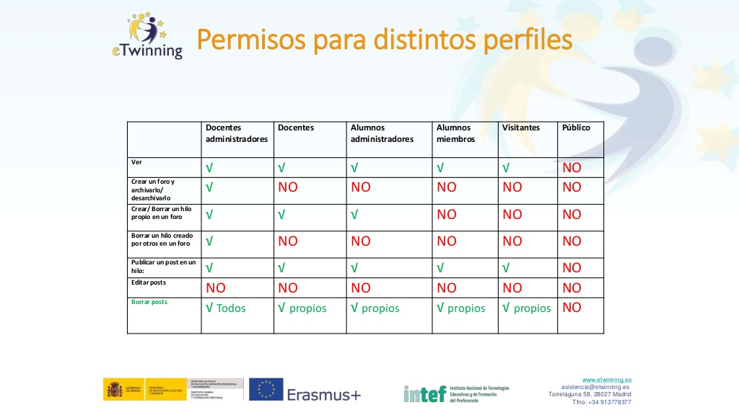
Some ideas aboutthe use of forums in a eTwinningproject:
- Discuss a specifictopic and seethestudents’ reaction.
- Choosetheprojectactivities.
- Introductionactivityforstudents.
- Project feedback.
- Creatediscussions in groups of differentnationalities.
- Value and assesstheproject.

CHAT AND VIDEOCONFERENCING (page 11,12)
Chats in thisroom are not private. All chats are logged and can be read by your TwinSpace administrator. Chats are storedfor 3 months.
CHAT:
TwinSpaceoffersseveraltools for synchronous communication:
There is a chatroom where all online members can takepart in a livediscussion.
Members can alsosend 1:1 direct messages to other participants who are online.
In the chatroom all online members can communicate at all times.
It is not possible to switch off thechatroom.
Teachers can download and export the chat history. It will prevent possiblebadbehavioronthestudents’ part.
The feature is also handy for pedagogical reasons: teachers can assess the contribution of all members to a conversation.
EVENT
Teachers can set up a Live Event for the members of TwinSpace
To make use of the tool you need to book a time slot.
Just before the starting time the ENTER ROOM button will become visible.
The Live Event tool offers different communication and interaction tools. Presenters can share their computer screen, open a collaborative whiteboard or show a presentation or a document.
Participants can communicate with audio and video or just make use of the chat box.
The organizer can invite participants, block the assistants, manage file types, manage rights microphone for participants...
To access the room, attendees can use the options on the top bar to adjust: speakers, microphone, video camera...
The Live Event session booked and organized in the TwinSpace cannot be recorded. Although the record button seems to be active it will not generate a recording of the meeting.
The Live Event cannot be accessed using the accounts of pupils. When organizing a virtual meeting with project partners, teachers should display the Live Event on a big screen in the classroom.

MEMBERS (page 13,14)
Invite other members
Administrators have the right to invite new members: teachers, pupils and visitors.
First of all, you need to invite your pupils and other teachers that are going to work with you in TwinSpace. You can add members to the TwinSpace whenever you like. To invite members, go to the TwinSpace Members box from the Homepage. There is a difference in inviting teachers and inviting pupils. Teachers receive the invitation in their personal email inbox, whilst pupils do not need to have an email address: the system will immediately generate the login name and password, which will be displayed on the screen.
Remember that pupils cannot change their password. Teachers can RESET the PASSWORD of pupils.
When adding your pupils to the TwinSpace, you must first decide what user rights you want them to be attributed. If needed, you can change these roles at any time. Pupil administrators can create PAGES and FORUMS.
Tips:
- Give administrator rights to pupils so that they are able to take ownership of the design and progress of the TwinSpace (especially for older pupils).
- Give administrator rights to some pupils with a certain managerial role in the project.
- Give member rights to pupils when working in a large group with a set of defined tasks to be accomplished (especially for younger pupils).
Teachers can export the data of logins and passwords of the students to Excel: EXPORT INVITED PUPILS.
To INVITE PUPILS you must write a name and surname. Click on “+” button for more than three pupils.
The system will propose a username and password for the pupil.You can change this data so it is possible to create an easier password, for example.
Torecoverthelogin and password of a studentitisnecessaryto:
- Gothememberstab.
- Clickon EXPORT INVITED PUPILS.
- Clickonthedownloadingicon. An Excel withtheaccesskeys of allthestudentslogged in bytheteacherwill be downloaded.

TWINMAIL (page 15)
The TwinMail is a messaging tool comparable to sending an email. Messages can be sent by all members of the TwinSpaces they are part of.
Messages can have attachments and they are stored.

PROFILE (page 16)
With the Profile settings users of the TwinSpace take the first steps in expressing their digital identity. Adding a profile picture and a short description are important for the first impression others have about you.
Click on your name to change the profile settings. The profile settings include a description and a picture. Members can also set the default display language.
The Profile settings (including picture and written description) will be displayed in all the TwinSpaces you are part of.
Teachers should provide guidelines for the students on how they must write the profile description: what the language must be, what type of information must (not) be shared, etc.
Teachers must also provide guidelines, if necessary, about the profile picture. A picture tells more than thousand words. Teachers cannot delete the profile picture of the student.

LINKS:
https://stm.etwinning.net/en/pub/collaboration_in_etwinning_/management_of_twinspace.htm
http://etwinning.es/?lang=en

