MODERN WONDERS OF CYPRUS
►Have a look at these modern wonders of our country and select your favourite one!
“Asprokremmos” Dam (Paphos)  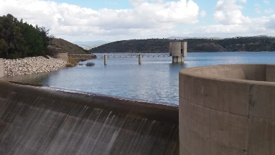 | 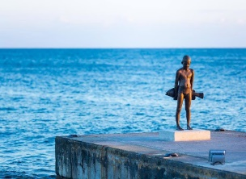  The “little fisherman” sculpture (Paphos harbour)
“The girl and the sparrow” (sculpture at the centre of Paphos)  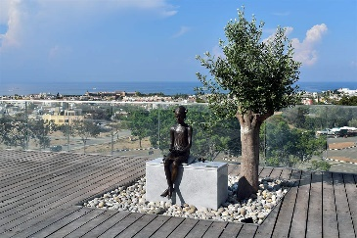 | 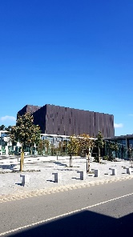  “Markideion” theatre of Paphos.
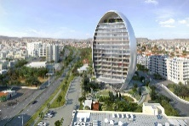  The “Oval” (Commercial building in Limassol) | 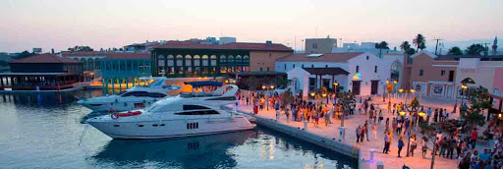  Limassol Marina.
“The modern Aphrodite” of Paphos.  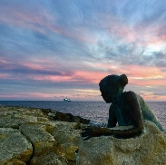 | 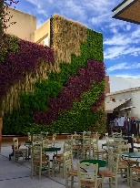  “Old town” square (Paphos).
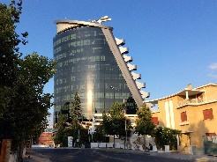  Wargaming Cyprus building (Nicosia) | 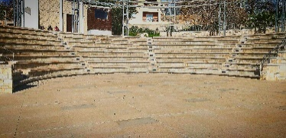  Amphitheatre “Vrysi” (Chloraka)

