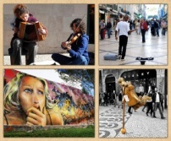
Worksheet 1

European Famous People

1- Which was the nationality of Alfred Nobel, founder of the Nobel Prizes?
a) Finnish b) Swedish c) Italian

2- Michelangelo, one of the greatest genius of the European art, was Spanish.
True or False?

3- Socrates, Plato and Aristotle were...
a) Greek philosophers b) Roman politicians c) Portuguese explorers

4- Salvador Dalí was a famous painter. Where was he from?
a) Italy b) Portugal c) Spain

5- Hergé, the author of “The Adventures of Tintim”, was…..
a) French b) Belgium c) Luxembourger

6- Alexandre Dumas, the author of “The Three Musketeers”, was….
a) Italian b) Spanish c) French

7- Cézanne, Gauguin and Matisse were painters from...
a) Belgium b) France c) Luxembourg

8- Bedřich Smetana is a symbol of the classical music. Where is he from?
a) The Czech Republic b) Hungary c) Poland

9- Pablo Picasso was an Italian painter.
True or False?

10- Nicholas Copernicus was a Polishastronomer.
True or False?

11- Bach, Wagner and Beethoven were composers from...
a) Austria b) Germany c) Hungary

12- Van Gogh andRembrant were very famous painters. Where were they from?
a) The Netherlands b) Belgium c) Austria

Adopted from Science4you Quiz Activities

Key: 1-b 2- F 3-a 4- c 5-b 6-c 7- b 8- a 9- F 10- T 11- b 12-a

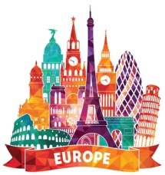
Worksheet 2

Culture

1- Which of these European capital cities is famous for its channels?
a) Madrid b) Romec) Amesterdam

2- The Versailles Palace was the residence of the kings of which country?
a) France b) Belgium c) Austria

3- In which European country can you visit the Westminster Abbey?
a) Ireland b) England c) Malta

4- In which European country can you visit the Atomium?
a) Luxembourg b) Hungary c) Belgium

5- In which European country is it possible to see the aurora borealis?
a) United Kingdom b) Estonia c) Finland

6- In Finland there is no sunset during the Summer.
True or False?

7- From which country is the Flamenco a traditional dance?
a) Romania b) Spain c) Italy

8- The Cannes festival, which happens in the South of France, is dedicated to
a) The cinema b) The theatre c) Music

Adopted from Science4you Quiz Activities

Key: 1- c 2-a 3- b 4- c 5- c 6- T 7- b 8- a

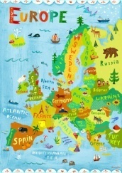
Worksheet 3

European Geography

1- In which country from the European Union is located the Etna volcano?
a) Italy b) Greece c) Romania

2- The Dark Forest is the biggest natural park from…
a) Austria b) Germany c)The Czech Republic

3- The Olimpus Mount is the highest mountain from….
a) Spain b) Greece c) Italy

4- The Bavariais a region from…
a) France b) Germany c) Belgium

5- Which of these seas isn’t near Italy?
a) Mediterranean Sea b) Black Sea c) Adriatic Sea

6- Which of these rivers crosses the London city?
a) Thames b) Danube c) Sena

7- The Republic of Ireland has a terrestrialfrontier with….
a) The United Kingdom b) France c) It doesn’t have any terrestrial frontier.

8- The Luxembourg is the smallest country from the European Union.
Trueor False?

Adopted from Science4you Quiz Activities

Key: 1- a; 2- b; 3- b;4- b; 5- b; 6- a; 7- a; 8- T

