Date of Travel.

Netherlands – 14 – 15 November 2019

Slovakia – 27-31st Jan 2020

Portugal- 11-15 May 2020

Ireland -21-25 Sept 2020

Poland- 11-15 May 2021

Turkey – 24-25th May 2021

Travel will include three teachers and four students. Any students under 15 can take part. Students that travel will then host a student on return visit in September 2020. Students will travel to Slovakia, Portugal and Poland only. It will be four different students traveling on each of the three trips. Cost of travel is funded by Erasmus+. A letter will be sent home to inform all parents/guardians of the project. Parents will then be invited in for an information evening.
Teachers interested in travel, please check the dates of travel and read the brief summary of what each time involves. Anyone interested can then email me and I can give you more details regarding the preparation before the trip, work during the trip and the follow up work on return from the trip.
Travel will not suit everyone and again only three teachers can travel on each trip. For those who do not travel and would like to get involved in the project a list of activities will be emailed to all staff and placed on the staff notice board. Teachers will be able to sign up for activities which interest them and their subject. The activities/tasks are not designed to not take up much class time.

Netherlands

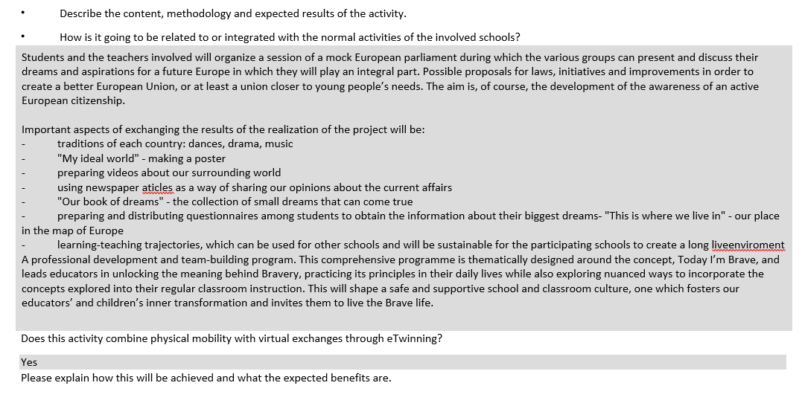

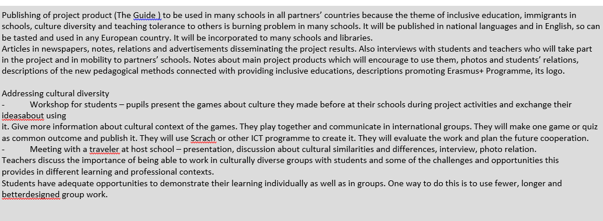

Slovakia
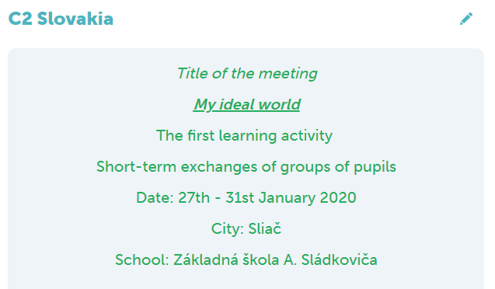

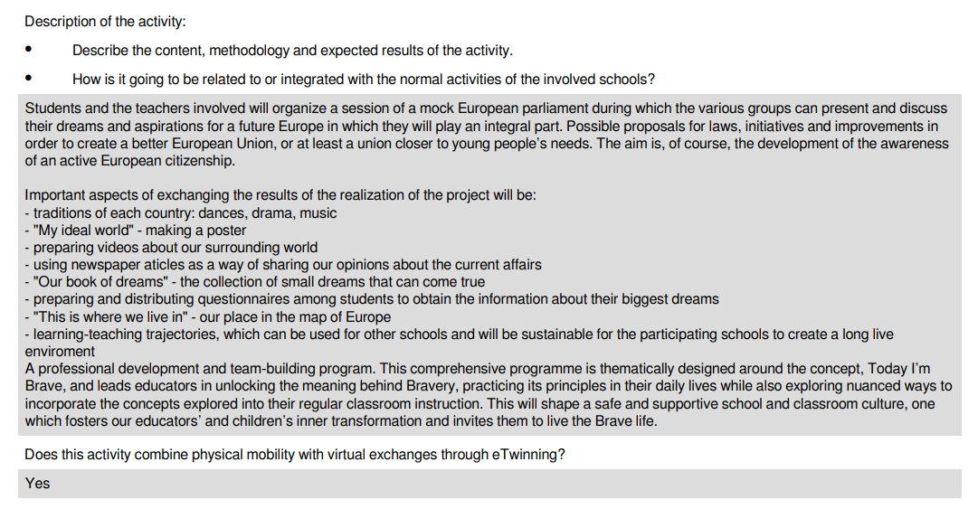
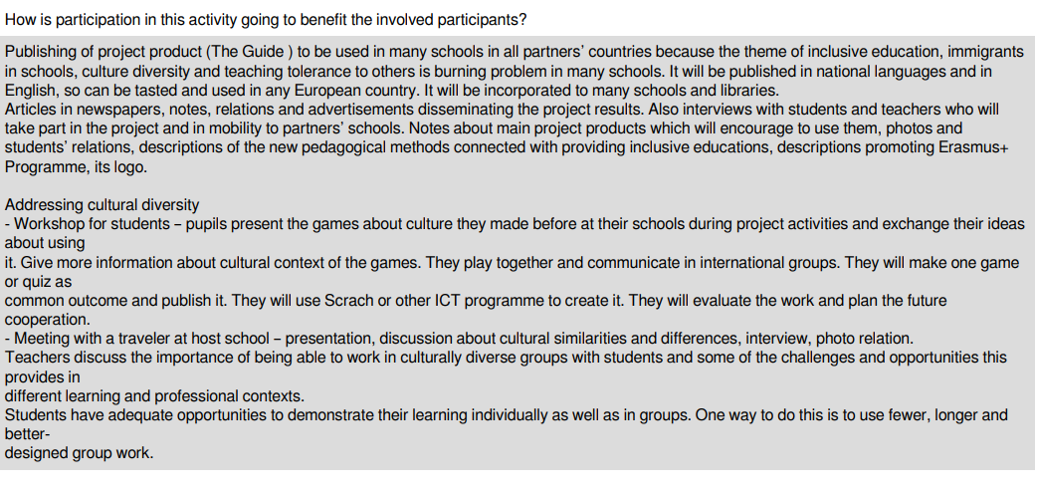

Portugal

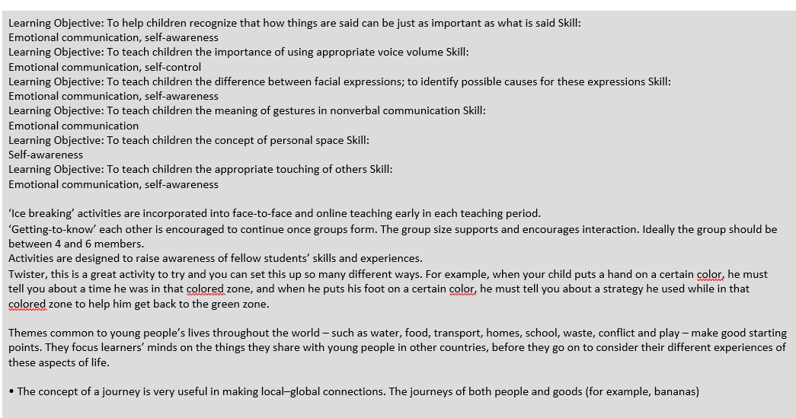
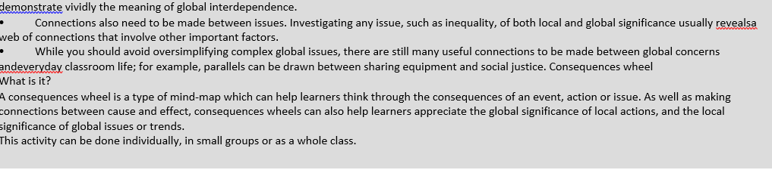
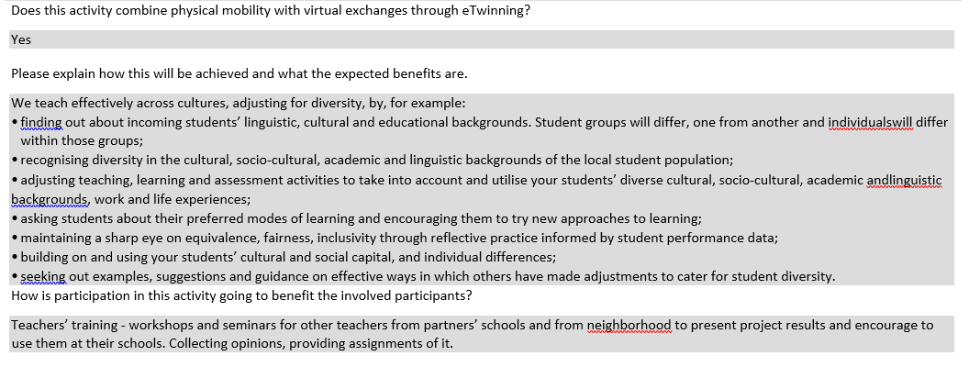
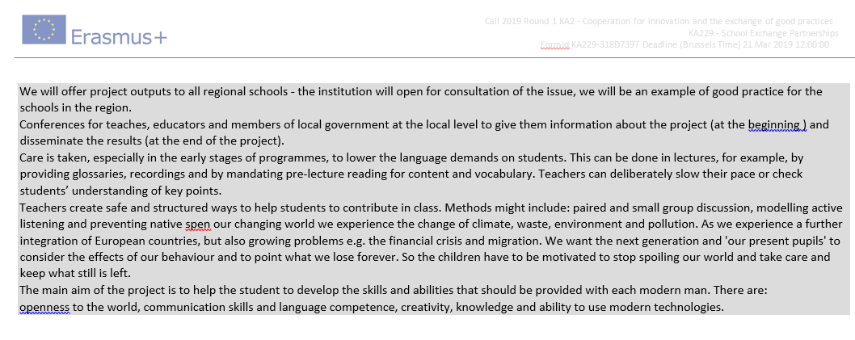

Turkey
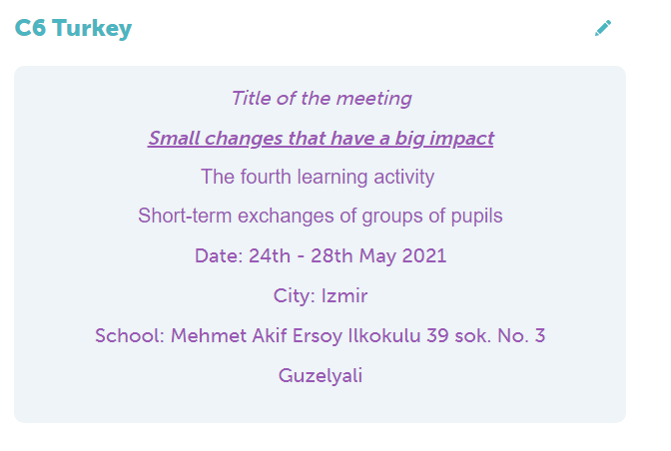
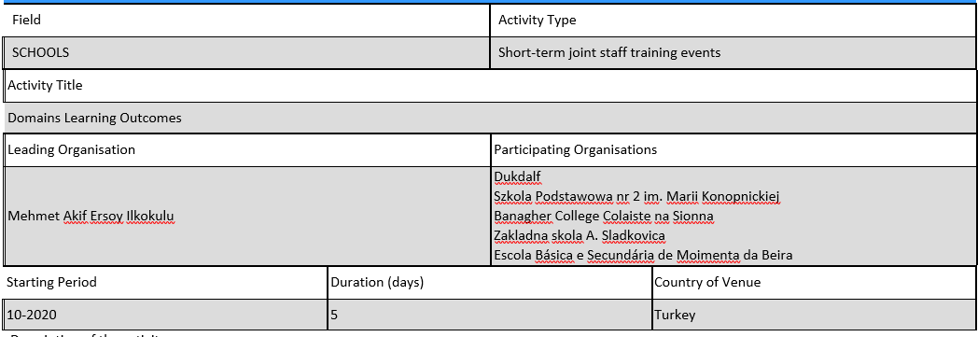

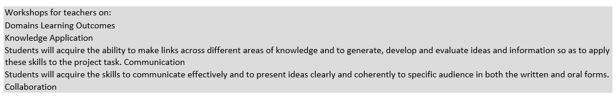
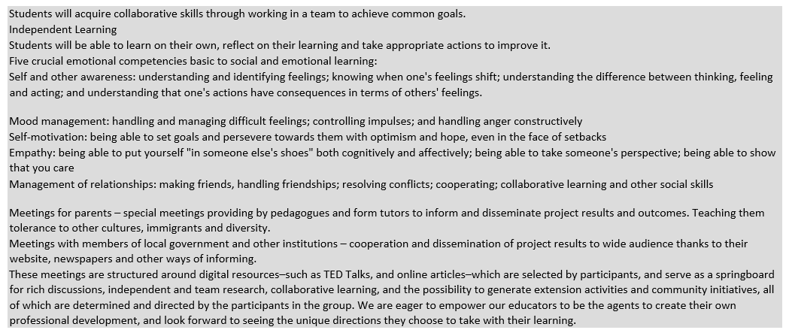
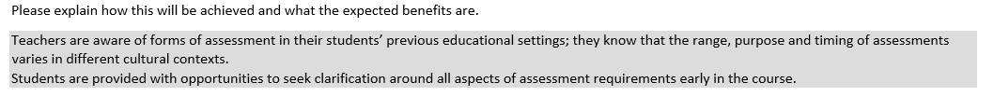

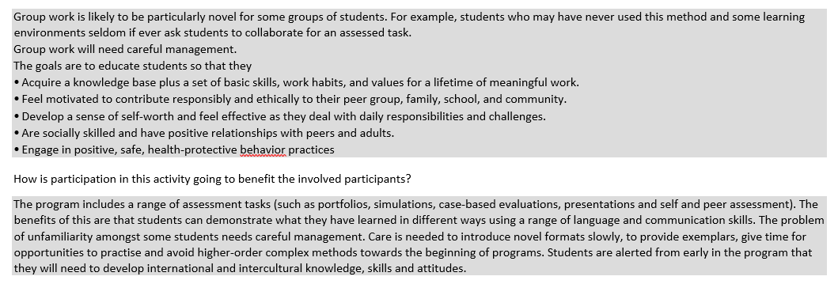

Poland
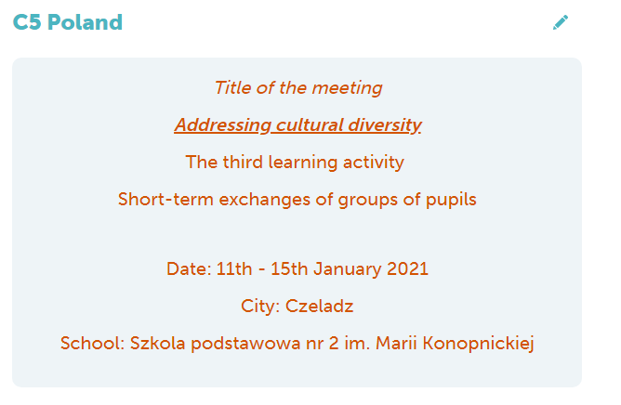
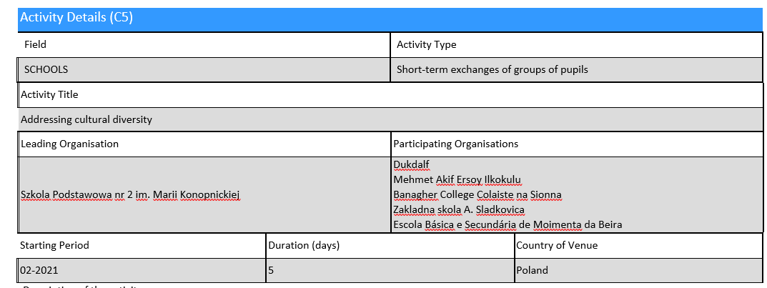

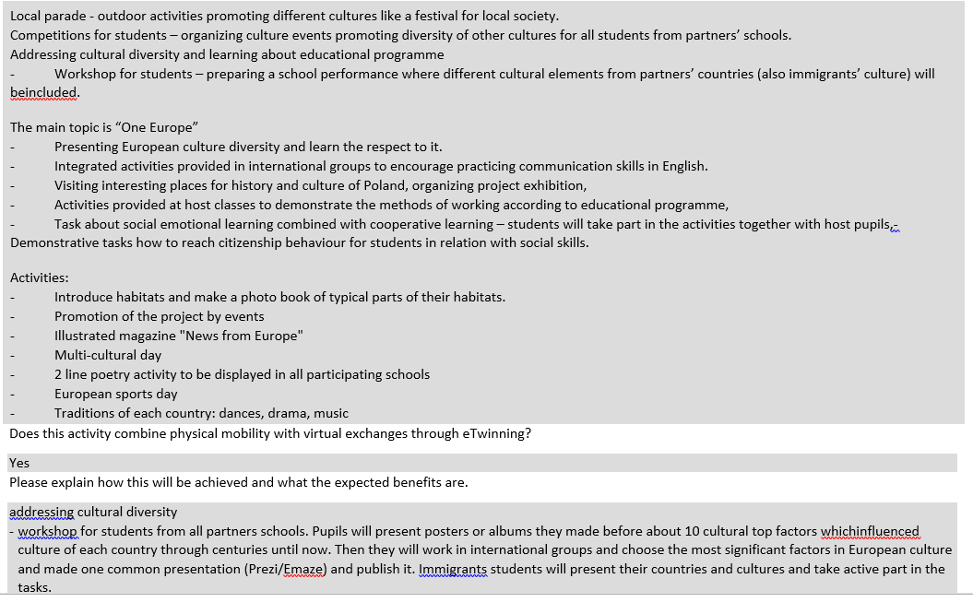
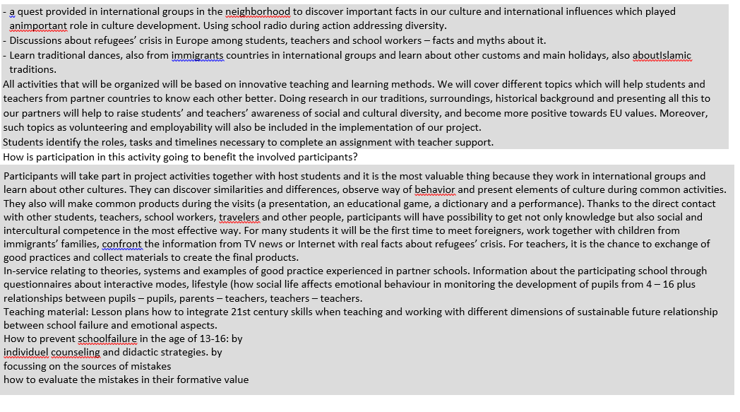
Ireland
