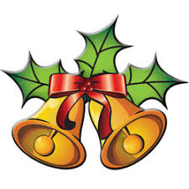
Our Holiday Season stars on December 1st, which is when people get into the Christmas spirit, the weather grows colder, the days shorter and longer nights thanks to daylight savings time ending.
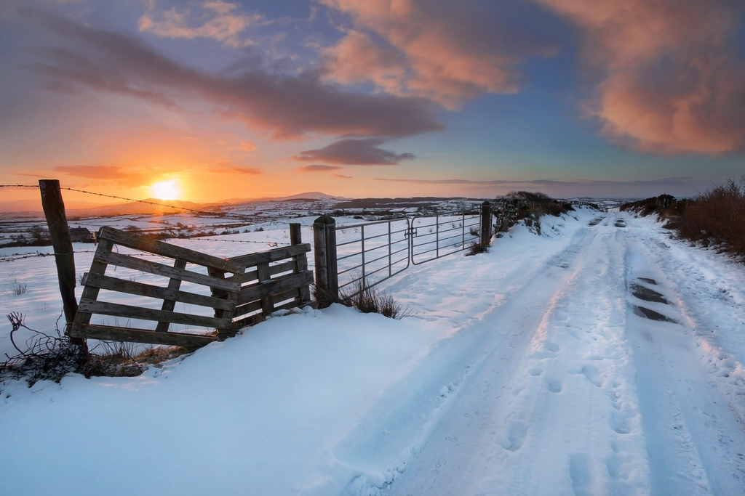
In Ireland Christmas decorations are traditionally put up on December 8th even though some people can't wait. December 8th is important to the catholic people in Ireland as it is the day of Immaculate Conception of the Blessed Virgin Mary there is usually special masses held on this day.
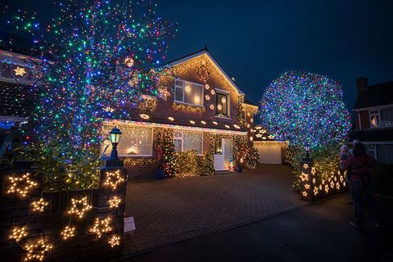
Like most countries the Irish enjoy decorating their houses for the festive season. Most houses have outdoor lights and of course a tree inside. Another tradition that was very widespread in the 1970’s but which seems to be dying out nowadays, is the ‘candle in the window’. Symbolically, the candle represented a welcome to Joseph and Mary as they wandered in search of lodgings. This year some houses put up these lights up early as a symbol of hope during the pandemic.
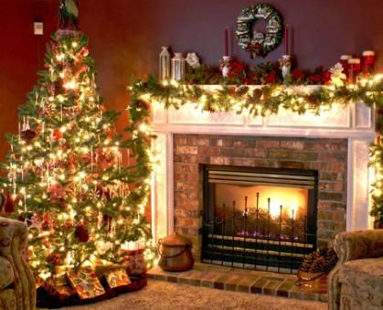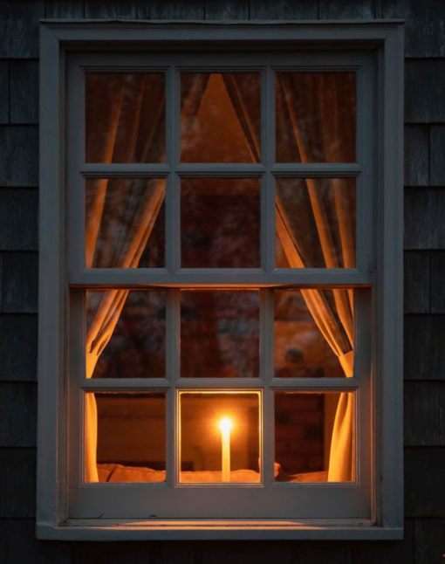
Another tradition that is big in Ireland because of the country's catholic roots and population is Lighting candles in an advent wreath to count down the days to the birth of Jesus. Within the Advent wreath are candles that generally represent the four weeks of the Advent season. The candles on the Advent wreath symbolize hope, love, joy and peace. Some denominations consider the fourth candle to mean purity, and most use a fifth candle, called the Christ candle, that is lit on Christmas to remind Christians of the light Jesus brings to the world.
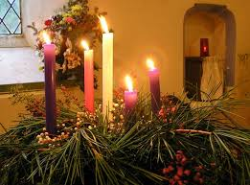
The 12 pubs of Christmas originated from an old Christmas carol that refers to the 12 days that lead up to Christmas Day and to the gifts that a couple of lovers would exchange on each of these days. Well, what better gift to give a loved one than a pint from each and every one of the 12 best pubs of your area? This tradition is often picked up by many Irish as well as tourists, but only a few of them can actually make it to the end! Most people partaking in this event dress up for the occasion in Christmas jumpers or Santa suits.
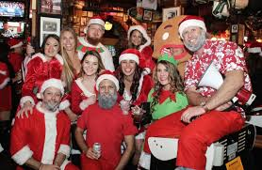
The next big event in the Irish Christmas calendar is midnight Christmas eve mass This is a huge social gathering where family, friends and neighbors who you may not have seen all year come together and celebrate Christmas. However, in some rural towns, you may see Midnight Mass taking place at 8pm!

We have all heard of leaving milk and cookies for Santa Claus to enjoy during his one night of worldwide travels, but here in Ireland things are done quite differently and Santy likes to indulge in some more hefty treats: a pint of Guinness and some traditional little tarts filled with candied fruit and spices, known as mince pies. And the old man is ready to jump back on the sleigh! (Just hold back on the pints, Santy!)
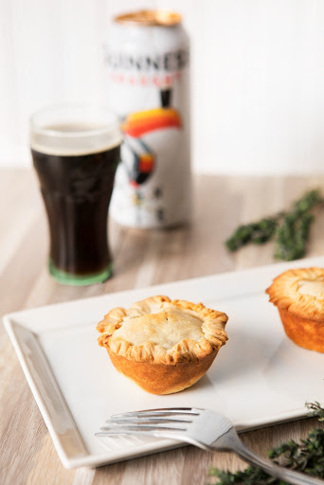
Ahh, the Irish. Sometimes we can be quite crazy. One of these instances takes place every Christmas Day in many towns and parishes in Ireland where some intrepid people meet up to have a swim in the freezing Irish waters all together. Chilling! This tradition is usually used to raise well needed funds for charities over the Christmas period.
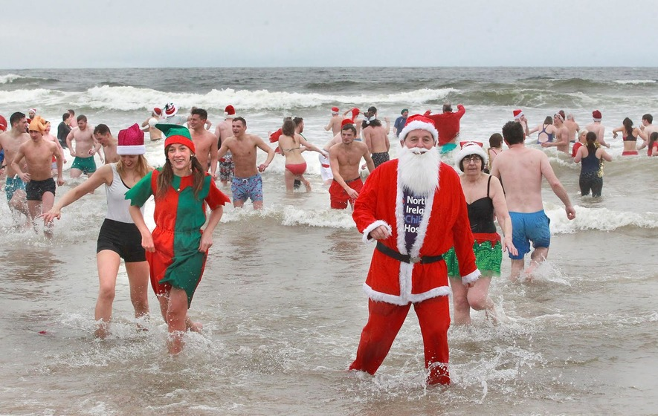
The wren Boy procession has its origins from both the pagan and catholic roots of Ireland. The wren was initially considered the king of the birds from the pagans but was later referred to as “the devil’s bird” from the Catholics. It is said to have betrayed the first martyr, St Stephen, and for this reason during ancient times, on St Stephen’s Day, a wren was hunted and killed. Nowadays, the tradition is quite less brutal: inhabitants of rural parts of Ireland are often seen parading, dressed in a way that resembles the bird (often just straw suits), celebrating its death to honor the saint on his name’s day: December 27th
.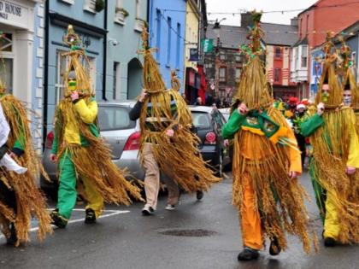
There is also a well-known song ‘The Wren Song’ which is song typically sung by children on st stephens day.

‘Little Christmas’ or ‘Women’s Christmas’ or Nollaig na mBan: this falls on the 6th of January (the Feast of the Epiphany) and marks the official end of the Christmas season. Traditionally, the men of the house take over for the day, preparing meals and allowing the women to have a rest. This is also the day on which all the Christmas decorations are removed. This day marks the end of the Irish Christmas season.

