Sevilla
Sevilla lies at an altitude of 7m and has an area of ​​140 km2. Sevilla has 704 198 inhabitants (according to data from 2010). The river Guadalquivir runs through the city. The city is divided into 11 districts.
Cathedral of St. Mary
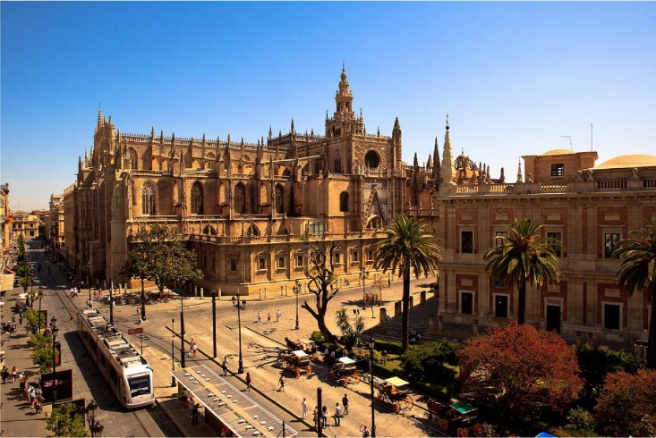
Cathedral / St. Mary's Cathedral is the largest Gothic church in the world. The cathedral has a bell tower called Giraldo, which is 105 meters high. We reach the top of the bell tower on the ramp. The cathedral has as many as 15 doors (the main gate is the gate of Mary's Assumption) and 80 chapels. Altar is one of the most expensive in the world because it is made of 3 tons of gold. In the cathedral there is also the tomb of Krištof Kolumba.
Alcázar
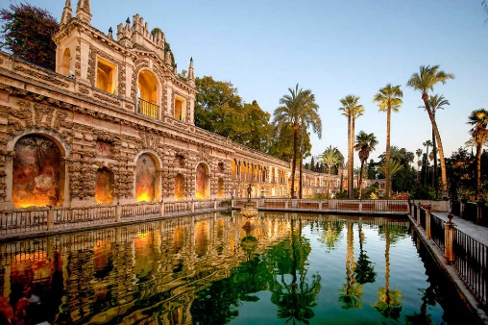
Alcazar is the oldest royal palace in use. It is divided into two levels: the ground floor (Moorish palace) and the upper part (Gothic palace). In front of the palace is the courtyard of Puerta del León. The palace is surrounded by Arabian walls.

Metropol Parasol
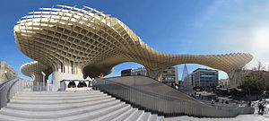
It is the largest wooden building in the world. In the building we find an archaeological museum, a market place, a raised city platform, and many bars and restaurants, and on the top you can walk across the panoramic terrace that offers views of the medieval city.

Ramón Sánchez Pizjuán Stadium
The stadium is the home of the football club Sevilla FC. It was built in 1955 and has a capacity of 42,500 spectators (fans).
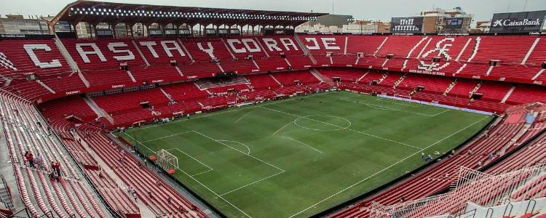

Granada
Granada lies at an altitude of 738 m and has an area of 88.02 km2. Granada has 234 758 inhabitants. The city is divided into nine quarters and lies at the confluence of three rivers (Beira, el Darra and Genila).
Alhambra
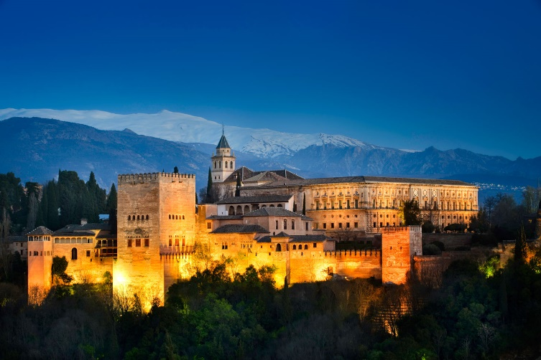
Originaly built as a fortress in 889 on one of the seven surrounding hills of Granada. Later it was used as a royal palace. One can come to Alhambra through a huge horseshoe-shaped door, called the door of justice. The palace is richly decorated. The most important yard is the lion's yard. In the middle of the yard, the fountain is supported by 12 marble lions. The fountain is surrounded by arcades and columns. The palace also consists of many gardens.
The Cathedral of Christ's Incarnation
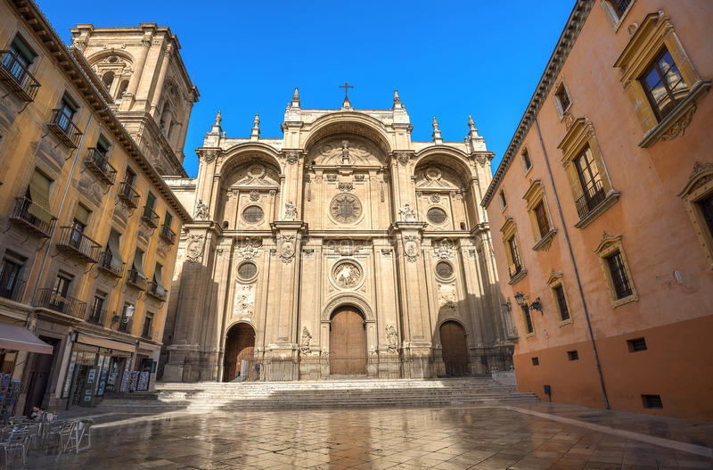
The cathedral consists of five ships and two towers. The main chapel consists of a series of Corinthian columns. The cathedral also consists of the Royal Chapel where the Catholic kings are buried.

Malaga
The city lies on the Sunny Coast (Costa del Sol). It is 395 km2 large and has 569 507 inhabitants (according to data from 2016). The city is located at 11m above sea level. At the same time, it also has one of the warmest winters in Europe.

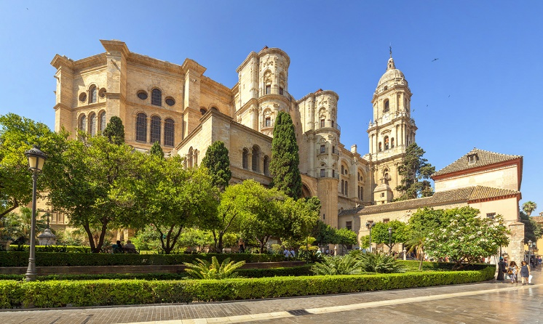
Cathedral in Malaga
The Cathedral is a Renaissance church consisting of 3 ships. It was built in 1782. The cathedral has its own gardens and a beautiful yard with oranges, reminiscent of old mosques. Its interior is made in Renaissance style. The north tower is 84m high, making it the second highest in Andalusia, after Giraldo in Seville.

Picasso Museum
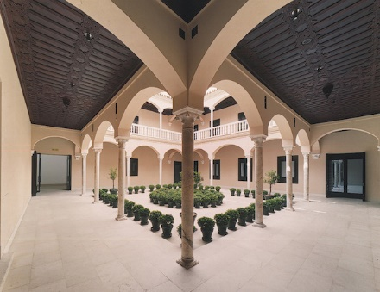
The museum, whose permanent collection includes 204 Picasso's works, was opened by Spanish King Juan Carlos. The museum stands close to Picasso's birth house, but it does not contain all of the important works of Picasso since they are exhibited in Paris, Barcelona and New York.

