E C O N O M Y I N A N D A L U S I A
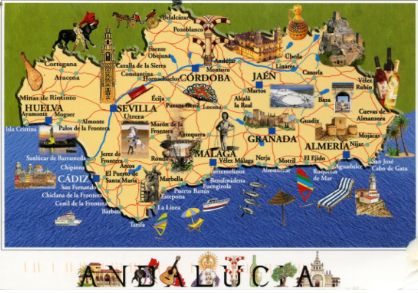
Andalusia is particularly rich in natural resources, but despite this fact, Andalusia continues to have one of the lowest GDP per capita in Spain. Andalusia is the 2th largest economy in Spain by nominal GDP.
Economically like agriculture still plays an important role in Andalusia. Mainly grain and vegetables, fruits, cereal, olives, wine and cotton are cultivated and also exported.
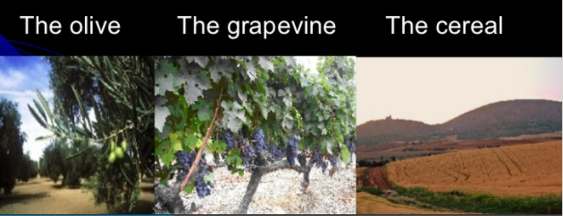
Industries consist of the mining, the (petro)chemical industry, shipbuilding and the processing of olive oil, wine, sugar and fish.
Major agricultural products of the region include olive oil and wine, whose production levels are gradually increasing with increased mechanization. The natural wealth of the region is found in its mineral deposits, particularly copper, iron, zinc, and lead. These minerals have been drawn from the region since Phoenician and Roman times.
While the agricultural portions of the economy continue to struggle, the service sector is becoming a significant part of the national product of Andalusia. More than 50% of the active pupulation is employed in the service sector, counting also trade, transport and the tourism sectors. Manufacturing and service sectors are growing exponentially, with the growth rates in Andalusia exceeding those found elsewhere in Spain. High growth rates in the service sector are expected to continue, especially as tourism becomes more prominent in the area.

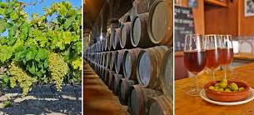

SOURCES:
http://www.newworldencyclopedia.org/entry/Andalusia
https://en.wikipedia.org/wiki/Andalusia
http://www.newworldencyclopedia.org/entry/Andalusia
http://www.andalusia-web.com/survey.htm

Written by Nejc Špenko

