CELEBRATIONS
Nacional parties

- Preseren Day:
It is celebrated on February 8, is the date of the death of Slovenian poet France Preseren. It is a cultural festival in which there are concerts, festivals and poetry recitals, in which the Preseren Prize and the Prizes of the Preseren Foundation are awarded.

- Day of the rising against occupation:
is celebrated on April 27, was established the National Liberation Front, which was a Slovenian political organization that was formed in response to the occupation of Slovenian territory by Germany, Italy, and Hungary during the Second World War.

- Day of the proclamation of the state of Slovenia:
is celebrated on June 25, on the occasion of the declaration of independence of Yugoslavia, in 1991.

- Day of the reform:
It is celebrated on October 31, it is of religious character. He had influence in the development of the Slovenian language and literature. At this time the first Slovenian books were written.

- Independence and union day:
It is celebrated on December 26, this day the results were published in favour of Slovenian independence.
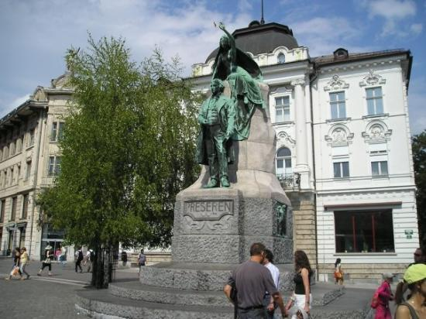

Christian parties:

-Easter:
It is celebrated on the first Sunday after the first full spring moon. It is the most important Christian festival. This tradition have their origin in the pagan culture. On Holy Friday there is a rigorous fast, it is the only day of the year when Mass is not celebrated, it is the day in which Christians commemorate the death of Christ. On Holy Saturday there is the blessing of typical foods such as ham, red painted eggs, roots of spicy turnip, bread and potica. On Easter Sunday, believers celebrate the resurrection of Christ and families gather to consume the blessed foods.

-Christmas:
It is celebrated on December 25, its traditions are: decorate the Christmas tree, put the nativity scene, meet to celebrate and sing Christmas carols.

-St Nicolas:
They are celebrated on December 6, in some cities parades are organized, accompanied by angels and imps who give candies and dried fruit to children.

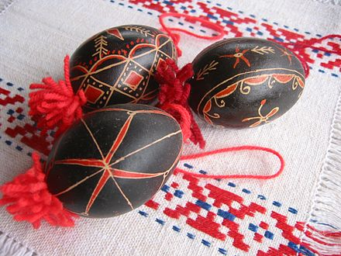

Popular parties:

- Pust:
It is the period between the New Year and Ash Wednesday, characterized by several carnivals. They disguise themselves with masks and costumes that represent supernatural forces, believing that this ritual scared away winter.

-The best-known Slovenian carnivals are:
- Carnival of Ptuj: it is the largest and oldest in Slovenia, it is a jewel of ethnological tradition and the cultural heritage of this country. The typical costume is the devil dressed in red.
-Carnival Cerknica: also called dance of witches. It is similar to the Ptuj but with masks and the main figure is the witch, the monsters ...
-Carnival of Cerkno: the typical figures are the laufarji, a group of 25 carnavelesque characters.

-San Gregorio Day:
It is celebrated on March 12, according to tradition it is the first day of spring, Saint Gregory is the saint who brings light. The custom is throwing lit boats to the river on the eve of the party.

- Martinmas:
It is celebrated on November 11, it has a profane character, its origins are pagan, after the harvest there were festivities and feasts. It is known as the must festival.

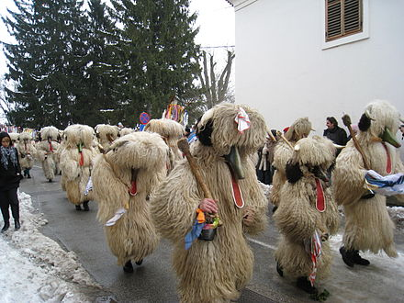
Made by : Jennifer López Pedrosa
Sheila López Rodriguez

