The most incredible way to obtain energy

Nuclear energy can be defined as the energy contained in the nucleus of an atom. Atoms are the smallest particles into which a chemical element can be divided while maintaining its properties. In the nucleus of each atom there are two types of particles (neutrons and protons) that are held together. Nuclear energy is the energy that holds together neutrons and protons.

Nuclear energy is generated in a process in which the atoms of a material called uranium are disintegrated. The energy released by the uranium as its atoms disintegrate produces heat that is used to boil the water found in nuclear reactors. As the water boils, it generates steam which is used to move the turbines inside the reactors, thus producing electricity. The function of nuclear energy is usually to produce electricity, although it can also be applied in other sectors such as medical, environmental or military applications.

There are two types of nuclear energy: nuclear fission and nuclear fusion. Nuclear fission releases energy from inside atoms by fragmentation. The nucleus is bombarded with neutrons to make it more unstable and split into two nuclei with the same mass. Nuclear fusion releases energy after the union of two atomic nuclei that fuse after colliding at very high speeds to obtain a new atomic nucleus.

Uranium is a naturally radioactive element. It is found in nature in almost all rocks, soils and air; it can reach the environment by erosion caused by wind and water; and a larger amount can be released into the environment by volcanic eruptions. Everyone is exposed to small amounts of uranium in food, water and air. Exposure to high levels of natural or depleted uranium can damage living beings.
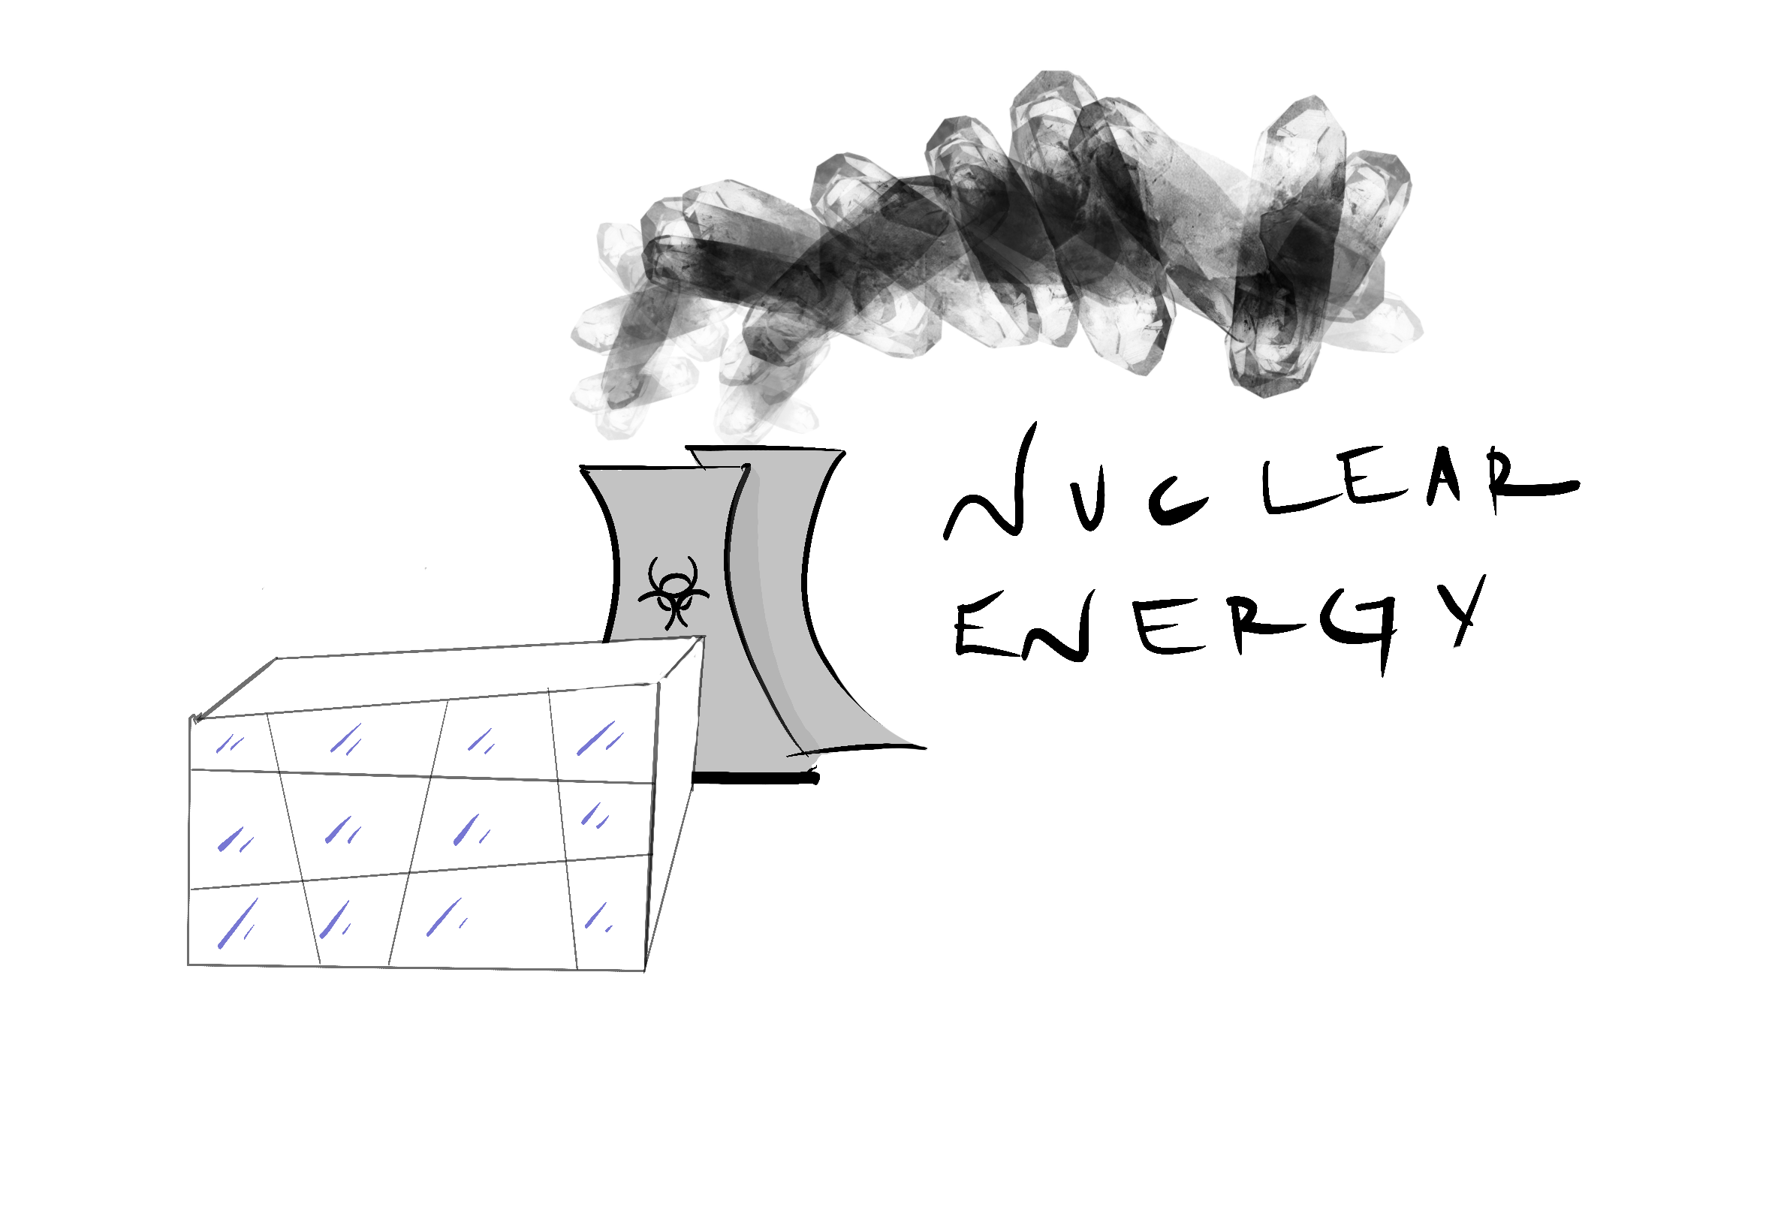

Bibliography:

https://twenergy.com/energia/energia-nuclear/
https://www.sgm.gob.mx/Web/MuseoVirtual/Aplicaciones_geologicas/Energia-nuclear.html
https://www.ecologiaverde.com/ejemplos-de-energia-nuclear-2746.html
https://www.atsdr.cdc.gov/es/toxfaqs/es_tfacts150.html
https://www.atsdr.cdc.gov/es/toxfaqs/es_tfacts150.html
https://energia-nuclear.net/que-es-la-energia-nuclear/ventajas-inconvenientes-energia-nuclear

