Which is the strongest material you can imagine?

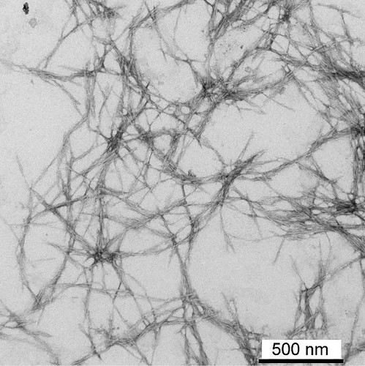
Nanocellulose is a new material that consists of cellulose nanofibers (chains of cellulose molecules of elongated tubular shape). The typical magnitude of the diameter is 10 to 20 nanometers and that of its length is 10 times or more bigger. The geometric property of the molecules makes them very sensitive to different fields of application as it is a polymer. Nanocellulose is classified into three types, microfibrillated cellulose (MFC), nanocrystalline cellulose (NCC) and bacterial cellulose (NBC).

Nanocellulose is basically extracted from any cellulose fiber such as cellulose pulp and can be presented in two ways, crystalline or random. It has many uses: it can be used to protect screens and to replace metallic materials and all kinds of organic plastic.

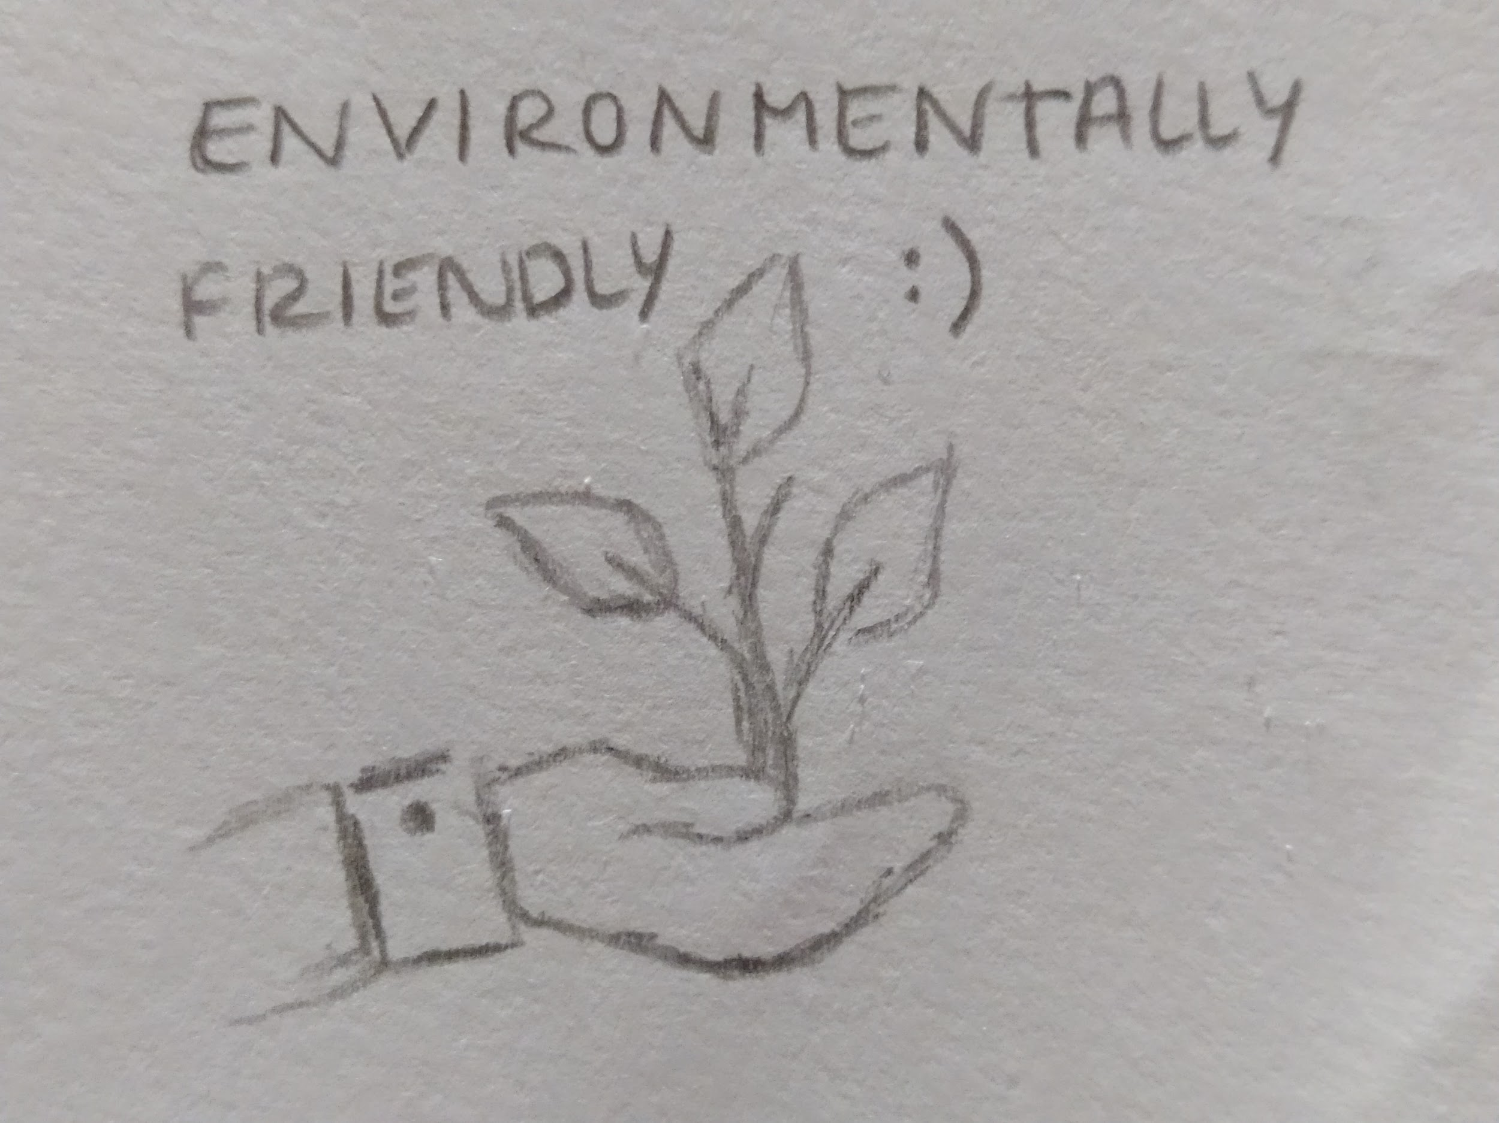
Because it is strong and light and ultra-absorbent, it can be made capable of supporting 10,000 times its own weight, replacing tampons and feminine pads.

Since nanocellulose is a derivative of cellulose, which is a raw material produced by plants in very large quantities each year, it is a renewable and environmentally friendly material.

Sources: Nanocelulosa - EcuRed Nanocelulosa - Wikipedia, la enciclopedia libre
Images: "Cellulose Nanotechnology" (2) by Region 5 Photography is licensed under CC BY 2.0 (1) & (3) by us

