What is that sound?

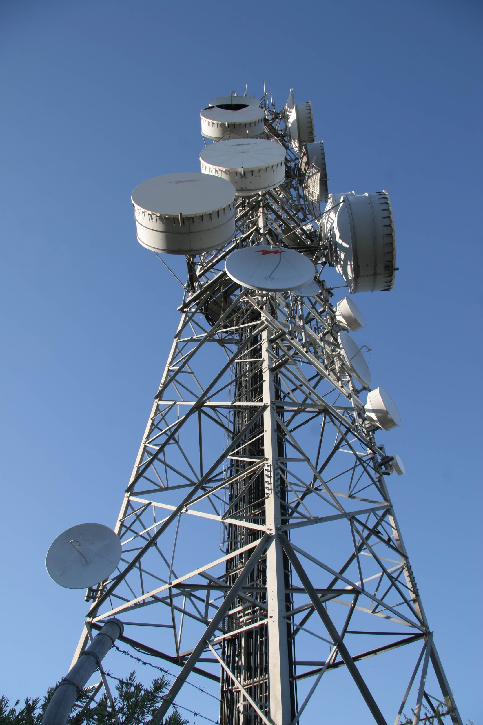
¿Have you ever wondered how we listen? ¿How does the television or radio signal reach our house? How is it possible that we communicate by cell phone? How do whales communicate with each other? How do bats, despite being blind, find objects and catch their food? The answer is: thanks to the airwaves.
Source: "broadcast antenna" by HerPhotographer is licensed under CC BY-NC-SA 2.0
But to generate a wave, there must first be a vibration, then: what is a vibration? A vibration is an oscillation with respect to a position in equilibrium. For example, when you ring a bell, it vibrates. These vibrations move through a space and to do this they require a certain time.
So what is a wave ? It is the displacement of particles in space during a certain time. In physical terms: a wave is a disturbance that propagates through a material medium (for example a string) or through a vacuum (electromagnetic waves). Some characteristics of a wave: The highest position with respect to the equilibrium position is called the crest The lowest position with respect to the equilibrium position is called valley. The maximum output of the wave with respect to the equilibrium position is called amplitude.
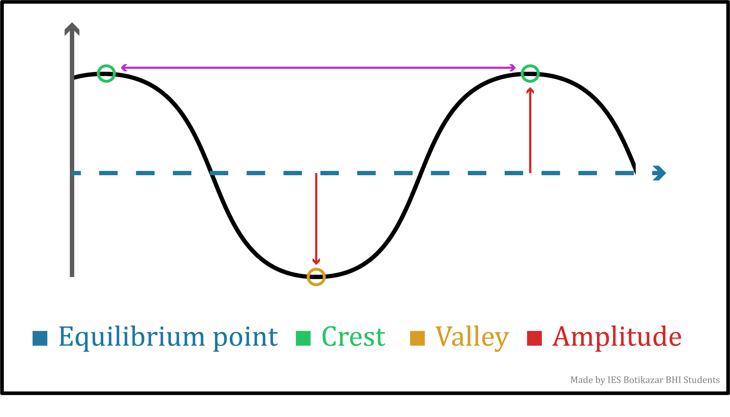
The distance between two peaks or two valleys is called the wavelength.The time elapsed between two consecutive waves is called the period. The number of waves emitted in each second is called frequency.
Source: Self produced
The speed of propagation depends on the characteristics of the medium in which it is propagating. The table shows sound propagation speed in different media.

Sound propagation speed in different media
medium | Speed (m/s)
Rubber | 60
Air (14 º C) | 340
Water steam | 500
Seawater | 1.450
Cement | 4.000
Copper | 5.000
Glass | 5.700
Steel | 6.000

https://elpais.com/elpais/2019/11/05/ciencia/1572947246_893680.html

