How was the vaccine for smallpox created ?

The Real Expedición Filantrópica de la Vacuna (Royal Philanthropic Vaccine Expedition) or better known as Balmis Expedition was the first sanitary expedition that went around the world from 1803 to 1806.

In the 18th century, smallpox, a very deadly disease, began to spread throughout the world. Every year two hundred thousand people died because of that disease, mostly children. A Britain doctor, Edward Jenner, was warned by the farmers that when milking their cows they realized that they weren’t contagious. Therefore, the doctor, introduced the fluid of an infected animal to a child, thus, it was permanently immunized.
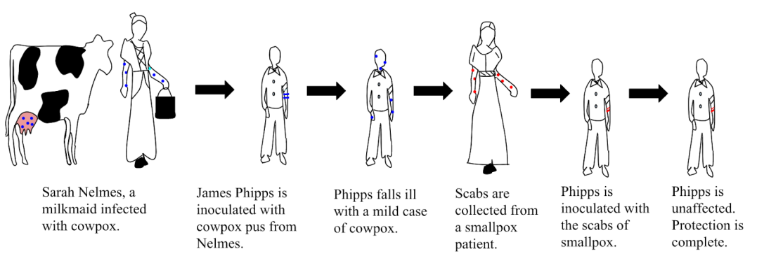

https://upload.wikimedia.org/wikipedia/commons/d/d8/Edward_Jenner-_Smallpox.svg

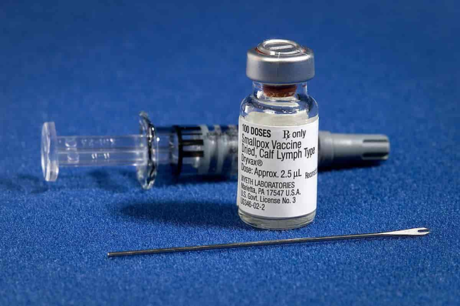
The new came quickly to Spain, and since the King Carlos IV’s daughter died because of the smallpox, he approved the idea of distributing the vaccine throughout his empire. They prepared an expedition led by Francisco Javier Balmis. A group of twenty two children was assembled and two of them were infected with the virus. When they developed the attenuated form of the disease they repeated that tecnic with another couple. Though this chain, the vaccine arrived fresh to America.
Av CDC/James Gathany.
Lisens: Falt i det fri (Public domain)

