What can save our life nowadays?

What is a PCR?
PCR is a technique that uses two matching DNA strands to amplify a targeted DNA sequence from just a few samples to billions of copies within just a couple of hours.
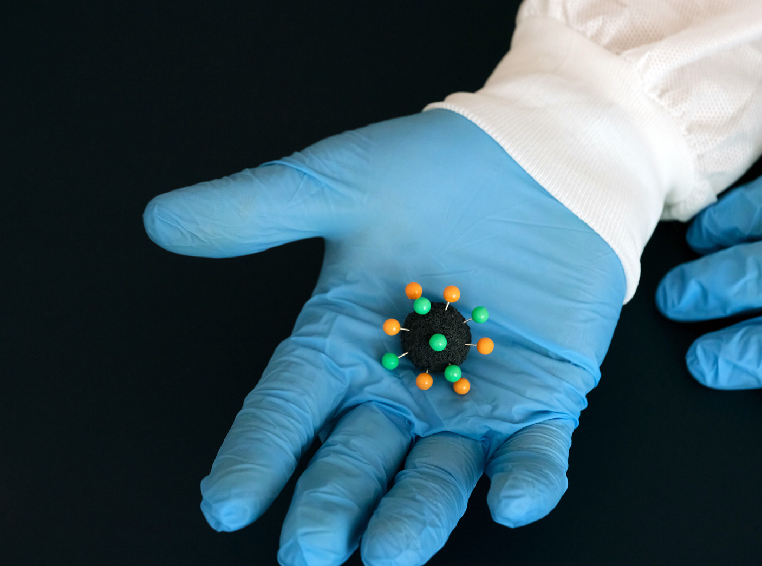
Photo source: https://www.flickr.com/photos/17423713@N03/49654935967
Author: Daniel Foster. (Creative Commons Attribution-Non Commercial-Share Alike)

PCR has radically reduced the time and number of steps required to create large quantities of DNA for use in multiple applications. Where it has had some of its most profound impact has been in the diagnostics field. Importantly, it has increased the speed and accuracy of diagnostics.

PCR is used, for example, in the identification of small DNA sequences involved in cancer. A well-known example is its use to detect the presence of coronavirus
Photo Source: https://www.flickr.com/photos/146321178@N05/49640411737
Author: Chad Davis (Creative Commons Attribution--Share Alike-2.0-Generic)

Bibliography

https://apliense.xtec.cat/arc/sites/default/files/Tecnica_PCR.pdf

