MARS, A PLANET FOR US
There has long been a popular belief about the existence of green men, also named Martian. The first 21 images taken by the Mariner probe denied these rumors, because on these images we just saw a cold and flat dead landscape. Mars was the twin of the Earth. There was water. There was also a thick atmosphere since its core stopped spinning. Its landscape totally changed. Now Mars is a giant desert which is dry and cold. It also has an amazing mountain with a top at 27 000 km named Olympus Mons (Which is the biggest mountain in the solar system). Above this volcano, there are majestic clouds called Nix Olympia. We can see a huge rift, Valles Marineris, and the three volcanoes Tharsis. It‘s the ideal planet for us thanks to its proximity. It also became famous with the expedition done on it (for example Opportunity and Curiosity). Its media coverage helped make it more famous (for example The Martians and the series Mars on Netflix). Now after multiple attempts humans know how to go on the “red planet”.
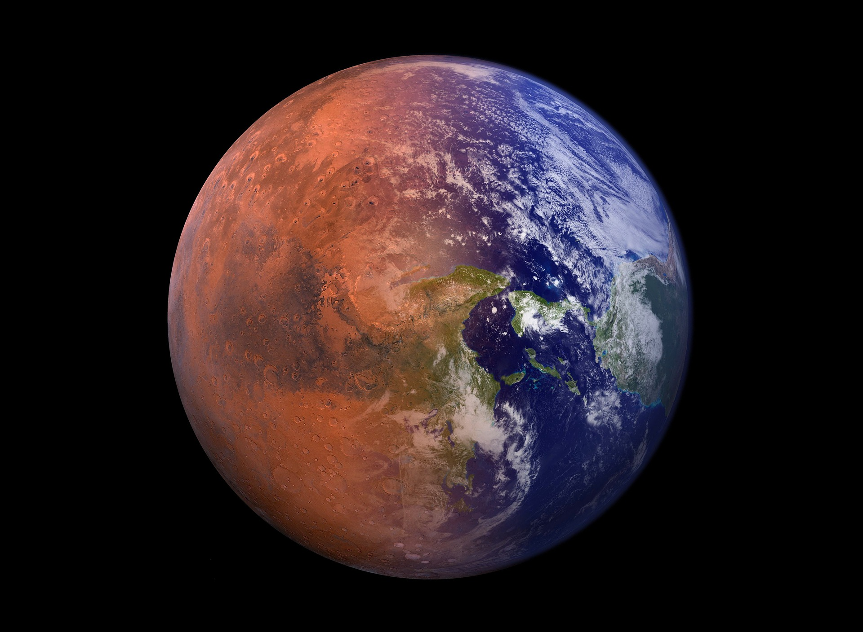
Picture of Tumisu https://pixabay.com/photos/terraforming-mars-colonization-5268447/
Webgraphy:
:https://www.futura-sciences.com/sciences/videos/mars-planete-rouge-bientot-portee-homme-5484/

