HOW AND WHY THE PCR TEST INFLUENCE THE 20TH CENTURY.
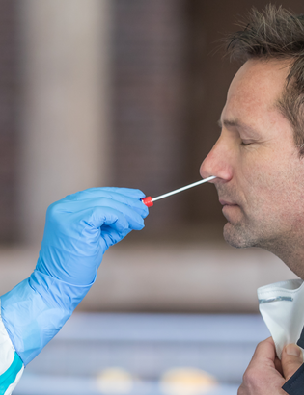
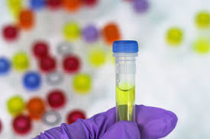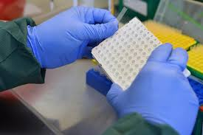
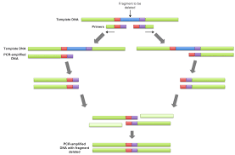
PCRs have been considered as one of the most important scientific advances in the 20th century. It has also been really helpful for the situation of coronavirus that we are confronting now.

PCRs is the polymerase chain reaction, which is a quick and easy way of making unlimited copies of DNA from one single original strand. These DNA copies can be used for several things such as, diagnosing illnesses (coronavirus) or for biological investigations.

They have turned into an essential tool for laboratories all over the world. PCRs have made us realise that even if our DNA looks similar, everyone has their one different sequence which makes us unique. Thanks to this scientific discovery, scientists have been able to establish parental relations, to detect bacteria or organism, identify endangered species…

In the year 1983 the scientist Kary Mullis of the Cetus corporation created this fresh way of coping. During two years, this group developed this theory until it became true and in 1985 the applications of this new method were published by the Science magazine.

The evolution of the PCR happened due to two reasons: The Taq and the Thermal Cycler. These two aportations helped because it decreased the human interaction in it and it made the process quicker and it could be done worldwide.

Since 1991 the company Roche has the rights of this invention and has continued improving it

1st,picture:https://www.lasemaineduroussillon.com/2020/07/26/perpignan-covid-19-ou-trouver-un-centre-de-depistage/
2nd,picture: https://pixabay.com/photos/tubes-ingredients-real-time-pcr-3857899/
3rd, picture: https://www.flickr.com/photos/iaea_imagebank/49869473421
4th,picture: https://commons.wikimedia.org/wiki/File:Overlap_Extension_PCR.png

