The earth’s temperature

Climate change is a natural effect of the earth that is aggravated by human activities.

It’s observed by different situations which the temperature for example, the earth has a natural rise of the temperature because between 1900 and 2007, the temperature was of 33,8°F.
With this rise of the temperature, there are many plants and animals which are
endangered because their environment disappeared.
There are many aquatic animals which are threatened : the dolphin, the whale and many terrestrial animals like birds, rabbits and earthworms.
Sadly, there are also species who are extinct. For example there are the dodo and different varieties of tigers, snakes, rhinoceroses.
The melting ice is an important subject because it’s the cause of global warming and the sea-level rise.
It is very dangerous because the ice takes the carbon dioxide which is responsible for climate change, white bears, penguins, auks and many species which are forced to quit their habitat.
Human activities are very dangerous because their actions destroy the earth.
They are responsible for the accentuation of this climate change.
For example agricultural chemicals pollute the waterways and kill the fishes !

Webgraphy: https://planet-vie.ens.fr/thematiques/ecologie/biodiversite/rechauffement-climatique-et-biodiversite

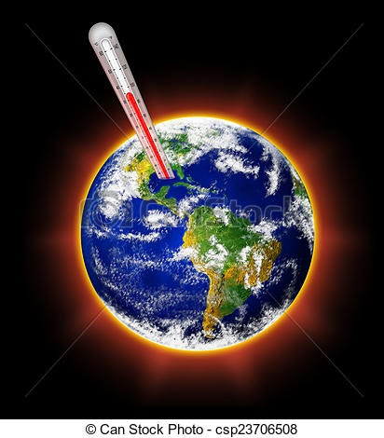
https://comps.canstockphoto.es/calentamiento-del-planeta-dibujo_csp23706508.jpg

