Why do we have to live here?

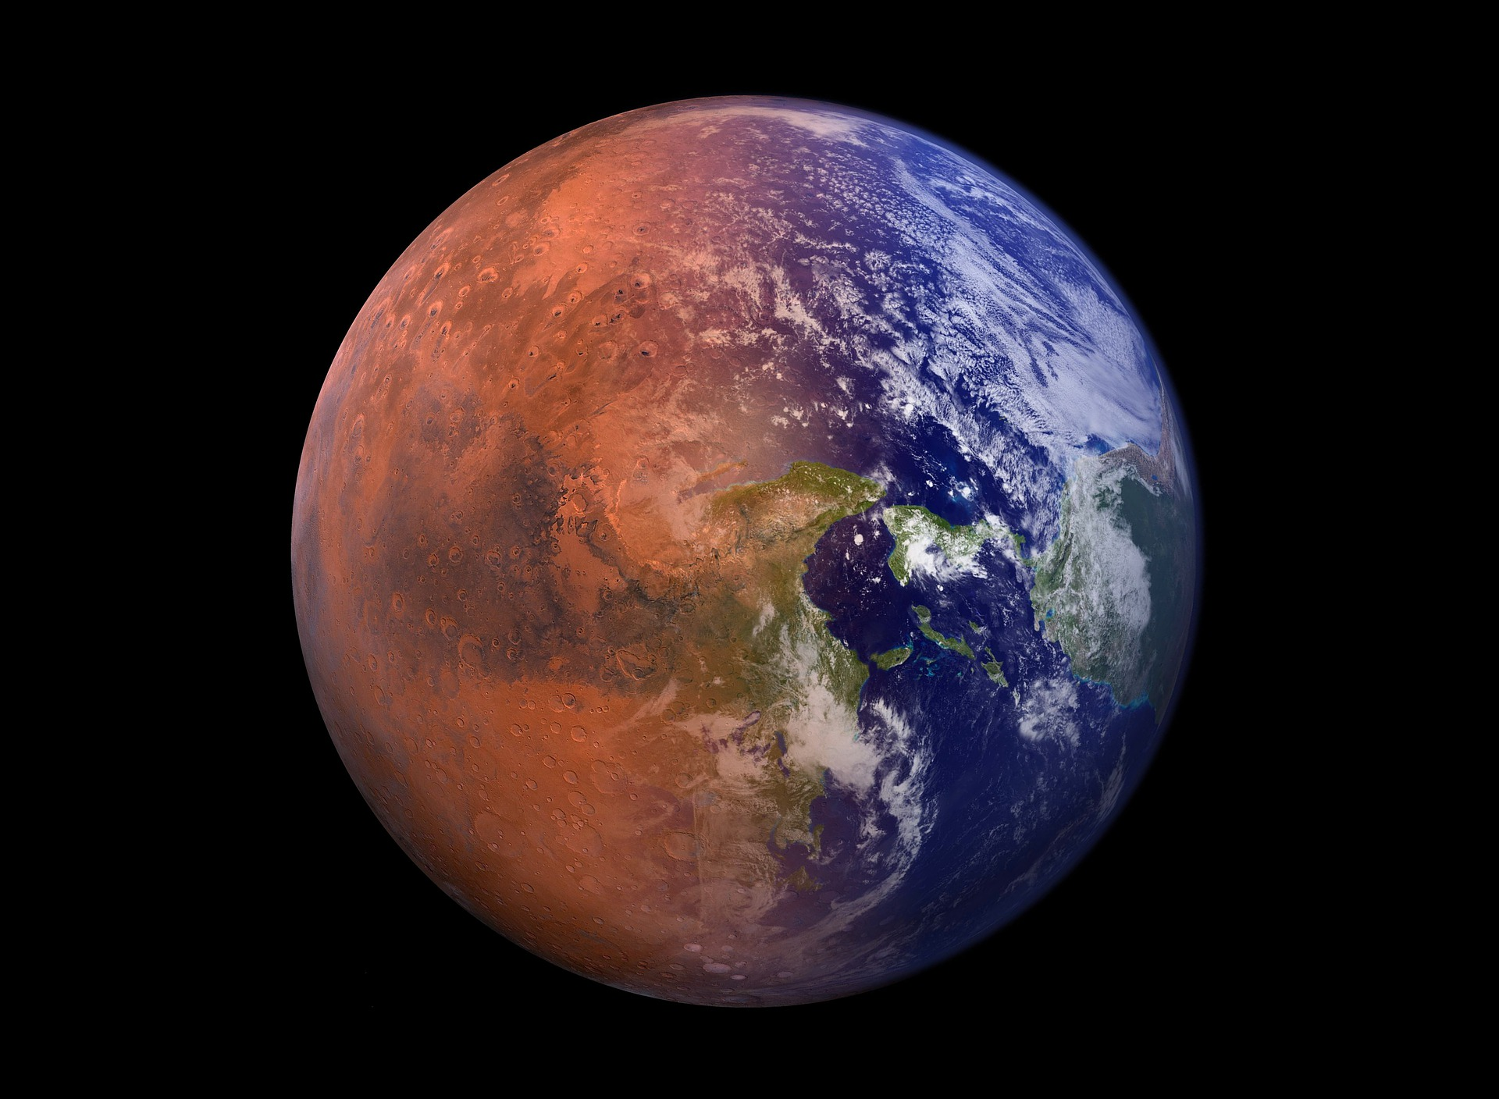

https://pixabay.com/photos/terraforming-mars-colonization-5268447/

The Earth is a garden of life, but is it the best of all the types of planets that have existed in the universe?
Our planet is the most habitable world and the only habitat that we have. The habitability of the Earth has changed drastically throughout its history and the Sun increases in brightness by 10% every approximately one billion years, but is in this sense the Sun the best star for a super-habitable world?

For a planet to be habitable, it must have an atmosphere, liquid water, an adequate size and that maintain tectonic activity for periods of time.
The earth is considered a habitable planet for different characteristics. One of them is the distance it has from the sun because it maintains the temperature of the earth above 15 degrees. Another point that makes it habitable is the presence of the atmosphere that accumulates gases fundamental for life and disintegrates many meteorites before reaching us. Also, we can live on the earth because we find there the three states of water and the planet has an adequate size. If it were larger, gravity could limit the presence of life due to the pressure that it would imply. Besides, the earth enjoys the gravitational effect of the moon and if it did not have this natural satellite, it would have been affected by the change of inclination in the axis of rotation. Finally, we can live on earth thanks to the fact that it has a protective magnetic field that deflects the particles released by the sun.

Our conclusion is that if there were a variation in all these characteristics, all living beings could not live on this planet.

An example of a super habitable planet is LHS 1140b, a super Earth located about 40 light years distant from Earth in the constellation Cetus. The planet orbits a red dwarf star and has a diameter of about 18,000 kilometers, is larger than Earth, and has a much larger mass, making it likely a rocky planet with a dense iron core inside. This super-Earth is also in the habitable zone around its red dwarf star (one of the most common in the galaxy), so it has the potential for liquid water and atmosphere essential to host life.

BIBLIOGRAPHY

https://danielmarin.naukas.com/2015/03/09/como-seria-el-planeta-ideal-para-la-vida/
https://www.hidden-nature.com/dodociencia/1o-eso/biologia-y-geologia/la-tierra-en-el-universo/caracteristicas-de-la-tierra-que-la-hacen-un-planeta-habitable/
https://www.electometro.es/condiciones-para-que-un-planeta-sea-habitable/
https://www.muyinteresante.es/ciencia/articulo/hallan-el-planeta-ideal-donde-encontrar-vida-161492676020
https://www.bbc.co.uk/programmes/p08xc2lh
https://www.reddit.com/r/NoMansSkyTheGame/comments/7kralk/describe_your_ideal_planet
/

