A massive phenomenon caused by two black holes
Two detectors in Europe and the United States have discovered the most powerful collision between two black holes ever observed.
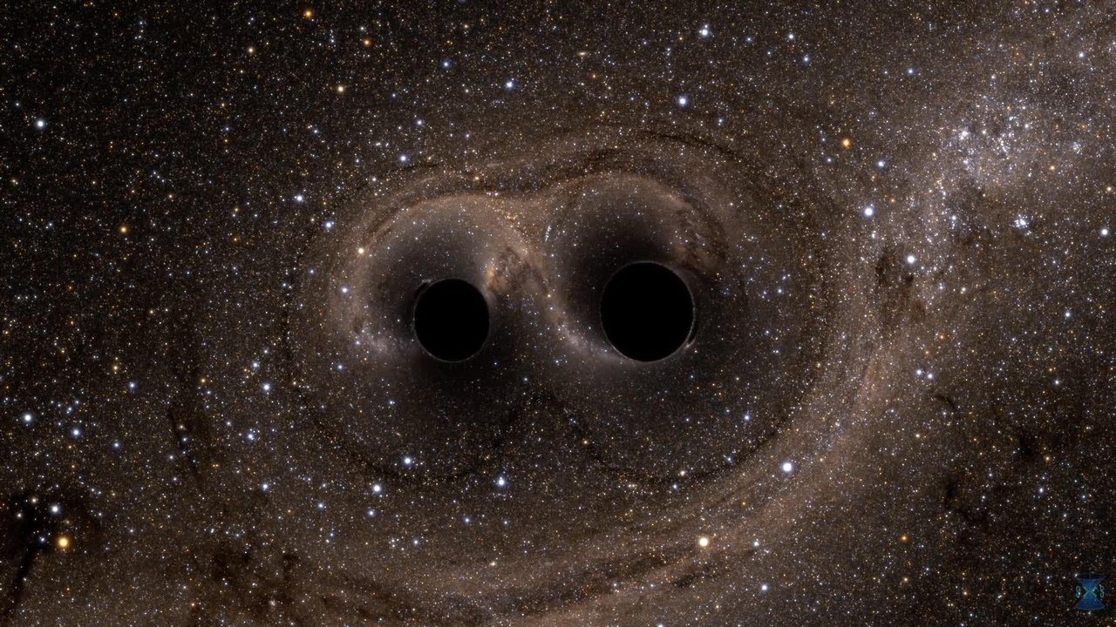
The signal was captured on the 21 st of May of 2019, and it didn’t even last a tenth of a second. After a year of investigating, scientists have found out how the little vibration the detectors discovered happened.

As it seems, the wave was produced because of two black holes merging and it’d be the biggest one captured as of today. This is the most important discovery since 2016 when the first gravitational wave was found. But, what is a black hole exactly? A black hole is an object that has so much density that their gravitational force attracts everything and traps it inside of it, including light, that’s why they are invisible.
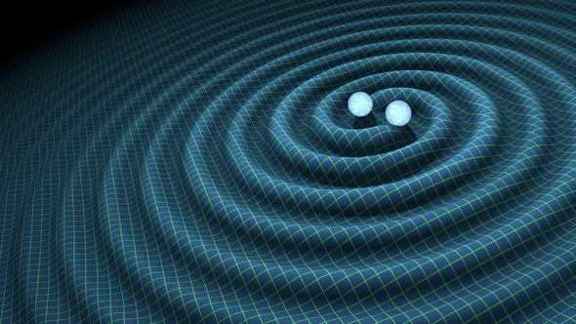
“After the collision, these two monsters merged and formed a black hole with a mass of 142 suns.” - says a scientist. The rest of the mass transformed into energy that expanded to all directions as if it was a bomb’s explosion.
The studies were done by more than 2.000 scientists from 19 different countries. These scientists that worked with the data that the detectors recorded analyzed the signals and then they rebuilt them with powerful computers in order to get all the phenomenon that could have caused them taking into account the rules that Einstein wrote in his Theory of Relativity.

The scientists assure that the explanation for this signal is that two black holes that were close, collided and merged together, producing those gravitational waves. Without a doubt, this is one of the biggest, if not the most important since the 1960s.

