SCIENCE PART - Group 1
Index Card
Graphene: a gateway to new possibilities

Let’s think about the thinnest object we know for a moment. Which could it be? If we thought rapidly we may come to the conclusion that it is a paper sheet or maybe a razor blade. But the truth is that there is an amazing thinner material: graphene.
This material is composed of only one layer of carbon atoms. Lots of materials are composed of carbon atoms such as diamonds and graphite.
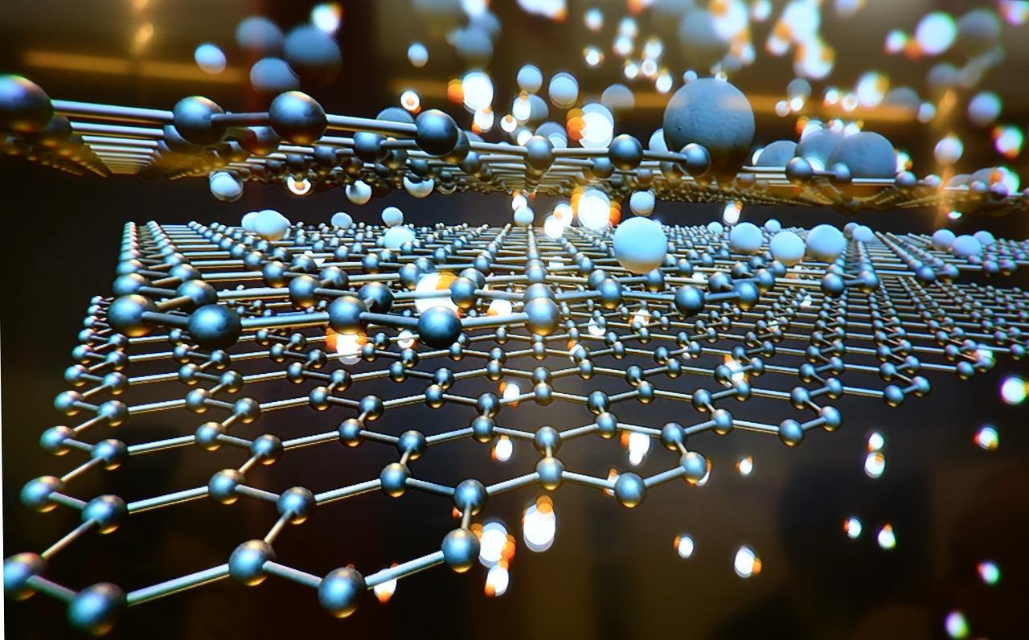
In 2004, two researchers of The Manchester College (England), André Geim and Konstantin Novoselov, discovered that it was possible to separate graphite layers using adhesive paper. With microscopy techniques they confirmed that their discovery was valid, this opened the door to a whole new world full of applications.
These scientists soon discovered the incredible electrical conductivity this material had. To explain this feature they applied equations directly taken from physics. Besides having discovered a new material they were also using new science to describe it. Electricity moves faster in graphene than in any other material. Thanks to this characteristic it was now possible to produce electrical energy faster and with higher efficiency.
However, graphene also has its drawbacks to be applied in the electronics industry; its bandgap limits it from being introduced in everyday products. Additionally, we have silicon. Silicon’s chemical features make it the best option leaving graphene and any other materials behind. We also have to take into account that if we want to start using new materials in the industry, it’s important that the economic profit is suitable for a transition.
Regardless, some multinational companies like IBM have started investigating the applications of graphene and they have already shown results.
In addition to having adequate properties for being applied to radio-wave technology, it also can be used for optic applications due to its transparent nature.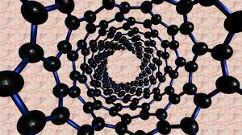
Are scientists the only ones interested in graphene? Is it going to reach the consumer industry? Is the adhesive paper discovery going to be rewarded with a Nobel prize?
It is always difficult to know what’s going to happen in the future, but we briefly think that this material has potential. We may see graphene’s true applications in electronics soon.

Garazi and Joritz.
https://pixabay.com/fr/photos/graph%C3%A8ne-technologie-2d-la-science-3193185/

https://pixabay.com/fr/photos/nanotube-de-carbone-bucky-graph%C3%A8ne-2842389/

