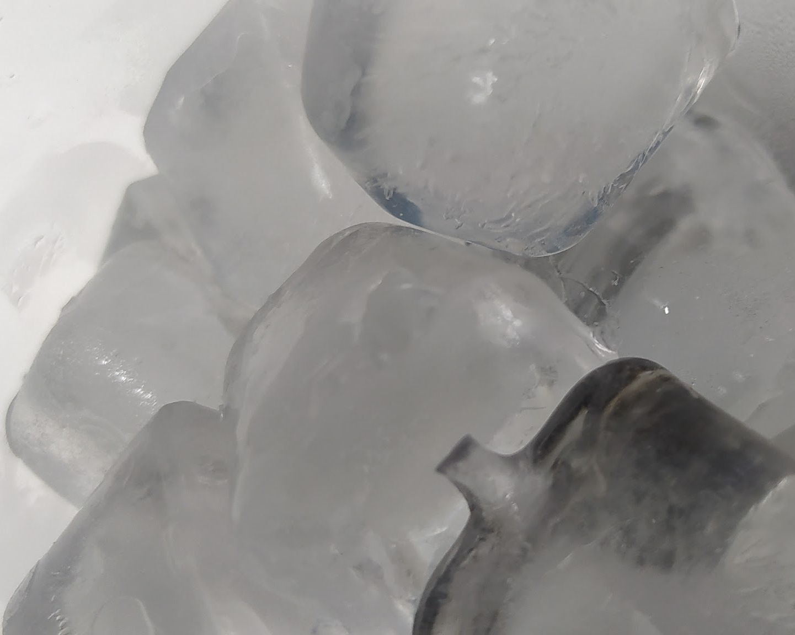
THE MELTING WORLD

There is a consequence of climate change that is of great concern to scientists: the disappearance of permafrost. Permafrost is the permanently frozen layer of soil — but not permanently covered in ice or snow — of very cold or periglacial regions, such as tundra. It can be found in circumpolar areas of Canada, Alaska, Siberia, Tibet, Norway, and on several islands in the South Atlantic Ocean such as the South Georgia Islands and the South Sandwich Islands. Permafrost can be divided into: pergelisol, the deepest icy layer, and mollisol, the most Photo made by us
superficial layer that usually thaws. Over hundreds of
thousands of years, the Arctic permafrost has accumulated large stores of organic carbon (1.4 to 1.85 trillion metric tons).

Forecasts predict a decrease in areas of permafrost due to increased global warming.
When permafrost thaws, carbon dioxide and methane are released. An expert said: “Permafrost temperatures have risen to record levels from 2007 to 2016 averaged in the polar mountain and high regions globally. Arctic and boreal permafrost contains 1460–1600 gigatons of organic carbon, almost twice the carbon in the atmosphere ”. The release of these great amounts of gases into the atmosphere is an alarming fact. Nowadays, we are one degree above the temperature of the 70s, but this is the world’s average, the Arctic is three degrees above average.

Pilar Marcos, a Greenpeace marine biologist highlights the danger of the loss of Permafrost: “the release of gases such as methane is a real bomb for our climate. In addition to the gas released on land, there are companies that want to extract the methane gas that is found in the oceans in the Arctic regions and that adds more greenhouse gases to our atmosphere ”.
Marcos recalls that with the disappearance of permafrost, pathogenic microbes are released. They have already caused fatal episodes, such as the case of anthrax released in Siberia in 2016. Moreover, there are diseases for which we are not immunized because pathogens have been frozen for a long time.

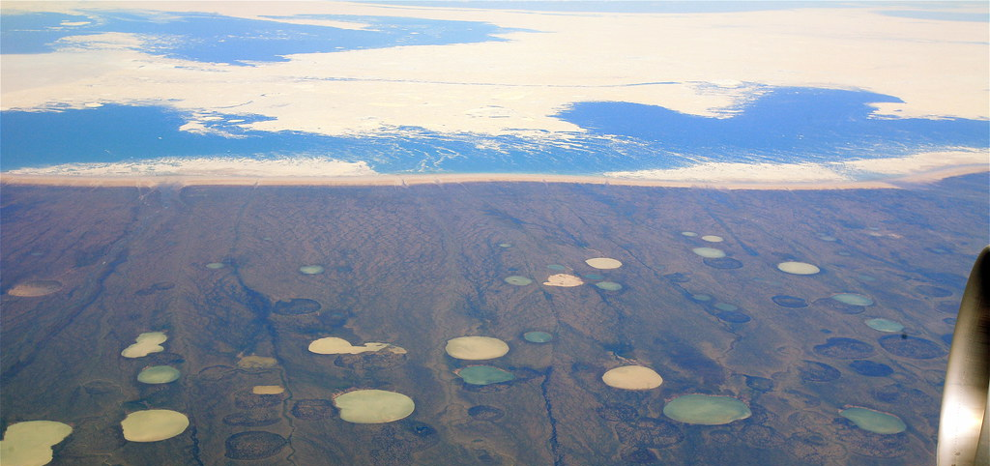
Photo by jurvetson (https://search.creativecommons.org/photos/4760945d-1e31-477f-94ca-c1ee1fdfd099)

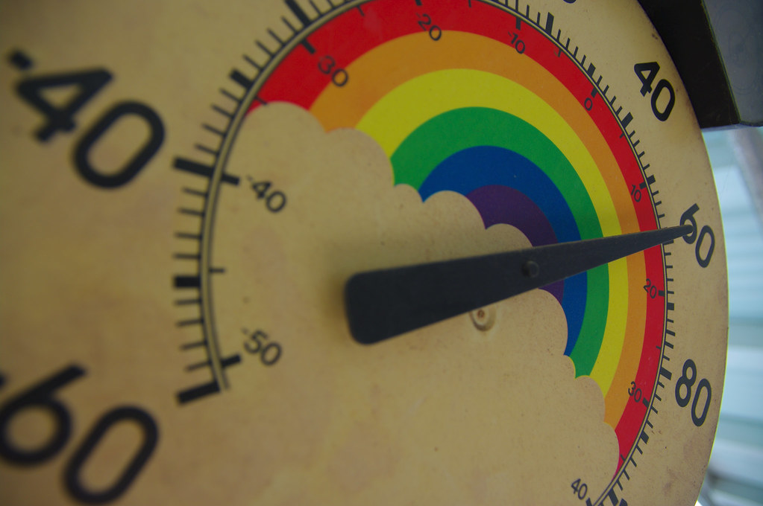
Photo by BBQ Junkie (https://search.creativecommons.org/photos/4ead3140-d9c7-449f-8d87-a3c41e9de2bf)

https://www.ccma.cat/el-temps/que-es-el-permagel-o-permafrosta/noticia/3075400/

https://es.wikipedia.org/wiki/Permafrost

https://www.nationalgeographic.es/medio-ambiente/2019/08/rapido-derretimiento-permafrost-artico-nos-afecta-todos

https://www.elindependiente.com/futuro/medio-ambiente/2019/09/25/que-es-el-permafrost-y-por-que-su-desaparicion-alarma-a-los-cientificos/

