What is cloning?

Cloning is the identical duplication of cells. It’s scientific manipulation.
Cloning is practiced on animals. After 276 tries Dolly is the first animal to be cloned with an adult cell. Dolly a ewe, was born in Scotland in July 1996. The cloning was released by Ian Wilmut and Keith Camphell. In general, ewes have an average lifespan of about 10 and 12 years : so, the experience was not totally perfect. Dolly gave life to 4 ewes even being a clone.
After the revelation of this experience, people contested cloning because it’s not natural and it’s frightening. But scientists have continued their experiences and cloned mice in 1998 with core’s cell. Then they cloned a horse, a pig, a cow… in 2003. Dolly therefore remains the most famous ewe.

Source :

https://www.science-et-vie.com/archives/15-ans-apres-dolly-ou-en-est-le-clonage-17510

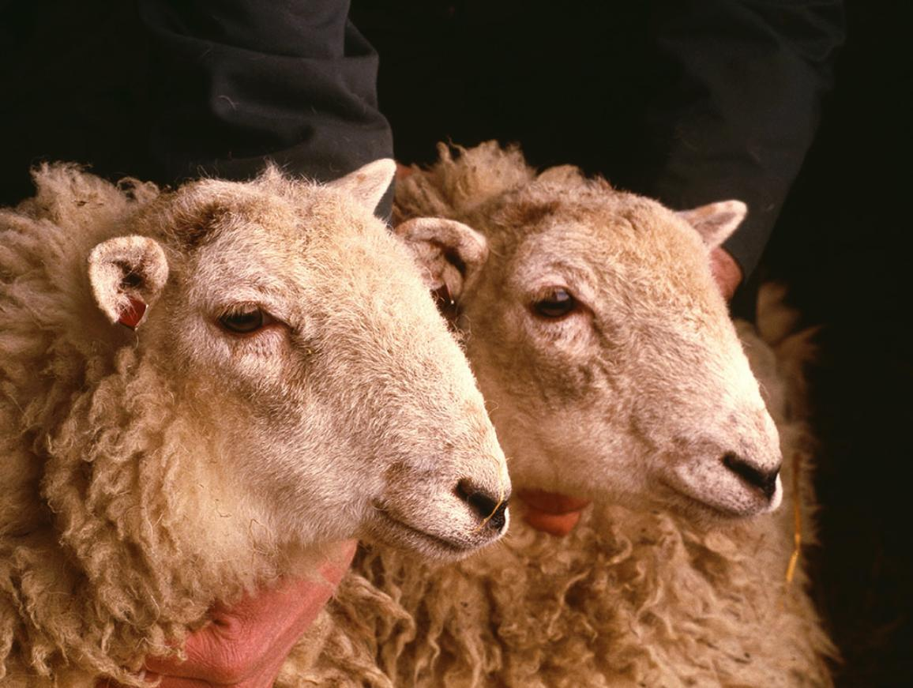
Photo Source: https://www.europarl.europa.eu/news/es/press-room/20150617IPR67269/ban-not-just-animal-cloning-but-cloned-food-feed-and-imports-too-say-meps

