"The life of the desert man"
Thédore Monod was a French explorer. He was born in 1902. He began his career in 1922 at the natural history museum. Théodore Monod has always been very invested in the protection of biodiversity . In the 1930s, he did his military service in the Sahara and he became a great specialist of the desert. He was also part of the first naturalists to participate in the creation of national parks. He was very attached to the African continent where he took refuge during the Second World War and where he did most of his research. Then, in 1938, he created a research institute in Dakar. He traveled the desert by collecting thousands of samples : stones, insects, plants and looking for meteorites. He became famous with the movie on his life named “Le vieil homme et le désert”. After that, the media nicknamed him “Le fou du désert” or in English “The desert madman”.
In numbers, Théodore Monod it is :
- 75 years of expeditions in desert
- 124 travels
Théodore Monod did his last travel in 1998, at the age of 96 years old. He died in 2000, at the age of 98 years old.

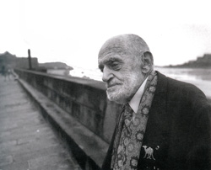
Source: https://www.etonnants-voyageurs.com/spip.php?article3935

Webgraphy:

france culture : https://www.franceculture.fr/emissions/une-vie-une-oeuvre/theodore-monod-1902-2000-0
Blog monde diplo : https://blog.mondediplo.net/2010-10-28-Theodore-Monod-le-Saharien
franceinfo : https://www.francetvinfo.fr/monde/afrique/theodore-monod-amoureux-du-sahara-et-defenseur-des-touaregs_4189215.html
Now you know :
https://nowyouknowproject.com/auteurs-definitions/theodore-monod/

