Heavy tensions for tungsten:

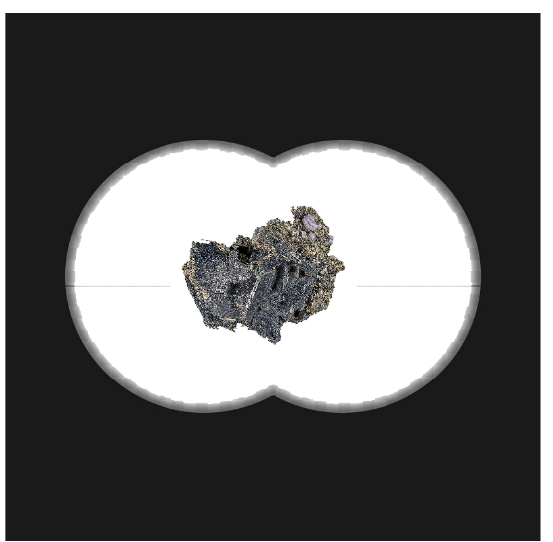
A letter was received in February 1778 by Juan José Elhuyar from the Count of Peñaflorida. The Minister of the Navy of Charles III, wanted technology to make new cannons. How? So the minister wanted to send a couple of spies and asked his friend Mazarredo from Bilbao to find people who would have enough technical knowledge for the mission
Mazarredo used the opportunity to talk to the minister about the Association of Friends of the Basque Country. They planned to set up a chair of mineralogy and metallurgy at the Bergara Seminary, bringing in the best experts from all Sweden
He proposed that all of this should be funded by the state, after all, because that would greatly improve the state's technology, as well as the cannons. Finally, he told her that it would also be interesting to send a couple of people to spy on Carron, but that he did not know anyone to do this difficult job, and he directed him to the Count of Peñaflorida
Munibe and Egia were the founders of the Association of Friends of the Basque Country, and the state managed to finance the association in exchange for being covered by the espionage plan. Juan Jose Elhuyar and his younger brother, Fausto Fermin, were key to this plan
Faustus would take over the chair of mineralogy and metallurgy in Bergara. Juan Jose, on the other hand, would do espionage work
Juan Jose became a student of Bergman, a chemistry teacher. And he received from him the hypothesis that the "stone weight" called tungsten in Swedish had an unknown element
He went to his brother, to Bergara. He talked to him about the weight of the stone and about the new element that might be in that stone. After working hard for several months, the Elhuyar brothers managed to isolate the desired element from the mineral tungsten. “A metal balloon party” they called it.
Photos from https://fr.wikipedia.org/wiki/Wolframite
https://fr.dreamstime.com/vue-r%C3%A9aliste-jumelles-militaires-r%C3%A9alistes-%C3%A0-l-int%C3%A9rieur-port%C3%A9e-des-marques-mesure-fond-transparent-image140864678
By Iñigo SB, Leire and Nico

