SOME CURIOSITIES ABOUT GRAPHENE

Graphene is a material that, as its name suggests, is created from graphite. The structure of

graphene is composed of a two-dimensional sheet, composed solely of carbon atoms

arranged in a hexagonal pattern. Andre Geim and Konstantin Novoselov are the two

physicists who braved the theoretical impossibility of building such a structure and managed

to isolate graphene sheets in 2004. They won a Nobel Prize in 2010 for their incredible

discovery. What is graphene for? Well, being a material 1 million times smaller than a hair

and 200 times stronger than steel, it would allow the creation of more efficient

computers, the creation of touch screens, solar panels and probably solar cells (graphene is

as good a conductor as copper). Graphene is a material with many practical attractions

that attract scientists from all over the world. The graphene market is worth no less than

100 millions dollars. The numbers of patents filed on graphene is led by China with more

than 1,500 patents. Europe has filed 500 patents (but it was Europeans who invented

graphene !). Europe has therefore created the “Flagship”, a project that aims to develop

commercial applications of graphene with a budget of 1 billion dollars. However, it is

complicated to manufacture graphene in industrial quantities, indeed, 1cm square of good

quality graphene costs around 100 dollars, or, it is 300 times more expensive than the

materials used in solar panels.

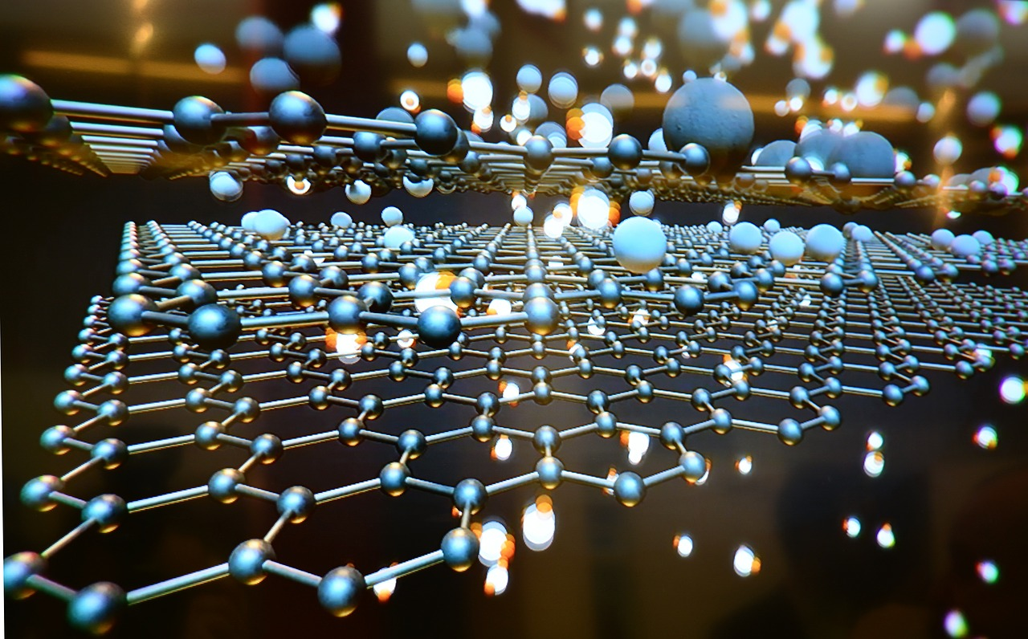
Grafeno Tecnología 2D La - Foto gratis en Pixabay

Sources : www.futura-sciences.com
https://www.sciencesetavenir.fr

