Diversity of ultraviolet lights

An ultraviolet ray is an invisible radiation that emits 100 to 400

nanometers (nm) waves (nm= one billionth of a meter). It has a shorter

wavelength than the visible light and contains more energy.Butterflies emit

light by "fluorescence",which means that some of their molecules emit

ultraviolet light. For the butterflies, the fluorescence's efficiency is low most of

the time, but it is sufficient for some species to change their colour with solar

UV. For example with the "Morpho sulkowskyi", a mythical blue butterfly (in

the Amazon , or Philippine Troides magellanus). The pigments found in the

wings of the butterflies are either made in the body or from plants that feed

the « caterpillars ». Insects see red but are sensitive to ultraviolet rays, other

animal species see black and white, so they cannot see the different colors

present on butterflies. The energy absorbed by the pigments is converted into

heat, so it participates in the thermal regulation of insects. Some of these

pigments are "toxic" to their predators because they protect them from an

attack. Humans want pigments too, but the they are not very stable and are

potentially « carcinogenic », which is why they are mainly prohibited in

cosmetics.

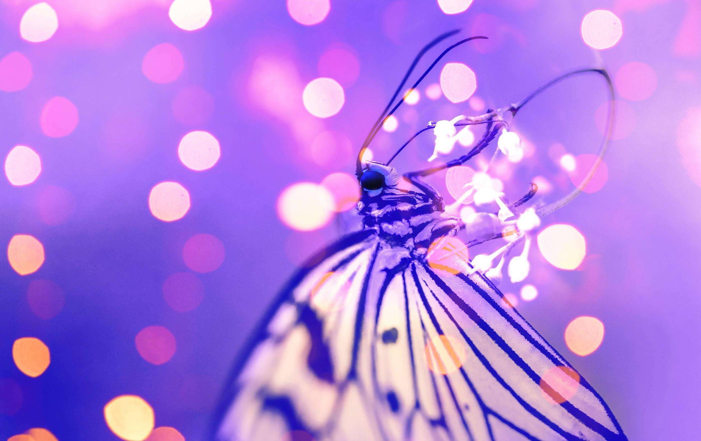
This image comes from Pexels. Musindo Kahonde in Pexels
https://www.pexels.com/es-es/foto/fotografia-macro-de-mariposas-cerca-de-luces-1021685/

Source : https://www.20minutes.fr/planete/2956483-20210120-comment-papillons-acquierent-magnifiques-couleurs

