For or against nuclear power?

Nuclear power was created by the Americans in 1942 . Nuclear is a form of energy which works with the fission of uranium atoms. That means that we break the atoms to extract their energy. That is made in the nuclear power station.
Nuclear divides opinions. Some of them are for it and others are against.
Arguments for:
-It’s less polluting, The nuclear doesn't produce CO2, contrary to thermal energy, like coal and gas, which contribute to global warming.
-It’s less costly: nuclear it’s on average less expensive than thermal energy because it’s less costly for production.
Arguments against:
-It’s dangerous for the health and for the environment because even a weak exposition can ruin the organism of a living being, whether human, animal or plant.
-Another danger of the nuclear is the nuclear accident. Like Fukushima in 2011, when the explosion of the central was creating a radioactive zone which was very dangerous for the person who lived around.

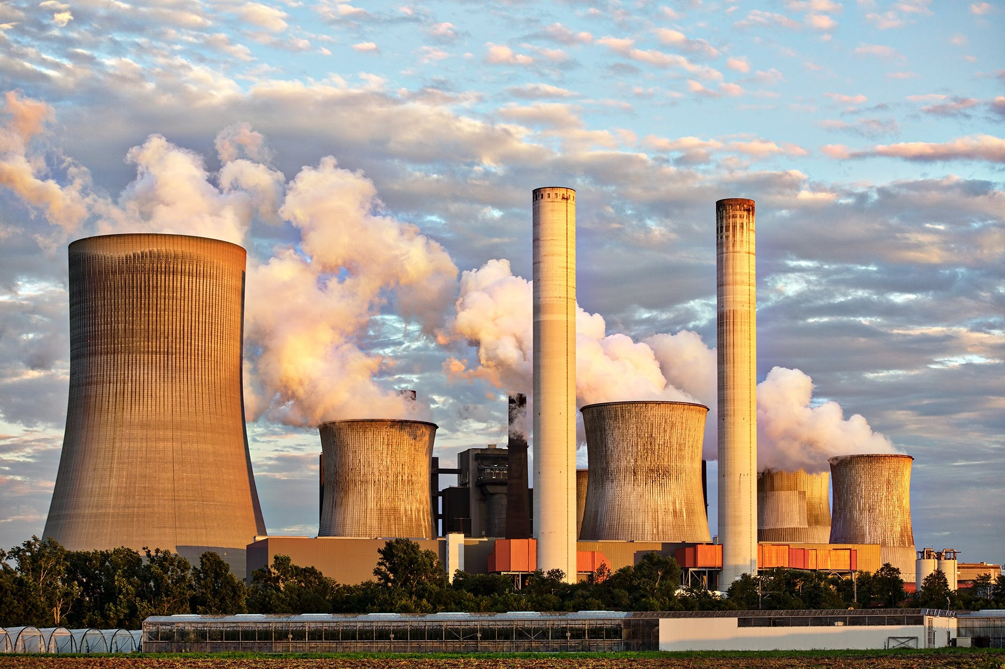
Image source: https://www.pexels.com/ca-es/foto/acer-actual-cansar-se-cel-459728/

Webgraphy:

https://www.capital.fr/economie-politique/pour-ou-contre-l-energie-nucleaire-1223865

