It might be the next Earth (maybe you're going to be the first to live

there !!)
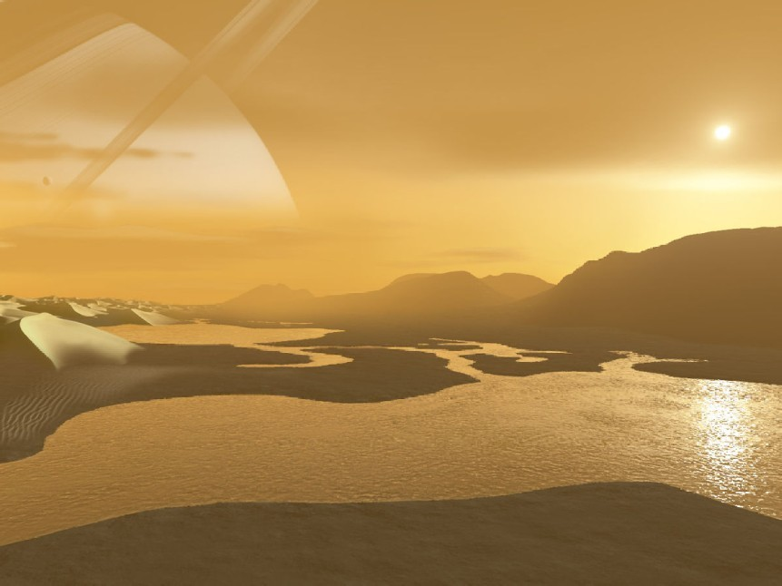

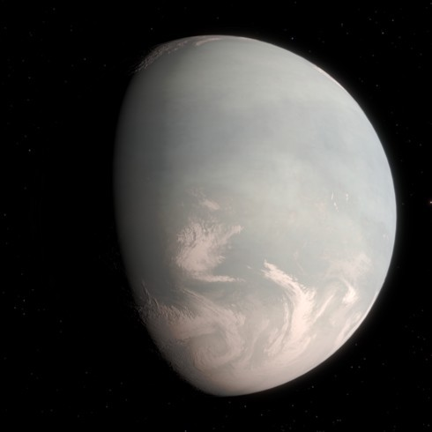

The new exoplanet is, according to scientists, the planet that most closely matches the requirements to become a substitute for the Earth, something like a twin. Among other things, it is the closest planet to us, being only 16 light years away.
The list of potentially habitable planets outside our solar system continues to grow. The newest addition to the list is Gliese 832 c, a super- Earth orbiting the red dwarf star Gliese 832, already known in the astronomical world for harbouring a planet similar to a cold Jupiter, Gliese 832 b.

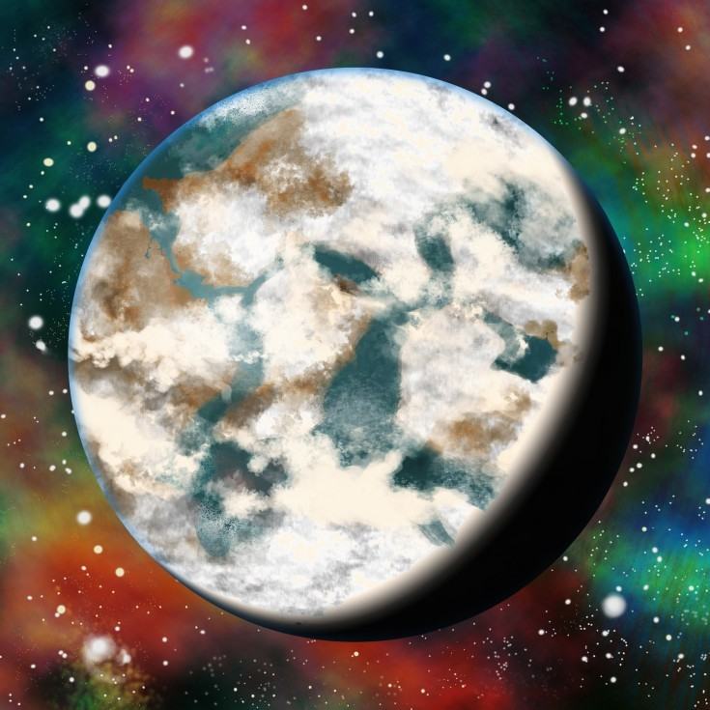

Article made by :

Credit :
Nitin Kapoor, CC BY-SA 3.0
Giese 832 c, was discovered by an international group of astronomers led by Robert A. Wittenmyer of UNSW Australia, has a 36-day orbit and its mass is at least five times the Earth’s mass. The astronomers believe that its temperature could be very similar to our world’s, because it receives the same energy from its star as the Earth receives from the Sun. The main mystery about this planet is if its atmosphere will be adequate one or no.

-Ayomide
-Thibaut
-Noah
<https://creativecommons.org/licenses/by-sa/3.0>, via Wikimedia Commons
Debivort at the English-language Wikipedia, CC BY-SA 3.0
<http://creativecommons.org/licenses/by- sa/3.0/>, via Wikimedia Commons

Radialvelocity, CC BY-SA 4.0
<https://creativecommons.org/licenses/by-sa/ 4.0>, via Wikimedia Commons

