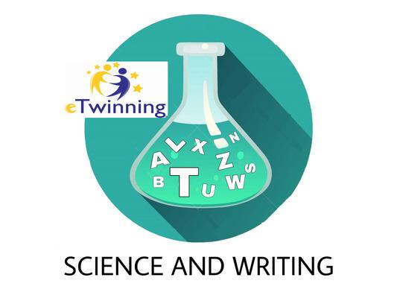

This year the students of the 1st year of high School have been in an eTwinning project called Science and Writing together with the schools IES Botikazar in Bilbao and the Lycée Jean-Pierre Timbaud in Brétigny Sur Orge (France).

We have worked and researched on science topics and we have written stories in English. These were made cooperatively in teams of students from the three schools.

First of all, each class was divided into teams of 3 people. In order to get to know us, each team created a personal presentation, explaining things about us, about our city and our shared institute.

We also designed and chose a logo that represented us.

We learned how to use images found on the Internet, security issues, and how we should address each other when we are connected.

Then, science topics were distributed among all the teams and we looked for information about them. We shared it with the other schools teams and completed them with images and titles cooperatively. A book has been made with all the articles.

Based on the topics of the articles, we started writing some stories that the other teams continued and finished. We also did illustrations and put titles and webography. A digital book has been made with all the stories.

We also did a video conference with the Brétigny school. We explained personal, school and city issues to each other. Then we played a kahoot that had been built with questions prepared by the different teams of each school.

Finally, we evaluated our work with a word cloud and a form.

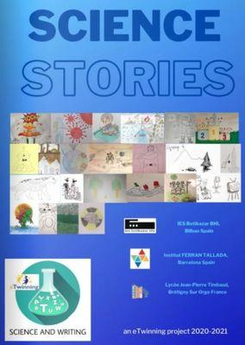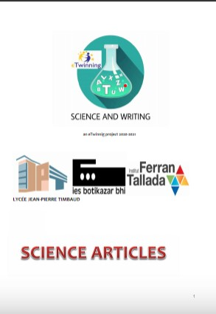

https://fr.calameo.com/read/004582801909004bad56a?authid=a3eeWMtZ7OEI
https://issuu.com/silviamaymo/docs/final_science_articles_pdf

Katherine, Lucía, Oriol, Valentín

