THE NEWEST OF THE GENETICS: GMO

GMO is the acronym for Genetically Modified Organism. This is the name given to any organism whose genetic material has been transformed by means other than natural reproduction or combined methods. To carry out the transformation, a technique called genetic manipulation or modification is used, which uses biotechnology to make very precise changes in the genetic characteristics of organisms and give them characteristics that they previously lacked. Thanks to it, the genes of one species can be inserted into another species, something that can’t be done by crossing, the classic technique of genetic improvement.

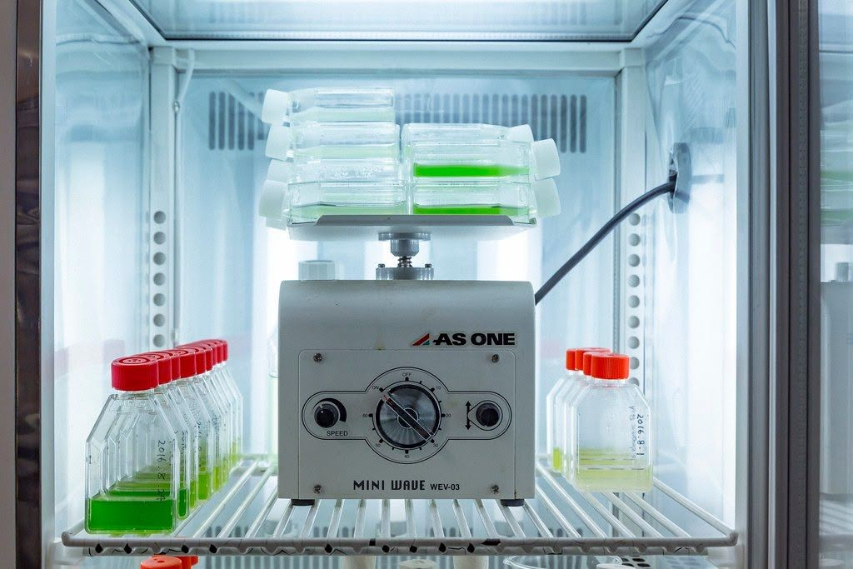
This is not sure, but maybe Genetically Modified Organisms (GMOs) or transgenic organisms can produce effects on human and animal health and represent a potential danger to all countries. Monopolization processes lead to the concentration of activities destroying the peasant economy and food security in the world s not guaranteed. Given these potentially harmful effects, it is important to regulate and effectively monitor all GMO introductions.
I’m Humanity” genetically-modified microorganism
by Ars Electronica (https://search.creativecommons.org/photos/988a1d9c-3001-40a3-8195-d29be2999e)

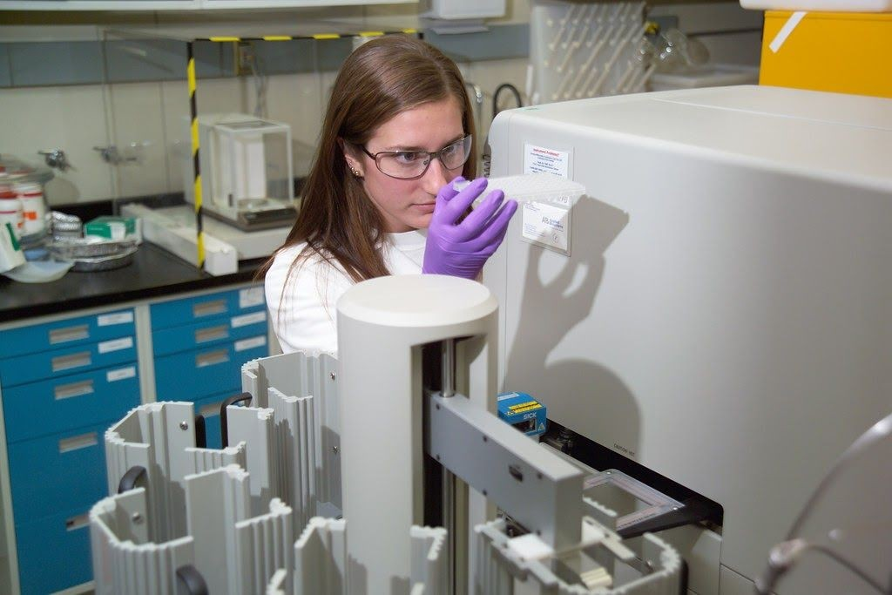
Biotechnology
by Idaho National Laboratory(https://search.creativecommons.org/photos/988a1d9c-3001-40a3-8195-d29be2999e)

BIBLIOGRAPHY

http://www.revista.unam.mx/vol.1/num3/art2/ http://www.fao.org/3/X9602S/x9602s07.htm
https://www.ocu.org/alimentacion/seguridad-alimentaria/informe/ogm-respondemos-a-sus-pr eguntas500144

