The Hirshon Latvian Potato Salad – Rasols

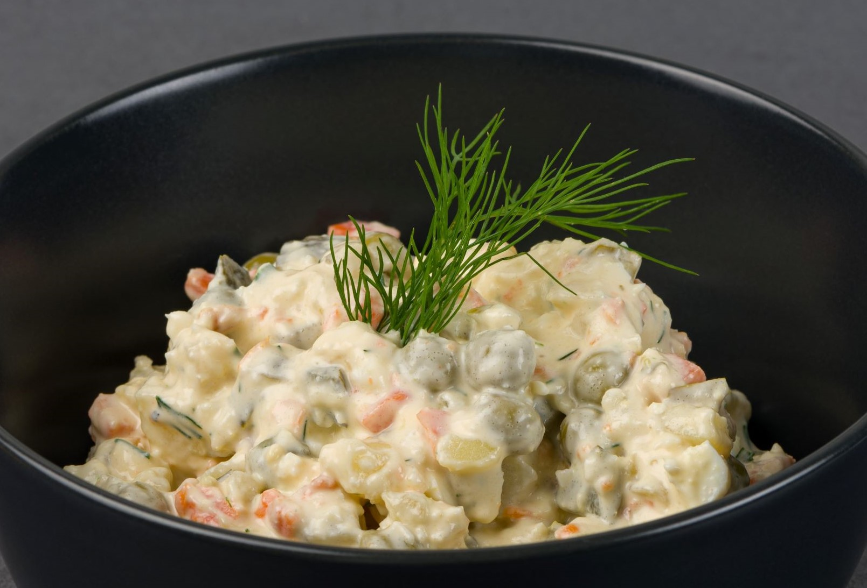

*Similar to a Russian potato salad, Rasols is packed with eggs and pickled vegetables, enveloped in a creamy sauce.

Ingredients:

- 6 potatoes (quite small)
- 4 eggs
- 2 eggs
- 4 Polish-style pickles
- 1 Asian cucumber or 2 small fresh cukes, seeds removed
- Approximately ½ cup pickled carrots – made from:
-1 pound carrots, cut into 3 ½– by ⅓-inch sticks
-1 ¼ cups water
-1 cup cider vinegar
-¼ cup sugar
-2 garlic cloves, lightly crushed
-1 ½ tablespoons dill seeds
-1 ½ tablespoons salt

Salad dressing ingredients:
- 3 large dollops mayonaise (Russian-style preferred, or use Duke’s or Best Foods/Hellman’s, if possible)
- 2 large dollops Smetana (sour cream if unavailable)
- 2 teaspoons Russian mustard (Mother-in-Law style, VERY sharp)
- 2 teaspoons Cider vinegar
- ¼ teaspoon salt
- ¼ teaspoon freshly-ground black pepper
- 1 teaspoon Worcestershire sauce
- 2 teaspoons white horseradish from the bottle
- 1 tiny dash Riga Black Balsam-brand bitters (VERY optional)
- 1 teaspoon minced fresh dill (optional)
- 1 teaspoon minced scallion (optional)
- 1 teaspoon minced garlic (optional)
- minced Dill and minced celery leaves for garnish

Instructions:

- For the pickled carrots:
- Blanch peeled carrots in a 4-quart nonreactive saucepan of boiling salted water 1 minute, then drain in a colander and rinse under cold water to stop cooking. Transfer carrots to a heatproof bowl.
- Bring remaining ingredients to a boil in saucepan, then reduce heat and simmer 2 minutes. Pour pickling liquid over carrots and cool, uncovered. Chill carrots, covered.
- Boil potatoes until fairly soft (but not until they are falling apart). Hard boil eggs. Remove skins from potatoes, and shells from eggs. Dice into fairly large chunks (about ½ inch (1 – 1.5 cm) in diameter). Dice other ingredients into smaller pieces. Put all diced ingredients into a very large bowl.
- Make salad dressing. Start with smaller amounts, and keep adding sour cream, vinegar, mustard, etc. until it tastes good to you. The salad dressing should taste somewhat salty and tart.
- Add salad dressing to diced ingredients. Stir well. Cover. Refrigerate at least an hour.

