Trongårdsskolen in Denmark (primary and lower secondary)
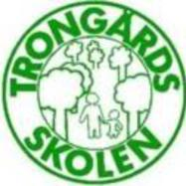
This is the school’s logo.

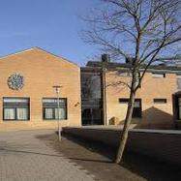 The new building for the primary section

