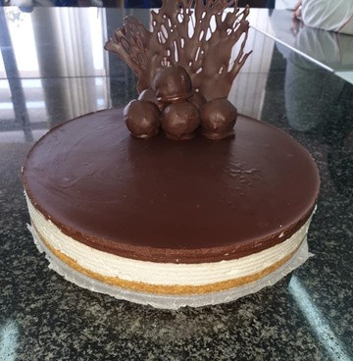
Lady Coco
For the base:
400 g of ground biscuits 180 g of butter

Cream:
500 g of mascarpone cheese, or cream cheese 200 g of powdered sugar
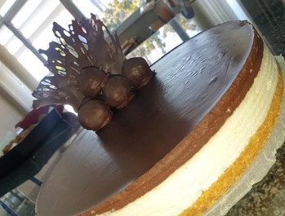
250 ml of sweet cream 200 g of coconut

Ganache:
250 g of chocolate 300 ml of sweet cream

Preparation procedure:
Grind the biscuit and pour over the melted butter. Stir to combine everything into a mass and press on the bottom of the cake pan. Pre-coat the mold with thin butter. Prepare the cream in a way that the cheese is made with a mixer, add powdered sugar and make a little more. Now add the sweet cream and use a mixer to make a frothy mixture. And now add the coconut. When you have added the coconut, lightly stir it with a spatula to get a homogeneous mixture. Put the cream on the pressed biscuits, flatten it nicely and put it in the fridge. Meanwhile, while your cake is cooling, prepare the ganache. You will prepare the ganache by putting the sweet cream to warm it up. It must not boil. Remove from the heat and add the torn chocolate into smaller pieces. Mix everything nicely, so that the chocolate melts nicely. Cool a little. About 5-10 minutes. At the end of the ganache pour over the cream and flatten nicely. Place the cake in the refrigerator and let it cool. At least 2 hours. In the meantime, prepare the decoration for your cake. We have prepared the decoration of the cream as it is in the cake. And if that is an additional job for you, we recommend that you do not put all the cream in a mold, but separate it for about 3 tablespoons and set it aside. So you can separate the ganache part for dipping the balls.

You can let your imagination run wild for decoration
We made coconut balls from the cream that is in the cake. We took 150 g of cheese, 50 g of powdered sugar and 50 g of coconut, and mixed everything nicely to combine the ingredients and formed balls which we cooled and dipped in ganache.

