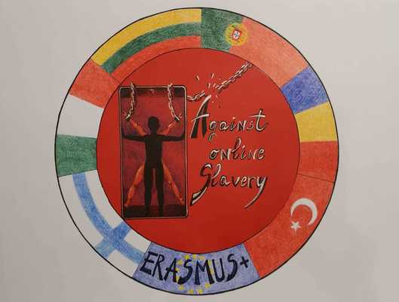
LESSON PLAN | AGAINST ONLINE SLAVERY (2019-1-FI01-KA229-060725)

Country + School: | Portugal – Agrupamento de Escolas de Idães
Teacher(-s) | Izabel Santos / National Republican Guard (GNR)
Subject / Course: | English
Topic: | Safe Social Networking
Age group: | 13-17 | Lesson Duration: | 90 minutes

- Workshop “Safe social networking”
“National Republican Guard,” conference in the “Felgueiras” Auditorium)
Lesson objectives which the students acquire:
After this lesson, students will be able to:
- Social media addiction and the impact this can have on an individual / teenagers
- Draw attention/ to be alert about the problem of the abusive use of social media
- Dangers and security precautions when using social networking sites
- How to break social media addiction and combat the pressures of advertisements
- Know how to evaluate the meaning and the significance of the various text messages sent
- Scheming through messages and selecting the most reliable information
- Social media awareness and the correct use of the internet tools.

Summary of Tasks / Activities:
Task 1- Brainstorming
Word cloud
1.1. Ask the students to share words that come to their minds when they hear the saying "social media" and "social network; (create a word cloud).
1.2. Have Images of a different social networking websites each on a separate Smartboard slide. When each slide is displayed ask the students who has used each separate service.
1.3. Record the number of users on each social network as well as the gender breakdown for each network.
Use the following social networking platform in the survey: Facebook, Twitter, Linkedin, Pintrest, Instagram, Facebook; Tumblr, Vine, YouTube, Kik & Snapchat.
Task 2: Video - "The Social Media Revolution" video.
2.1. Have students work in their table groups (groups of 4) and compile a chart with the positive and negative effects of social media.
2.2. Each group share with the class one positive and one negative effect that they had on their chart.
2.3. Explain Opinions: Articulate, represent and explain personal viewpoints clearly.
Task 3
3.1. Prior Knowledge: Make connections between previous experiences, prior knowledge, and a variety of texts, and apply them to new contexts.
Use Personal Knowledge: Determine personal knowledge of a topic to generate possible areas of inquiry or research.
3.2. Experience Various Texts: Experience texts from a variety of forms and genres [such as magazine articles, diaries, drama, advertisements...] and cultural traditions; compare own interpretations to those of others.
3.3. Contribute to Group Inquiry: Contribute ideas, knowledge, and strategies to help identify group information needs and sources.
Task 4
4.1 Create and Follow a Plan: Prepare and use a plan to access, gather, and record in own words relevant information.
4.2. Choose Forms: Compose using specific forms [such as biographies or letters to the editor, newspaper articles, audio-visual presentations...] that ensure a match between content, audience, and purpose.
Task 5
Students:
Work in Groups: Organize and complete tasks cooperatively and collaboratively.
5.1. Will receive entire class to work on researching and creating their video or podcast. (60 Minutes)
5.2. Once the videos are completed groups will upload the final product to the internet / etwinning …..
5.3. Groups will have to submit a script of their video or podcast.
Task 6 (to be done later in the English class)
Watch the videos and podcasts in class
6.1. While watching the videos, students will be able to respond and ask questions about the videos on "Todays Meet."
6.2. After each video/podcast the groups will have the opportunity to respond to the questions that were asked.

Materials / Equipment:
- SmartBoard
- Internet
- Quiz on Social Media Addiction Questionnaire
- Today´s meet
- SmartBoard slides
- Computers

References/ theories/ teaching methods used:
Cooperative learning

Evaluation of the objectives acquired:
Students´assessment
Formative evaluation – students fill in the questionnaire about their achievement in class.; group productivity and efficiency.
Students will be graded on their video or podcast.
Teacher´s Reflection
How did the assignment go?
Could this be used again? Did the students enjoy the assignment?
Did the students learn valuable information? Were the videos/podcasts well done?
Did the students thoughtfully respond to the blog? Was there good information in the videos/podcasts?

