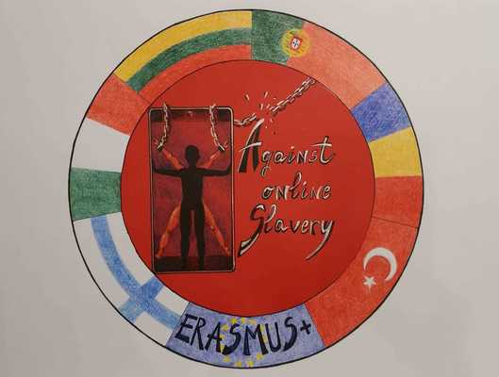
LESSON PLAN | AGAINST ONLINE SLAVERY (2019-1-FI01-KA229-060725)

Country + School: | Portugal – Agrupamento de Escolas de Idães
Teacher(-s) | Izabel Santos / Susana Pereira
Subject / Course: | English
Topic: | Cyberbullying- “Crossing the Line”
Age group: | 13-17 | Lessons: 3 and 4 | Duration: 90 minutes

Essential Question
When does inappropriate online behavior cross the line to cyberbullying, and what can you do about it?
Testimonials Quotes: Famous People-Cyberbullying
Lesson objectives which the students acquire:
After this lesson, students will be able to:
- Learn to distinguish good-natured teasing from cyberbullying;
- Analyze online bullying behaviours that “cross the line.”
- Learn about serious forms of cyberbullying, which include harassment, deception, “flaming,” and threats to safety;
- Adopt the point of view of teens who have been cyberbullied, and offer solutions;
- Pose questions, collect data, represent and analyze the data, and interpret results;
- Learn to distinguish good-natured teasing from cyberbullying.;
- Gather Famous people testimonials/ quotes that have suffered cyberbullying

Summary of Tasks / Activities:
Warm-up (10 minutes)
Ask Students:
What are some of the ways that you and your friends tease each other online for fun?
- Examples- send jokes back and forth;
- Alter photos of one another, in a goofy (not mean) way
- When does teasing “cross the line” and become harmful?
What are some signs, and what does it feel like to be in that situation?
- The teasing begins to feel scary, not funny anymore.
- You feel helpless.
- You feel like your reputation might suffer.
- You are worried about your safety.
ASK students if they have ever heard of the the Key Vocabulary terms harassing, deceiving, flaming, and hate speech. Have students describe the terms, and then provide their definitions.
POINT OUT to students that these are examples of situations that definitely “cross the line” and are considered cyberbullying.
DISCUSS with students why someone might not want to talk to other people about a cyberbullying situation.
What would the roadblocks be? Why?
Emphasize to students that, no matter what label they put on a situation, if it makes them feel uncomfortable, upset, or hurt, they should talk to someone about it

TASK 1
- ASK students if they have ever heard of the the Key Vocabulary terms harassing, deceiving, flaming, and hate speech. Have students describe the terms, and then provide their definitions.
- POINT OUT to students that these are examples of situations that definitely “cross the line” and are considered cyberbullying.
- DISCUSS with students why someone might not want to talk to other people about a cyberbullying situation.

What would the roadblocks be? Why?
Emphasize to students that, no matter what label they put on a situation, if it makes them feel uncomfortable, upset, or hurt, they should talk to someone about it

Students will :
- formulate questions regarding cyberbullying of students on their grade level.
- write questions focused on the interactions of their peers ex. interactions between social groups based on on-line communication.

TASK 2

EXPLAIN that you are going to watch a video of a teen reflecting on a cyberbullying experience a documentary-style story in which a girl reflects on what it was like to be the target of cyberbullying.
SHOW students the video “Stacey’s Story – When Rumors Escalate.” https://www.youtube.com/watch?v=uVKb3Pu7Rd8
DIVIDE students into groups .
DISTRIBUTE copies of the Cyberbullying: Crossing the Line Student Discussion Guide to each student, and have students discuss the Video Discussion Questions in small groups.
ENGAGE students in a full-class discussion about their responses to the Video Discussion Questions.

TASK 3
Case Study Analysis -Famous people
HAVE each group read and discuss a case study of a famous person that suffered Cyberbullying
ENGAGE students in a full-class discussion

TASK 4
Ask Students
- What does it feel like when a teasing situation “crosses the line” from harmless to harmful?
- When teasing no longer feels funny and starts to feel upsetting or scary, then students should start taking it seriously. People can feel helpless, ganged up on, worried about their reputation, worried about their safety, etc.
- What are some different forms of cyberbullying?
Sample responses:
- Harassment, which feels virtually impossible to escape
- Deception, because it is dishonest to impersonate someone else, and it can damage their reputation
- Flaming, because of the extreme and cruel language
- Hate speech, which is discriminatory, and very damaging to someone’s reputation
TASK 5
Students:
Organize and complete tasks cooperatively and collaboratively.
Present their case study analysis to their colleagues
TASK 6
Students:
Gather all the information: graphics, texts, images…
Task 6 (to be done in IT Classes)
Students produce a booklet

Materials / Equipment:
- Video, “Stacey’s Story – When Rumors Escalate,”
- Internet
- Computers

References/ theories/ teaching methods used:
Cooperative learning

Evaluation of the objectives acquired:
Students´assessment
Formative evaluation: Students report to the class their results and their analysis.
Students will construct a booklet
Teacher´s Reflection
How did the assignment go?
Could this be used again? Did the students enjoy the assignment?
Did the students learn valuable information?
Was booklet well done?

