ROMANIA | The Peles Castle
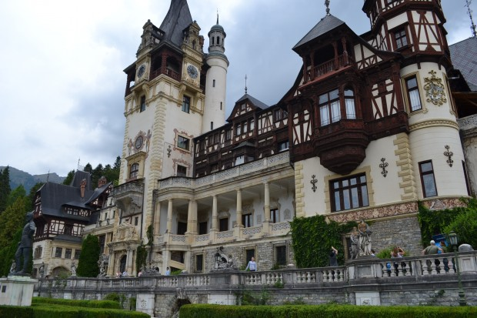 | The Peles Castle is one of Romania’s most important and impressive landmarks, originally representing a place for relaxation and leisure for the country’s monarchs. The castle was sketched out by architects Karel Liman and Johannes Schultz, and it was built in 1914 in Sinaia, Prahova, just 27 miles away from the beautiful city of Brasov.  During their visit, tourists are able to admire the sheer luxury and majestic beauty of this architectural masterpiece. Highlights include a series if lavish rooms such as the theatre room, council room, arms room and living room. However, the Imperial Bedroom is by far the most impressive room in the building, flaunting exquisite decorations such a wonderful chandelier made using Bohemian crystal.

