European Thoughts – collections of QR Codes made by pupils from the United Kingdom (April 2017)

“Famous Landmarks of Britain”

Scan the QR codes to visit the class BLOG for each Junior Class.

The Flying Scotsman (4A) Blackpool Tower (5C)

National Space Centre (4P) The Clifton Suspension Bridge (5P)

Cambridge (4A) Trams (5EC)

Westminster Cathedral (6JR) Houses of Parliament (6W)

Buckingham Palace (6C) Angel of the North (3D)

Blackpool War Memorial (3W) Liverpool Docks (3M)

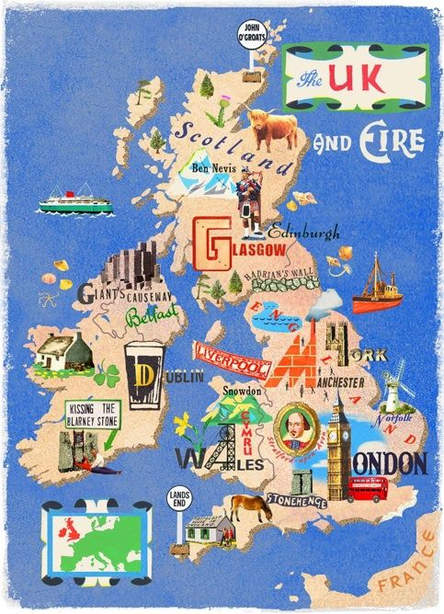
Thanks to all the children and teachers of Stanley Primary School who supported the activities.

