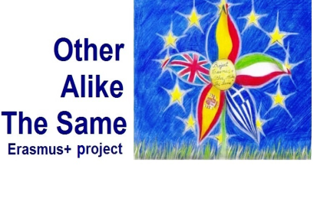

**European Thoughts – QR Codes  
made by pupils from Greece (April 2017)**

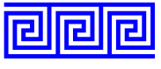

**“Landmarks of Greece”**

**1st Primary School of Efkarpia**





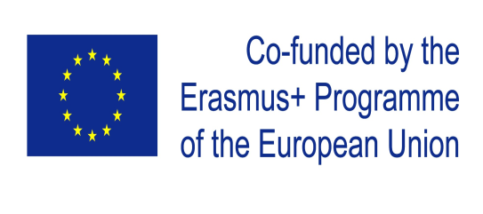

|  |  |
| --- | --- |
| C:\Users\User\AppData\Local\Microsoft\Windows\INetCache\Content.Word\QR01.png | C:\Users\User\Desktop\Erasmus+\Erasmus QR Codes\QR Codes Συμπληρωμένο\01.png  ***1. The Parthenon, Athena's temple,***  ***symbol of Greek and Athenian democracy.*** |
| C:\Users\User\AppData\Local\Microsoft\Windows\INetCache\Content.Word\QR02.png | ***C:\Users\User\Desktop\Erasmus+\Erasmus QR Codes\QR Codes Συμπληρωμένο\02.png***  ***2. The volcano of Santorini*** |
| QR03 | C:\Users\User\Desktop\Erasmus+\Erasmus QR Codes\QR Codes Συμπληρωμένο\03.png  **3. Lion Gate, Mykines** |
| QR06 | C:\Users\User\Desktop\Erasmus+\Erasmus QR Codes\QR Codes Συμπληρωμένο\06.png *4. Lighting Ceremony of the* *Olympic Flame, Οlympia* |
| QR07 | C:\Users\User\Desktop\Erasmus+\Erasmus QR Codes\QR Codes Συμπληρωμένο\07.png  ***5. Church of St. Dimitrios,***  ***patron saint of Thessaloniki*** |
| QR08 | C:\Users\User\Desktop\Erasmus+\Erasmus QR Codes\QR Codes Συμπληρωμένο\08.png  ***6. The palace of Knossos,***  ***Heraklion, Crete*** |
| QR10 | C:\Users\User\Desktop\Erasmus+\Erasmus QR Codes\QR Codes Συμπληρωμένο\10b.pngC:\Users\User\Desktop\Erasmus+\Erasmus QR Codes\QR Codes Συμπληρωμένο\10.png  ***7. The Macedonian tombs, Vergina*** |
| QR11 | C:\Users\User\Desktop\Erasmus+\Erasmus QR Codes\QR Codes Συμπληρωμένο\11.png  ***8. The ancient theatre of Epidaurus.*** |
| QR12 | C:\Users\User\Desktop\Erasmus+\Erasmus QR Codes\QR Codes Συμπληρωμένο\12.png  ***9. The White Tower, Thessaloniki*** |
| QR13 | C:\Users\User\Desktop\Erasmus+\Erasmus QR Codes\QR Codes Συμπληρωμένο\13.png  ***10. Thessaloniki’s Rotunda,***  ***an ancient church*** |