Paska
Ingredients:
500ml of milk
500g of sugar
2tbsp of sour cream
8 eggs
500g of butter
250g of raisins
1 tsp of salt
1.5-2kg of flour
3tbsp of dry yeast
1tbsp of ground nutmeg
1tbsp of ground cardamon
1/4tbsp of ground ginger
1/2 cup of oil
Preparation:
Prepare the ferment first: mix a bit of flour with yeast, pour in some warm milk (with 2 teaspoons of sugar dissolved in it beforehand) and add flour little by little until you get a paste with thickness resembling sour cream. Cover it with a rag and let it rise. Whip up butter, salt and sugar; add eggs, sour cream and spices.
When the dough ferment rises, mix the buttery mass with it and add more flour. Calculate the amount of flour to add so that the result would yield a tender yet coherent mass. Put the dough in a warm place and let it rise again. After it does, dip your hands in oil, knead it twice over and let it rise yet again.

After it rises for the third time, add raisins to the dough and pour it into forms wrapped in tracing paper. Make sure that you fill only 2/3 of the forms. Put the filled forms in a warm place (again) and let the dough rise (again). After the dough rises in the forms, put them into an oven and bake at an average temperature.
In order for raisins and dry/candied fruit to be evenly distributed within a paska, wash, dry and lightly sprinkle them with flour before adding them to the dough.
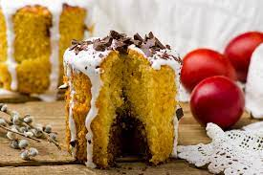

DYEING EGGS RED FOR ORTHODOX EASTER

On Good Friday, Orthodox Christians in Georgia dye hard boiled eggs a red color using the root of the Madder plant and onion peel. The eggs represent the blood of Christ and are placed on green wheat grass, which symbolizes new life, resurrection, and eternity.

To make the red dye:
Ingredients: 15 eggs, 500 grams of madder root, 1 tbs of vinegar and the skin of two onions.
Preparation: Fill a deep pot with room temperature water. Thoroughly wash and then crush or break the madder root. Remove the skin from the onions. Add the eggs, madder root, onion skins and vinegar to the pot.

Heat on a very low temperature until the liquid boils. Allow to simmer for 15 minutes and then remove from the heat. Allow to stand for 3-4 hours.
Carefully remove the dyed eggs. Dry them with a cloth and rub with a little vegetable oil to make them shiny.
Orthodox Christians congratulate each other on Easter with several dyed eggs laid on a dish of green wheat grass and with a traditional Paska cake.
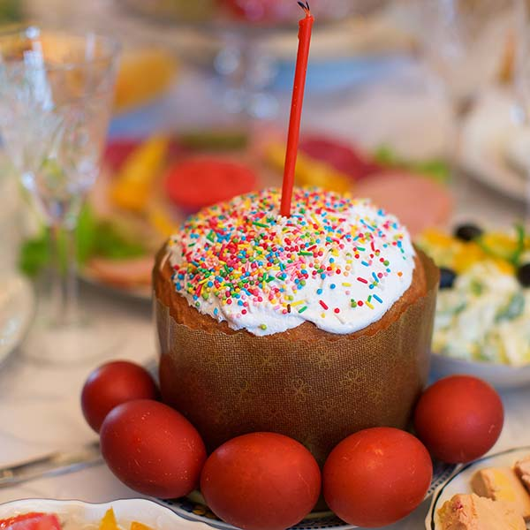

Chakapuli
is a popular Georgian stew made with lamb or beef, dry white wine, tarragon leaves, unripe (sour) green plums, green onions, green peppers, green coriander, garlic and salt. It is popular in the Spring when the plums are unripe.

Ingredients (6 servings): 700 grams of diced lamb or beef.

150 grams of wild sour green plums.

200 grams of tarragon.

200 grams of green onions, 150 grams fresh green coriander, 2 green peppers, 200 ml of white wine, 30 grams of garlic, 1 liter of water, salt (according to taste). Do not add black or red pepper as this will affect the overall taste.
Preparation:
Add the diced lamb or beef to a deep pan. Pour in 200 ml of white wine and cook on a low heat until the wine reduces (usually 15-20 minutes). Stir occasionally with a wooden spoon.
Whilst the meat is cooking, pinch off the tops of the tarragon and strip leaves from their stalks. Chop the tarragon leaves (not too finely). Finely chop the onions, coriander and green peppers.
Crush the garlic.
Add the chopped ingredients, garlic and plums to the pan containing the meat once the wine has reduced. Add 1 liter of water, cover the pan and cook on a low heat for about one hour.

Stir occasionally and add salt (according to taste) near the end of cooking.

Serving: Serve hot with Georgian bread. Be careful not to swallow the plum stones.
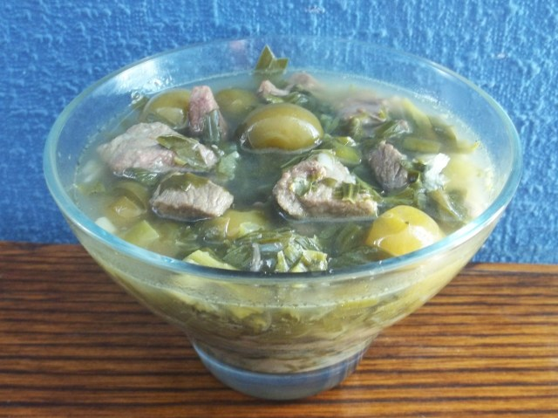
Enjoy your Chakapuli!

