Spanish playing cards have four suits, and a deck is usually made up of 40 or 48 cards. It has strong similarities with the Italian deck. Spanish cards are used in Spain, southern Italy, parts of France, Hispanic America, North Africa, and the Philippines.
Playing cards, originally of Chinese origin, were adopted in Egypt by the 14th century if not earlier, and from there spread to the Iberian peninsula in the latter half of the 14th century.
The four suits are: bastos (clubs), oros (golds or coins), copas (cups), espadas (swords).
Spanish playing cards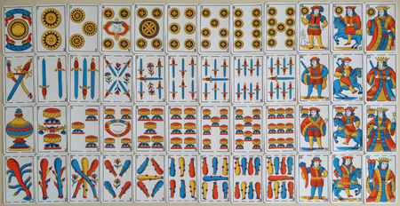
Sicilian playing cards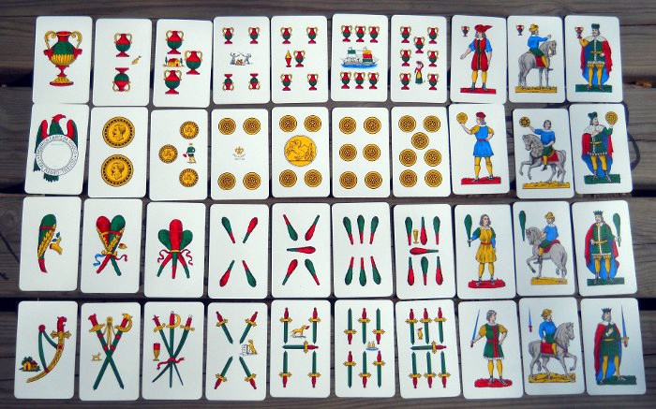
Look at the pictures and complete the table with the given sentences: they are 40- they are 48- they have numbers from one to seven- they have numbers from one to nine- the king is worth 10- the king is worth 12- the horse is worth 9- the horse is worth 11- the woman is worth 8-the jack is worth 10.
 | Spanish cards | Sicilian cards
Similarities | They have four suits | They have four suits
 | They have three figures | They have three figures
Differences

The most popular games are:
Brisca is a popular Spanish card game played by two teams of four with a 40-card Spanish-suited pack or two teams of six using a 48-card pack. Brisca is widespread in many countries, especially in the Mediterranean and Latin American areas. Related games include Italian Briscola. To win this game a player must earn as many points as possible, winning the rounds. The highest cards of each suit are: Ace, Three, king, knight, Jack or Woman.
Escoba is a variant of the Italian card game Scopa, which means "broom", a name that refers to the situation in the game where all of the cards from the board are "swept" in one turn. The game is usually played with a deck of traditional Spanish playing cards.
Burro (English: donkey) is a card game played with Spanish playing cards. The principal objective of the game is to get four cards of the same number. The ideal number of players is from 4 to 8. The objective of the game is to run out of cards as quickly as possible. Each time one of the players lose, they are assigned a letter of the word burro. The player who is first to complete the word becomes the ultimate loser of the game. The final winner will be the player who has failed to complete the word when others do. To win a game a player must place their hand face down in the middle of the table.
Siete y Media is a card game similar to blackjack. It is traditionally played in Italy during Christmas holidays with the name “Sette e mezzo”. The game is also known in English as “Seven and a half”. Players must bet before receiving their first card, which is dealt face down. After receiving it, they must decide whether to stand (end their turn) or hit (receive another card). Players may stand or hit as long as they do not go bust (exceed 7¹⁄₂). When a player goes bust they must show their face down card and immediately lose their bet, regardless of whether the dealer goes bust later. When a player achieves 7¹⁄₂ they must announce it and show their face down card.

TRUE or FALSE?
- Spanish and Sicilian cards have strong similarities. T F
- Sicilian cards consist of fifty cards. T F
- Playing cards is of Arab origin. T F
- Playing cards spread to Spain in 12th century. T F
- The suits of the cards are four. T F
- “Brisca” is the Italian “Briscola”. T F
- The highest cards in Brisca are seven and eight. T F
- “Escoba” means bush in English. T F
- “Burro” means donkey in English. T F
- “Sette e mezzo” is Seven and half in English. T F

