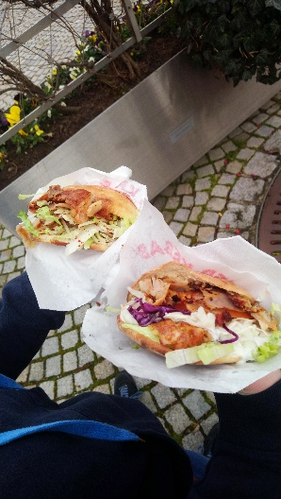
What do you like to eat?
For lunch we often eat doner Kebab.
In Wertingen there are two restaurants, that sell these. They are filled with meet, salad, onion
and cabbage.

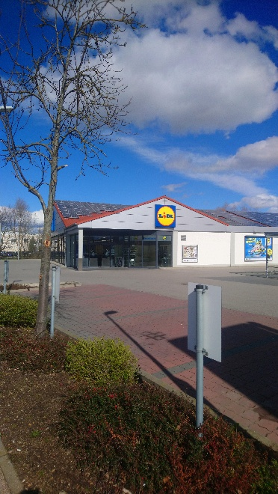

Where do you purchase your stuff?
For our daily needed stuff we go to a supermarket like Lidl.

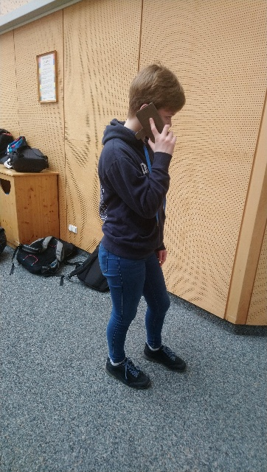

How do you communicate with others?
We talk to them by using the mobilephone
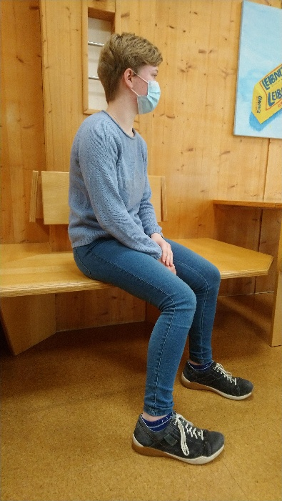
What clothes do you usually wear?
We normally wear a sweater with jeans

What do you do in your free timetime?
We chat with friends or play games.
