Last project:

In the first pictures, you can see the clothes I usually wear: a hoodie (in this example from the brand “Nike”), jeans and sneaker. I prefer to wear black pullovers.
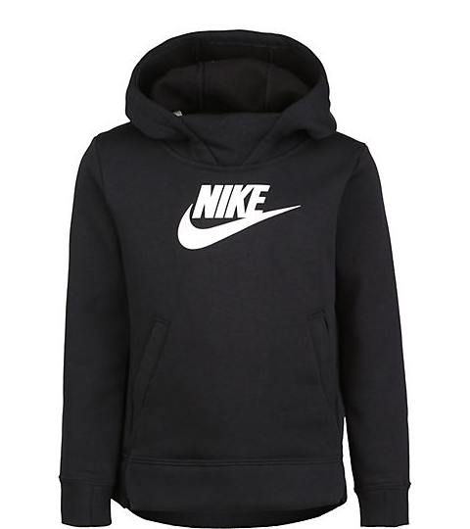
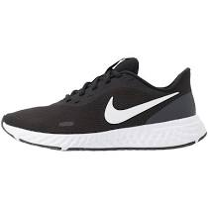
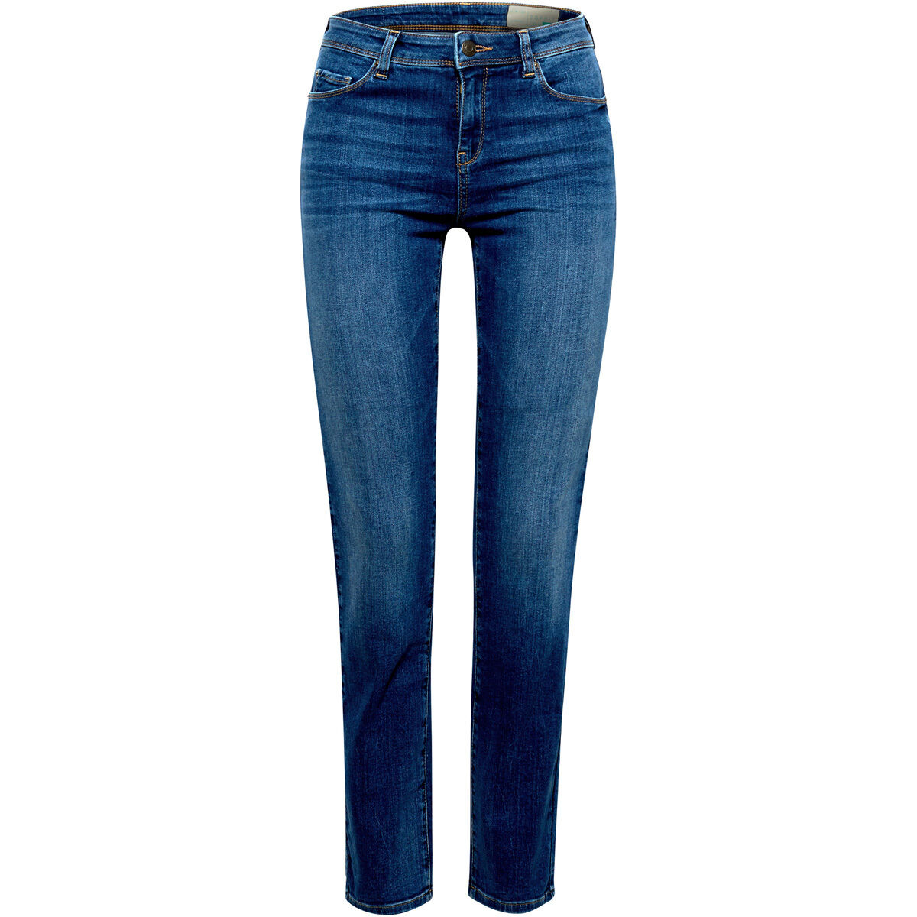

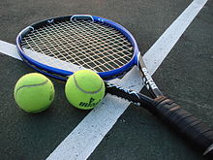
When I got in the “Oberstufe”, I stopped playing tennis and wanted to look for a part-time job, which was made more difficult by Corona.

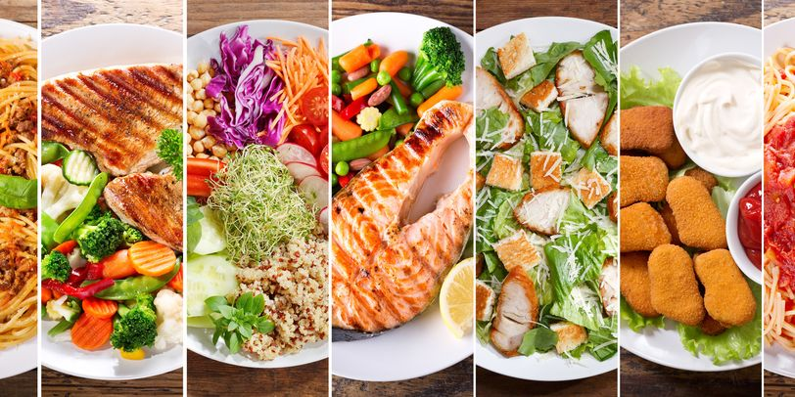
I don't have a favorite food, I actually like everything, with some exceptions.

For groceries or everyday objects I go to a supermarket, mostly Aldi, and for clothes I go to shopping centers with shops such as "Only". We also order often from “Amazon” or “Asos”.
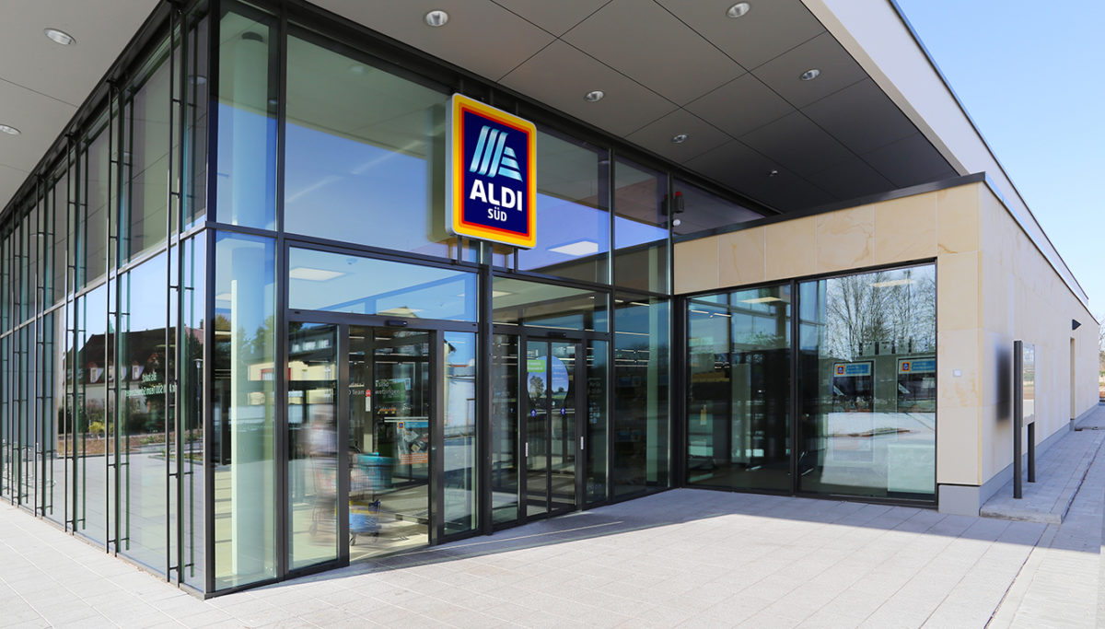



I communicate with others either personally at school or at private meetings and otherwise via WhatsApp. I rarely make phone calls, except for the time of the lockdown.

Interview with my parents:
Like me, my parents wore jeans in their childhood, along with sweaters and T-shirts. In their free time they went ice skating, played handball, and read. They ate the same as we do today and went shopping in supermarkets, shops and so-called "Tante Emma Läden". What was different in the past, is that if they wanted to communicate with others and that wasn't personal, they wrote letters.

