Basics of programming and robotization for primary schools

A) Theoretical section

Table of contents
Basics of programming and robotization for primary schools 1
A) Theoretical section 1
1. Introduction 2
2. Learning from everyday activities 3
3. Basic rules and procedure for supporting and developing algorithmic thinking 4
B) Practical section 5
4. Description of activities 5
5. Grade one, two and three: 6
6. Grade three and four: 6
7. Worksheets 7

Introduction
Demonstrate the options, advantages, and benefits of programming to children. Develop logical thinking in children and prepare them for the arrival of modern technologies and Industry 4.0.
Children can start programming even from grade 1 at the primary school. Programs for grade one, two and three children, as well as programs for grade four and five children are prepared here.
We use the most entertaining form possible - the robot called Ozobot - to teach programming. The advantage of this approach is that children can program this robot with color symbols drawn on paper, as well as mobile phones and tablets.
Ozobot is simple and interactive to develop creativity and logical thinking. At the same time, it is an ideal teaching aid providing the shortest and the most entertaining pathway to real programming and robotics. The supporting application, flexible programming environment and worksheets make integration of Ozobot in the School Education Program easy.

Description of programming tuition and advantages of individual lessons:
- 4 x 45 min of guided activity
- The tutor (teacher) leads the lesson and communicates with students
- Combination of programming tuition with specialized subjects (such as natural sciences, geography, history, physics, foreign language, etc.)
- One Ozobot for each pair develops cooperation and teamwork
- No technical equipment is required from the school (if the school has tablets or PCs, it is an advantage but not a prerequisite).
- During lessons, art supplies, such as paper, markers, scissors, and glue, are used in addition to Ozobots
- Each lesson comes with specific worksheets, clear specification of tasks and aim
- Higher grades can use their own telephones and tablets in tuition
- Simple control is typical for Ozobot - providing commands using color combinations. All students manage controlling and programming the robot!
- The tuition is delivered using the STEM method
- The tutor emphasizes computational thinking, logic and algorithmization, all of which will be useful even in children’s everyday life
- The lessons are designed to include communication among several Ozobots and thus among individual teams. This communication among teams develops work in groups, cooperation, and organization of groups
- Ozobot is welcome refreshment in the worlds of mathematics, logic, and programming for children. It prepares children for the future and the world of Industry 4.0
What is Ozobot?
Ozobot is a miniature robot, the smallest of its kind. It is an interactive toy for developing creativity and logical thinking. At the same time, it is an ideal teaching aid providing the shortest and the most entertaining pathway to real programming and robotics.
Ozobot’s capabilities are provided using optic sensors. While following a line, Ozobot recognizes the drawn instructions created from color codes and responds according to the commands provided. The line can be in various colors, Ozobot recognizes the color and lights the LEDs on the top of its body in the same color

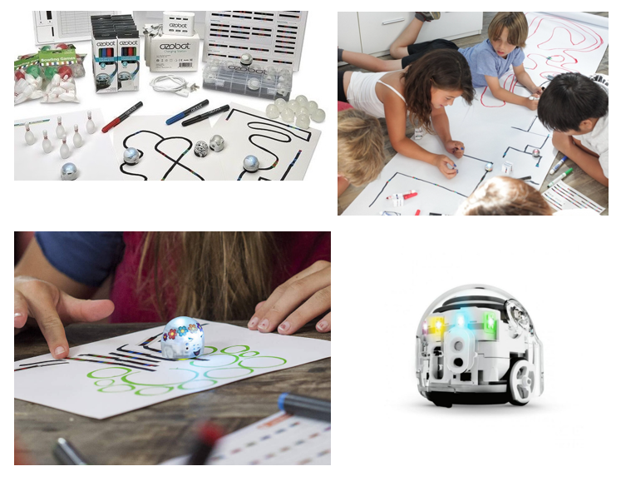

Learning from everyday activities
In our everyday life, we come across activities that repeat and consist of individual steps performed typically in a specific sequence. What are these activities? Let’s take the example of brushing teeth, preparing breakfast, cleaning the household, getting dressed. We can call the individual steps commands and the procedure consisting of these steps may be called a simple algorithm.
An algorithm is a precise procedure that can be used to solve a specific task. It consists of specific commands leading to the relevant solution. Programming simply is writing algorithms in a form comprehensible to a computer. It is essentially specification of consecutive commands to a computer to instruct the computer what to do and in which order to reach the desired outcome. These commands must be sufficiently simple so that the computer understands them and sufficiently clear and precise to avoid any errors. If commands are not formulated clearly and precisely, the computer makes mistakes.
Spatial awareness in connection with computational thinking means correct understanding of the meaning of position (on the top, at the bottom, at the back, at the front, high, low, above, below, etc.). By practicing this, children notice relationships between objects in their field of vision, estimate the direction, lengths and estimates individual steps leading to the solution of the specified task. They use and understand the terms such as the first, last, middle, second last. They master the notion of left and right on their own bodies. They recognize the left and right side on a person standing opposite to them. When drawing a picture, they can estimate its structure and proportions. They can work appropriately with the specified area on paper. They can identify an object on a surface and in space according to instructions provided by another person

Basic rules and procedure for supporting and developing algorithmic thinking
We recommend using the following procedure with all activities to ensure that children use their own reflection of procedures, are able to abandon an erroneous plan and find and test a new strategy.

B) Practical section

Description of activities
Individual activities for primary school grades are described below. The table describes activities for children, their duration, necessary resources, and worksheets for the relevant activity.

Grade one, two and three:

Grade three and four:

Worksheets

